Local Government Budget Management System (LGBMS)
Phases 3 & 4
PROJECT MANAGEMENT PLAN
(PMP)

Executive Sponsor – Donnie Quintana

Business Owner – Debbie Romero

Project Manager – Elizabeth Jaramillo

Original Plan Date: January 17, 2017

Revision Date: June 30, 2020
Revision: 1
Revision History iii
Preparing the Project Management plan iv
About This Document iv
Project Oversight Process Memorandum – DoIT, July 2007 iv
1.0 Project Overview 1
1.1 Executive Summary- rationale for the Project 1
1.2 funding and sources 1
1.3 constraints 1
1.4 dependencies 1
1.5 ASSUMPTIONS 1
1.6 Initial Project Risks Identified 2
2.0 Project Authority and Organizational Structure 2
2.1 Stakeholders 2
2.2 Project Governance Structure 3
2.2.1 Describe the organizational structure – Org Chart 3
2.2.2 Describe the role and members of the project steering committee 3
2.2.3 Organizational Boundaries, interfaces and responsibilities 3
2.3 Executive Reporting 3
3.0 Scope 3
3.1 Project Objectives 3
3.1.1 Business Objectives 3
3.1.2 Technical Objectives 3
3.2 Project exclusions 3
3.3 Critical Success Factors 4
4.0 Project Deliverables and methodology 4
4.1 Project Management Life Cycle 4
4.1.1 Project Management Deliverables 4
4.1.2 Deliverable Approval Authority Designations 5
4.1.3 Deliverable Acceptance Procedure 5
4.2 PRODUCT LIFE CYCLE 5
4.2.1 Technical Strategy 5
4.2.2 Product and Product Development Deliverables 6
4.2.3 Deliverable Approval Authority Designations 6
4.2.4 Deliverable Acceptance Procedure 6
5.0 Project Work 6
5.1 Work Breakdown Structure (WBS) 6
5.2 Schedule allocation -Project Timeline 7
5.3 Project Budget 7
5.4 Project Team 8
5.4.1 Project Team Organizational Structure 8
5.4.2 Project Team Roles and Responsibilities 9
5.5 STAFF PLANNING AND Resource ACQUISITION 9
5.5.1 Project Staff 9
5.5.2 Non-Personnel resources 9
5.6 PROJECT LOGISTICS 10
5.6.1 Project Team Training 10
6.0 Project Management and Controls 10
6.1 Risk and issue Management 10
6.1.1 Risk Management Strategy 11
6.1.2 Project Risk Identification 11
6.1.3 Project Risk Mitigation Approach 11
6.1.4 Risk Reporting and Escalation Strategy 11
6.1.5 Project Risk Tracking Approach 11
6.1.6 ISSUE MANAGEMENT 11
6.2 INDEPENDENT Verification And Validation - Iv&V 11
6.3 Scope Management Plan 11
6.3.1 Change Control 12
6.4 Project Budget Management 12
6.4.1 Budget Tracking 12
6.5 Communication Plan 12
6.5.1 Communication Matrix 12
6.5.2 Status Meetings 12
6.5.3 Project Status Reports 12
6.6 PERFORMANCE MEASUREMENT (PROJECT METRICS) 12
6.6.1 Baselines 13
6.6.2 Metrics Library 13
6.7 QUALITY OBJECTIVES AND CONTROL 13
6.7.1 quality Standards 13
6.7.2 Project and Product Review AND ASSESSMENTS 14
6.7.3 Agency/Customer Satisfaction 14
6.7.4 PRODUCT DELIVERABLE ACCEPTANCE PROCESS 14
6.8 CONFIGURATION MANAGEMENT 15
6.8.1 Version Control 15
6.8.2 Project Repository (Project Library) 15
6.9 PROCUREMENT MANAGEMENT PLAN 15
7. 0 Project Close 15
7.1 Administrative Close 16
7.2 Contract Close 16
AttachmentS 16

Revision History
Revision Number | Date | Comment
1.0 | July 27th, 2007 | DoIT Project Management Office Revision
2.0 | June 30th, 2020 | DFA/Local Government Division
2.1
2.2

1.0 Project Overview

Due to the successful implementation of Phase I and II of the Local Government Budget Management System LGBMS project, this project focus is to plan and implement a Property Tax Module (PTM) as a component of the LGBMS system. This project continues a phased approach, consisting of Phase III & IV of the LGBMS system implementation. .1.1 Executive Summary- rationale for the Project
The mission of the Department of Finance and Administration’s (DFA) Local Government Division (LGD) is to assist local governments, local representatives, and citizens with the appropriate use of public funds and to strengthen their ability to better serve New Mexico communities to improve their quality of life. The Budget and Finance Bureau (BFB) within LGD provides budget and finance oversight of counties, municipalities, and special districts. This oversight entails reviewing revenues to ensure projections for operating budgets are reasonable based on local economic conditions. One of the main revenue sources for counties, municipalities and some special districts are property taxes which in Tax Year 2018 were expected to generate approximately $1.819 billion in tax revenues statewide. Approximately, 90.8% and 65.6% of property tax revenues flowing to counties and municipalities respectively fund the operations of the local governments. BFB, on behalf of the DFA Secretary, collects, analyzes and calculates assessed property valuations and other financial data related to operational, special, and general obligation bond mill levies in order to set property tax mill rates for all taxing entities pursuant to Sections 7-37-7(A) and 7-38-33(A) NMSA 1978.
DFA-LGD was awarded $500,000 in a special appropriation to build out a Property Tax Module (PTM) within LGBMS to remedy the manual process of key entering several sources of data input into a very large Excel workbook. This manual process requires a significant amount of time, is subject to key entry errors, and makes it difficult to easily share data with other state agencies and local governments involved in property tax rate setting.
Due to the successful implementation of LGBMS, DFA plans to continue the LGBMS project with implementation of a PTM in a phased approach consisting of Phase III & IV. The implementation of the PTM will benefit DFA, other state agencies (such as the Taxation and Revenue Department/Property Tax Division, Higher Education Department and Public Education Department), and local government bodies by allowing more efficient data sharing, improving data validation and integrity, enabling automated calculation of property tax rates, and implementing backup of data. The property tax system in New Mexico has always been a manual process for all state and local entities involved. The same assessed valuation data is entered multiple times by various entities in order to generate mill levy rates. The potential for errors is great and historically has been mitigated by comparing spreadsheets generated by the various participating entities to catch errors as early as possible. Errors that have to be corrected late in the process can impact each of the 33 county treasurers’ ability to issue property tax bills on a timely basis which could potentially delay the receipt of revenue that is heavily relied on by local entities (counties, municipalities, special districts, school districts, and higher education institutions) to fund general operations, debt payments and capital outlay needs. The state also depends on property tax revenues to make debt payments on general obligation bonds that voters have approved to fund important capital outlay projects throughout the state. Ultimately, having a better way to accurately set property tax mill levy rates will benefit all property tax owners throughout the state.

1.2 funding and sources

Source | Amount | Associated restrictions | Approvers
Special AppropriatION  Laws of 2019, HB2 Section 7, Paragraph 9 | $500K | June 30, 2021 expiration of funds. | DOIT-EPMO

1.3 constraints
Constraints are factors that restrict the project by scope, resource, or schedule.

Number | Description
1 | Resource – Project coincides with State Budget System Development & Implementation. Making IT staff time more limited.
2 | Budget and Schedule – Funding will expire at the end of FY2021

1.4 dependencies
Types include the following and should be associated with each dependency listed.
- Mandatory dependencies are dependencies that are inherent to the work being done.
- D- Discretionary dependencies are dependencies defined by the project management team. This may also encompass particular approaches because a specific sequence of activities is preferred, but not mandatory in the project life cycle.
- E-External dependencies are dependencies that involve a relationship between project activities and non-project activities such as purchasing/procurement

Number | Description | Type M,D,E
1 | Dependent upon full cooperation of local public bodies of New Mexico. | M
2 | Dependent upon continued availability of state resources including funding and support staff. | M
3 | Dependent on procuring a software developer with knowledge in budget systems including MySql & PHP languages. | M
4 | Dependent upon Procurement & Use of IV&V | M
5 | Dependent upon rental/use of training facilities, IT equipment, & Materials. | E

1.5 ASSUMPTIONS
Assumptions are planning factors that, for planning purposes, will be considered true, real, or certain.

Number | Description
1 | There will be adequate IT resources for Phase 3 & 4 of this project, including the Project Manager, the database analyst, a technical lead/application developer, and technical staff.
2 | Project Support and Approval from DoIT, key stakeholders, DFA staff, & local government bodies.
3 | Subject Matter Expert & Pilot Group availability within Project Schedule
4 | Vendor will stay in business and their key technical staff will remain in place.

1.6 Initial Project Risks Identified
This section identifies and describes how each risk will be managed. The following tables include the steps that will be taken to maximize activity that will result in minimizing probability and impact of each risk.
Executive Support
Description – Lack of Executive Support | Probability Low | Impact High
 | Mitigation Strategy: Effective communication with executive stakeholders
 | Contingency Plan Utilize team meetings, emails, and progress updates to engage the executive team by demonstrating the effectiveness and importance of LGBMS.

Scope Creep
Description – Scope Creep | Probability High | Impact high
 | Mitigation Strategy: Validate if any change request is essential to completing scope and functional goals. Continued use of Change Request Plan. Appropriate use of IV&V Reports, Project Manager oversight of PMP & Project scope. Maintaining close communications with project team members.
 | Contingency Plan: Implement only changes that are within Project Scope. Identify funding/time to extend project.

Stakeholder Cooperation
Description – Cooperation between all Stakeholders including: Executive, Local Governmental Bodies, Budget & Finance Bureau Staff, Tax & Revenue Property Tax Division& Project Team Members | Probability High | Impact high
 | Mitigation Strategy: Timely and effective Communication, Strategic Planning & Marketing, Effective support & training. Establish a Communication Plan.
 | Contingency Plan: Commitment to stay on schedule and scope & implement buy-in strategies for Local Government Bodies.
Executive Turnover
Description – Executive Staff Turn Over | Probability Low | Impact Med
 | Mitigation Strategy: N/A
 | Contingency Plan: Update New Executive Leadership and establish good lines of communication.

2.0 Project Authority and Organizational Structure
Presented in this section is the project organization which includes descriptions of the different roles, responsibilities, and an organizational chart that illustrates the hierarchy of the project team.
The Project Organization describes the roles and responsibilities of the project team. It also identifies the other organizational groups that are part of the project and graphically depicts the hierarchical configuration of those groups. It exists to clarify interaction with the project team.

2.1 Stakeholders
The following is a list all of the major stakeholders in this project, that includes their stake in the Project.

name | Stake in Project | Organization | Title
Debbie Romero | Governing Agency Head | DFA | Acting Cabinet Secretary
Donnie Quintana | Governing Department Head | DFA | Director
Elena Tercero | Governing Financial Head | DFA | CFO
Joseph Baros Jr | Governing Head of IT | DFA | CIO
Elizabeth Jaramillo | Project Manager/ IT SME | DFA | Network Administrator
Stephanie Schardin-Clarke | Owns System that will provide output for Property Tax Module input | TRD Property Tax Division | Cabinet Secretary
DFA-IT | Governing IT Dept/ IT SME | DFA | N/A
Brenda Suazo-Giles | Governing Bureau Head/ Business SME | DFA | Bureau Chief
Jolene Gonzales | Management of Special Projects/ Business SME | DFA | Special Projects Manager
BFB Analysts | UAT Testers, SME, Users of Current System | DFA | BFB Analysts
Pilot Group | UAT Testers, Users of Current System | Various Counties, Municipalities, & Special Districts | N/A
Local Government Entities | Users of Current System | Various Counties, Municipalities, & Special Districts, Misc. Public Officials | N/A

2.2 Project Governance Structure

2.2.1 Describe the organizational structure – Org Chart
The following diagram depicts the steering committee and interaction between the steering committee, the project manager, and the rest of the Project Team.
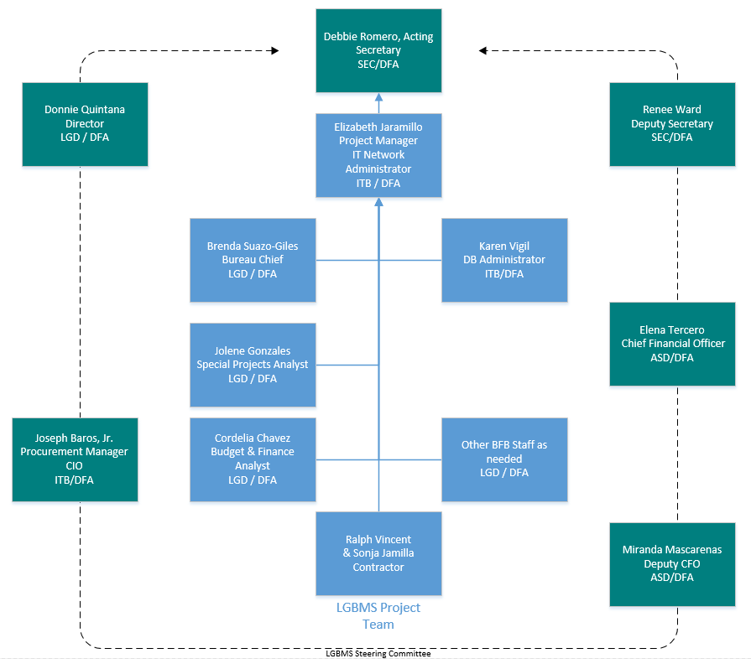

2.2.2 Describe the role and members of the project steering committee
The Steering Committee consists of management grade personnel. The Committee is responsible for overseeing the progress of the project and responding to any strategic problems as they arise. The committee is involved from project planning and initiation including development of the project definition in concurrence with the Project Manager. Once the project is initiated, the committee actively reviews the projects progress. In addition, the Committee will negotiate through delicate diplomatic areas of the project.
The Project Steering Committee Consists of:
- Debbie Romero, Acting Cabinet Secretary
- Renee Ward, Deputy Cabinet Secretary
- Elena Tercero, Chief Financial Officer
- Miranda Mascarenas, Deputy Chief Financial Officer
- Joseph Baros, Jr., Chief Information Officer
- Donnie Quintana, LGD Director

2.2.3 Organizational Boundaries, interfaces and responsibilities
The Steering Committee is chartered to provide governance over the direction and support of the project.
The Steering Committee member responsibilities include:
- Attend and participate in meetings, as necessary.
- Acceptance of IV&V reports from the IV&V Contractor (TBD)
- Assist with issue resolution for issues requiring escalation to the Committee.
- Approval and Acceptance of Issues and Risk Logs.
- Guidance and Approval/Disapproval of Change Requests.
- Approval and Acceptance of Deliverables.

2.3 Executive Reporting
The Steering Committee will meet at frequent intervals based on their project tasks. In between meetings, the Project Manager will send pertinent emails to project staff and committee members as needed. This process will be summarized on an as needed basis to distribute to the Executive Sponsors, Collaborative stakeholders as appropriate, and to the Department of Information Technology (DoIT).

3.0 Scope

3.1 Project Objectives

3.1.1 Business Objectives
Number | Description
Bus. Objective 1 | IMPLEMENT ALL SPECIAL DISTRICTS IN LGBMS
Bus. Objective 2 | CALCULATE MILL LEVY RATES WITHIN LGBMS
Bus. Objective 3 | INCREASE ACCURACY & EFFICIENCY OF BUDGET & TAX DATA
Bus. Objective 4 | IMPROVE DATA SHARING AND REPORTING PROCESSES
Bus. Objective 5 | IMPROVED COMMUNICAITON WITH USERS

3.1.2 Technical Objectives
Number | Description
Tech. Objective 1 | IMPROVE DATA INTEGRITY
Tech. Objective 2 | IMPROVE OVERALL SYSTEM SECURITY
Tech Objective 3 | IMPROVE SYSTEM ADMINISTRATION
Tech Objective 4 | REDUCE MANUAL PROCESSES AND TIME TO COMPLETE THEM
Tech Objective 5 | REDUCE USER ERROR BY BUILDING VALIDATION INTO AUTOMATED PROCESSES

3.2 Project exclusions
No Project exclusions or exceptions are identified at this time. This project will require IV&V services and is subject to all requirements related to DoIT Certified Projects including those of the DoIT Technical Architecture Review Committee (TARC) and Project Certification Committee (PCC). The project team and the IV&V contractor will work together to ensure the scope of work and proposed features and items adhere to the scope of work. Items, features or reports that are identified during the execution of the project that are not included in the scope of work will be recorded for consideration in future phases.

3.3 Critical Success Factors
The following is a list of critical success factors for achieving success in this project.

Number | Description
Quality Metrics 1 | Project Manager to Keep Project on Schedule
Quality Metrics 2 | procurement manager to keep project within budget
Quality Metrics 3 | System will be able to accept bond/loan submission & Analyst/Chief will be able to review and approve
Quality Metrics 4 | System will accept Occupancy Tax Rates and validate
Quality Metrics 5 | system will accept ytd values associated with lodgers’ tax related budget items & Analyst/Chief will be able to review and approve
Quality Metrics 6 | System will prepare & produce a standard lodgers tax report
Quality Metrics 7 | System will import TRD data & associated reports
Quality Metrics 8 | System will accurately calculate property mill levy rates in order to generate the Certificate of Tax Rates and other property tax reports
Quality Metrics 9 | Complete tasks for existing module enhancements
Quality Metrics 10 | complete tasks for administrative module build-out

4.0 Project Deliverables and methodology

4.1 Project Management Life Cycle
Phase | Summary of Phase | Key Deliverables
Planning, Strategize, & Initiation | This task outlines how the project will be conducted. | - Project Plan and schedule  - Resource requirements  - Weekly and Monthly Report Templates  - Risk and Issue Log Templates  - Project Management Procedures document (escalation process, issue resolution process)  - Phase 3 & 4 scope definition  - Needs assessment
System Design & Development | The process, functional, and technical design and build activities will occur in this task. | - Requirements Documentation  - Configuration Design  - Technical Architectural Review Committee (TARC) Waiver  - Reports and Workflow Design  - Process Flow Design  - Configure and Build
System Implementation & Acceptance Testing | This phase will consist of an agile approach of Development, Unit Testing, System Testing, and User Testing. | - Test plan  - Testing and Defect Tracking Log  - Creating and using Test Scripts that mimic the established / created Business Process  - Unit Testing  - User Acceptance Testing  - Test environment  - Production environment  - Code
Knowledge Transfer & Training | This task will address End User Training & Training Materials. | - Job Aids (User & Technical)  - Training Materials (User & Technical) Maybe automated or self-guided  - Training Delivery (User & Technical)  - Knowledge transfer (Technical)
Deployment to Production | This task will address Plan and deployment to production environment. | - Implementation of Plan and Schedule  - Implementation Issue(s) Tracking Log  - Cut over to production
Project Closeout | This phase will address project completion. | - Lessons Learned  - IV&V Final Report  - Project Closeout Report

4.1.1 Project Management Deliverables
Project Deliverables are work products or artifacts that are driven by the project management methodology requirements and standard project management practices regardless of the product requirements of the project.

4.1.1.1 Weekly Status Reports
Description – Weekly Management Status Reports | Deliverable Acceptance Criteria: Sign-off by Business Owner Donnie Quintana, Renee Ward may sign in lieu of Business Owner’s absence.
 | Standards for Content and Format – To be created by Project Manager and Contractor and agreed upon by Project Team.
Quality Review - Peer review for completeness, grammar, and spelling.

Key project team members will review for consensus and approval.

4.1.1.2 (Regular) IV & V Reports
Description – Prepared IV & V Reports will update PM and Steering Committee on the overall health and status of the project | Deliverable Acceptance Criteria – Shall be delivered to DFA CIO, Executive Steering Committee and DoIT EPMO.
 | Standards for Content and Format – Outlined in IV&V contract for each report.
 | Quality Review – Outlined in IV&V Contract.

4.1.1.3 Issues & Risk Logs
Description – Logs created and maintained to track issues and risks that arise and are resolved through the life of the project. | Deliverable Acceptance Criteria – Approval and Sign-off by Steering Committee and Project Management.
 | Standards for Content and Format – Outlined in Contract with Vendor Vincent & Associates and KiP.
 | Quality Review – Key project team members will review for consensus and approval.

4.1.2 Deliverable Approval Authority Designations

The following table lists the deliverables that this project is to produce, and names the person or persons who have authority to approve each deliverable.

Deliverable Number | Deliverable | Approvers (Who can approve) | Date Approved
PRJ-DEL-001 | Project Management & Coordination | DFA
PRJ-DEL-002 | Outstanding debt module functional requirements | DFA
PRJ-DEL-003 | Lodgers' tax module functional requirements | DFA
PRJ-DEL-004 | Administration and security enhancements functional requirements | DFA
PRJ-DEL-005 | Property Tax Module functional requirements | DFA
PRJ-DEL-006 | Training/knowledge transfer plan | DFA
PRJ-DEL-007 | Outstanding debt module | DFA
PRJ-DEL-008 | Lodgers' tax module | DFA
PRJ-DEL-009 | Administration and Security Enhancements | DFA
PRJ-DEL-010 | Property tax module | DFA
PRJ-DEL-011 | User Acceptance Testing Scripts | DFA
PRJ-DEL-012 | Documentation/Training Material | DFA
PRJ-DEL-013 | PHP Code | DFA
PRJ-DEL-014 | Database schema | DFA
PRJ-DEL-015 | Meeting summary and progress reports | DFA

4.1.3 Deliverable Acceptance Procedure

The Contractor in concordance with the Project Manager will submit the deliverable with a Deliverable Approval sign-off sheet to the steering committee approvers for review and approval.

4.2 PRODUCT LIFE CYCLE
Since this project has known requirements, a sequential activities, specific deliverable dates, and dependencies, the waterfall method will be the core approach followed for this this project. However, it will be supplemented with the agile approach specifically in the development stage of the project. This allows for feedback and improvement of the modules through input from the project team and pilot group participants.
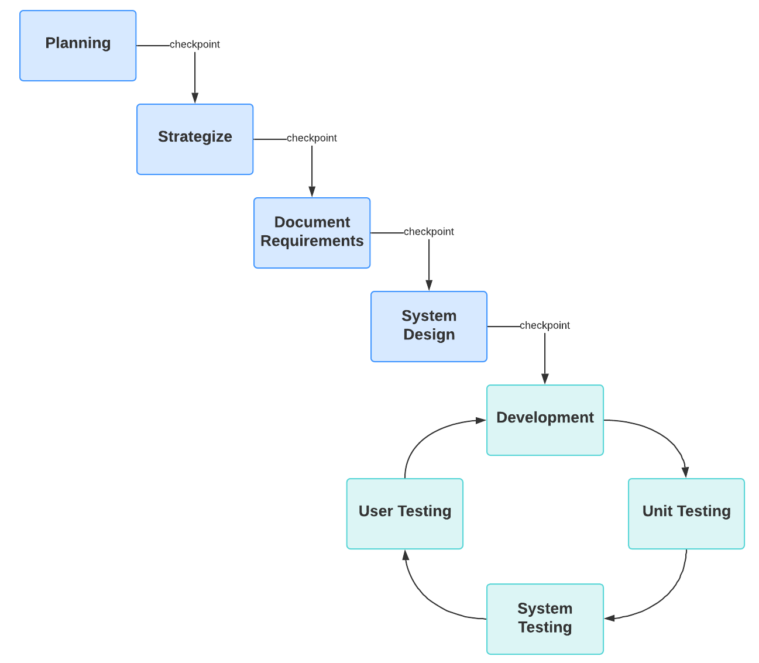
During the project management lifecycle, agencies shall select and implement a phase product development lifecycle methodology approved by the Department.

 | Work Package Description | Key Deliverable
Planning
P.1 | Project Management Support & Coordination | Project Management Plan  Project Schedule  Monthly Reports
P.2 | Outstanding debt module functional requirements | Functional requirements/planning document
P.3 | Lodgers' tax module functional requirements | Functional requirements/planning document
P.4 | Administration and security enhancements functional requirements | Functional requirements/planning document
P.5 | Property Tax Module functional requirements | Functional requirements/planning document
P.6 | Training/knowledge transfer plan | Training and knowledge transfer planning document
Phase III
3.1 | Project Management Support & Coordination | Project Management Plan  Project Schedule  Monthly Reports
3.2 | Outstanding debt module | Outstanding debt module integrated into LGBMS use case diagrams will be developed and included in the functional requirements document.
3.3 | Lodgers' tax module | Lodgers' Tax module integrated into LGBMS use case diagrams will be developed and included in the functional requirements document.
3.4 | User Acceptance Testing | User Acceptance documentation.
3.5 | Administration and Security Enhancements | Administration and Security Enhancements integrated into LGBMS use case diagrams will be developed and included in the functional requirements document.
3.6 | Documentation/Training Material | Final Phase III Documentation and Training Materials.
3.7 | Deployment | Successful deployment in LGBMS.
Phase IV
4.1 | Project Management Support & Coordination | Project Management Plan  Project Schedule  Monthly Reports
4.2 | Property Tax Module | TRD Data Integration module integrated into LGBMS use case diagrams will be developed and included in the functional requirements document.
4.3 | User Acceptance Testing | User Acceptance documentation.
4.4 | Documentation/Training Material | Final Phase IV Documentation and Training Materials.
4.5 | Deployment | Successful deployment in LGBMS.

4.2.1 Technical Strategy
The key technical strategies for achieving success will be:
- Use outlined mitigation strategies to reduce risk
- Ensure the system updates/changes and business process is sustainable by LGD
- Ensure the implementation and configuration meet the usability of the stakeholders
- Ensure the architecture allows for future growth and expansion

4.2.2 Product and Product Development Deliverables
The following are Product Deliverables driven by the product management methodology requirements and standard project management practices.

4.2.2.1 Deliverable 1
Contractor shall provide project management support and related coordination activities in support of this project. Coordination shall include effective and timely completion of project deliverables, maintaining project schedule, providing monthly status reports | Deliverable Acceptance Criteria – that the contractor meet the procuring agencies objectives for this deliverable.
 | Standards for Content and Format – Word Processing Document, PDF, & online project team software for team collaboration agreed upon by procuring agency.
 | Quality Review – Procuring Agency Project Manager on an ongoing basis through-out the project.

4.2.2.1 Deliverable 2
Functional requirements/planning documents | Deliverable Acceptance Criteria – includes the functional requirements for the modules and training to be developed.
 | Standards for Content and Format – Word document.
 | Quality Review – peer review by vendor and project team review.

4.2.2.1 Deliverable 3
Use case diagrams | Deliverable Acceptance Criteria – includes all use cases to be developed.
 | Standards for Content and Format – Excel or word document with use case table that includes case name, participants/roles, brief description.
 | Quality Review – peer review by vendor and project team review.

4.2.2.2 Deliverable 4
Workflows | Deliverable Acceptance Criteria – includes all workflows to be developed.
 | Standards for Content and Format – PDF of flowcharts.
 | Quality Review - peer review by vendor and project team review.

4.2.2.3 Deliverable 5
Mock-ups | Deliverable Acceptance Criteria – includes new screens to be designed.
 | Standards for Content and Format – PDF of mockups.
 | Quality Review - peer review by vendor and project team review.

4.2.2.3 Deliverable 6
PHP Code | Deliverable Acceptance Criteria – exact copy of what was deployed in production.
 | Standards for Content and Format – Zip file code
 | Quality Review - peer review by vendor and project team review.

4.2.2.3 Deliverable 7
Database schema | Deliverable Acceptance Criteria – representative of database structure.
 | Standards for Content and Format – PDF of schema
 | Quality Review - peer review by vendor and project team review.

4.2.3 Deliverable Approval Authority Designations
The following table addresses the deliverables this project is to produce, and the name of the person or persons who have authority to approve each deliverable.

Deliverable Number | Deliverable | Approvers (Who can approve) | Date Approved
All | All Deliverables identified in Section 4.2 Product Life Cycle | Project Steering Committee | TBD

4.2.4 Deliverable Acceptance Procedure
The project manager will review then present the deliverables to the Project Steering Committee that ultimately is responsible for the formal acceptance of the project deliverables.

5.0 Project Work

5.1 Work Breakdown Structure (WBS)
The definition or objectives, and the milestones and deliverables of each work package is presented in the chart below which is a high level presentation of the work breakdown structure.

Identifier | Work Package Description | Definition/Objective | Milestone/Deliverable
Planning
P.1 | Outstanding debt module functional requirements/planning | To identify and document the how the module should function and how the user is to navigate the system. | Outstanding debt module functional requirements delivered.
P.2 | Lodgers' tax module functional requirements/planning | To identify and document the how the module should function and how the user is to navigate the system. | Lodgers' tax module functional requirements delivered.
P.3 | Administration and security enhancements functional requirements/planning | To identify and document the how the module should function and how the user is to navigate the system. | Administration and security enhancements functional requirements delivered.
P.4 | Property Tax Module functional requirements/planning | To identify and document the how the module should function and how the user is to navigate the system. | Property Tax Module functional requirements delivered.
P.5 | Training/knowledge transfer planning | To identify and document the how to transfer the knowledge and train end users. | Training/knowledge transfer plan delivered.
Phase III
3.1 | Outstanding debt module |  | Outstanding debt module integrated into LGBMS use case diagrams will be developed and included in the functional requirements document.
3.1.1 | Development and unit testing | Development and unit testing | Phase Documentation
3.1.2 | LGBMS team testing | LGBMS team testing | Phase Documentation
3.1.3 | Security testing | Security testing | Phase Documentation
3.1.4 | Modifications/changes | Modifications/changes | Phase Documentation
3.1.5 | LGBMS team testing | LGBMS team testing | Phase Documentation
3.1.6 | Incorporate UAT comments | Incorporate UAT comments | Phase Documentation
3.2 | Lodgers' tax module |  | Lodgers' Tax module integrated into LGBMS use case diagrams will be developed and included in the functional requirements document.
3.2.1 | Development and unit testing | Development and unit testing | Phase Documentation
3.2.2 | LGBMS team testing | LGBMS team testing | Phase Documentation
3.2.3 | Security testing | Security testing | Phase Documentation
3.2.4 | Modifications/changes | Modifications/changes | Phase Documentation
3.2.5 | LGBMS team testing | LGBMS team testing | Phase Documentation
3.2.6 | Incorporate UAT comments | Incorporate UAT comments | Phase Documentation
3.3 | User Acceptance Testing |  | User Acceptance documentation.
3.3.1 | Test Scripts | Test Scripts | Test Script Documentation
3.3.2 | Pilot Group training | Pilot Group training | Pilot Group training
3.3.3 | UAT facilitation | UAT facilitation | UAT facilitation
3.4 | Administration and Security Enhancements |  | Administration and Security Enhancements integrated into LGBMS use case diagrams will be developed and included in the functional requirements document.
3.4.1 | Administration & Security Enhancements module | Administration & Security Enhancements module | Phase Documentation
3.4.1.1 | User Acceptance Testing | User Acceptance Testing | User Acceptance documentation.
3.4.2 | Embed system access form and approval process | Embed system access form and approval process | Phase Documentation
3.4.2.1 | User Acceptance Testing | User Acceptance Testing | User Acceptance testing documentation.
3.4.3 | Test/Training Version | Test/Training Version | Test/Training Version
3.4.3.1 | User Acceptance Testing | User Acceptance Testing | User Acceptance documentation.
3.5 | Documentation/Training Material |  | Final Phase III Documentation and Training Materials.
3.5.1 | Draft | Draft Documentation/Training Materials | Draft Documentation/Training Materials
3.5.2 | Final | Final Documentation/Training Materials | Final Documentation/Training Materials
3.6 | Deployment |  | Successful deployment in LGBMS.
3.6.1 | Module Deployment | Outstanding Debt and Lodger's Tax Module | Successful deployment in LGBMS.
3.6.2 | Final Testing | Final Testing | Testing Documentation
Phase IV
4.1 | Property Tax Module |  | Property Tax Module integrated into LGBMS use case diagrams will be developed and included in the functional requirements document.
4.1.1 | Development and unit testing | Development and unit testing | Phase Documentation
4.1.2 | LGBMS team testing | LGBMS team testing | Phase Documentation
4.1.3 | Security testing | Security testing | Phase Documentation
4.1.4 | Modifications/changes | Modifications/changes | Phase Documentation
4.1.5 | LGBMS team testing | LGBMS team testing | Phase Documentation
4.1.6 | Incorporate UAT comments | Incorporate UAT comments | Phase Documentation
4.2 | User Acceptance Testing |  | User Acceptance documentation.
4.2.1 | Test Scripts | Test Scripts | Test Script Documentation
4.2.2 | Pilot Group training | Pilot Group training | Pilot Group training
4.2.3 | UAT facilitation | UAT facilitation | UAT facilitation
4.3 | Documentation/Training Material |  | Final Phase IV Documentation and Training Materials.
4.3.1 | Draft | Draft Documentation/Training Materials | Draft Documentation/Training Materials
4.3.2 | Final | Final Documentation/Training Materials | Final Documentation/Training Materials
4.4 | Deployment |  | Successful deployment in LGBMS.
4.4.1 | Property Tax Module | Property Tax Module and Reporting | Successful deployment in LGBMS.
4.4.2 | Final Testing | Final Testing | Testing Documentation

5.2 Schedule allocation - Project Timeline

The table below provides a high-level view of the project timeline.

Identifier | Task/Activity Name | Resource  Name | Milestone (Y/N) | Effort/  Duration | Start | Finish | Dependent Task
 | Planning Phase - Kick Off |  |  | 1 day
 | Functional and training requirements identification |  |  | 2 weeks
 | Requirements/planning documentation |  |  | 3 weeks
 | Documentation review, revision, and finalization. |  | Y | 2 weeks
 | Phase 3 Kick Off |  |  | 1 day
 | Outstanding Module Development |  |  | 5 months
 | Lodgers Tax Module Development |  |  | 5 months
 | Outstanding Module System DFA-LGD Testing |  | Y | 2 weeks
 | Lodgers Tax Module System DFA-LGD Testing |  | Y | 2 weeks
 | Existing System Enhancement Development |  |  | 2 months
 | Existing System Enhancements System DFA-LGD testing |  | Y | 2 weeks
 | Administration & Security Enhancements Development |  |  | 1 month
 | Administration & Security Enhancements DFA-LGD Testing |  | Y | 2 weeks
 | User Acceptance Testing |  | Y | 2 months
 | Deployment to Production |  | Y | 2 weeks
 | Final Testing |  |  | 2 days
 | Phase 4 - Kick Off |  |  | 1 day
 | Data Import Functionality Development |  |  | 1 month
 | Reports Development |  |  | 3 months
 | Module DFA-LGD testing |  | Y | 3 weeks
 | User Acceptance Testing |  | Y | 1 month
 | Deployment to Production |  | Y | 2 weeks
 | Final Testing |  |  | 2 days

5.3 Project Budget
The following is a list of cost estimates for activities in this Project.

Identifier | Work Package or Budget Category | Estimated Cost
 | Functional requirements/planning documents | $25,000.00
 | Planning – Project and Contract Management | $2,500.00
 | Outstanding debt module | $37,000.00
 | Lodgers' tax module | $34,000.00
 | User Acceptance Testing | $ 9,500.00
 | Other system enhancements | $19,000.00
 | Phase 3 Documentation / Training material | $4,000.00
 | Phase 3 Deployment | $6,500.00
 | Property Tax Module | $70,000.00
 | Phase 4 Documentation / Training material | $4,000.00
 | User Acceptance Testing | $12,000.00
 | Documentation / Training material | $4,000.00
 | Phase 4 Deployment | $6,500.00
 | Phase ¾ - Project and contract management | $20,500.00
 | Total (not incl. GRT) | $254,500.00

5.4 Project Team

5.4.1 Project Team Organizational Structure
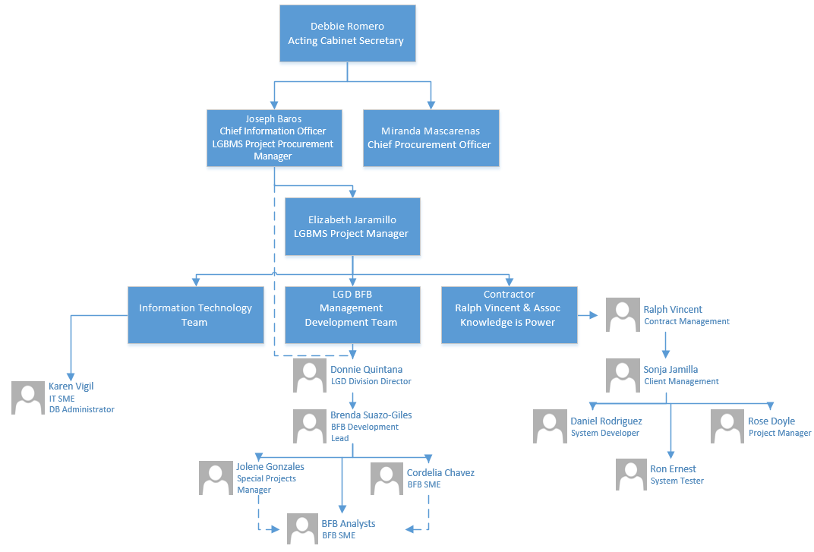

5.4.2 Project Team Roles and Responsibilities
The following is a list of the team members, their role, responsibility, and functional manager.

Role | Responsibility
Project Manager | This person will develop, in concurrence with the Project Steering Committee, a project definition. As the lead on the planning and development of all project deliverables, the Project Manager will ensure that the project is delivered on time, to budget and to the required quality standards within agreement specifications. The Project Manager will ensure that the project is efficiently resourced and will manage relationships with a wide range of groups, which includes developing and maintaining project documentation to keep the Steering Committee apprised of the progress. The Project Manager will manage the work of the vendor, allocating and utilizing resources in an efficient manner while maintaining a supportive and motivated successful team. ,
Project Steering Committee | The role of the Steering Committee is to oversee the progress of the project using information and reports provided to the committee by the Project Manager. As needed, the Steering Committee will assist the Project Manager with responding to any strategic problems as they arise.
BFB Development Team | Consists of BFB Analysts, LGD Upper Management, and Pilot Groups. The role of this group is to provide input to business requirements, acceptance of deliverables during testing and implementation.
Technical Implementation Group | The role of this group is to implement and manage the infrastructure that is the foundation of the data warehouse. Group members are familiar with the hardware and software likely to be used, experienced in administration of these and are able to direct fine-tuning and optimizing efforts as the data warehouse develops. The technical implementation group helps ensure that the needed technical resources are available.

5.5 STAFF PLANNING AND Resource ACQUISITION
The following chart will be completed in the Planning Phase.

5.5.1 Project Staff
Resource | Cost Estimate | Estimated Hours | Availability | Skill Set | Work Product/Deliverable

5.5.2 Non-Personnel resources
This list of services or product (HW/SW and such) needed for the project will be determined during the Planning Phase.
Resource | Cost Estimate | Estimated units/hours | Availability | Source | Work Product/Deliverable

5.6 PROJECT LOGISTICS

The majority of the work will be conducted remotely. Team meetings will be conducted using teleconferencing tools if in-person meetings continue to be restricted.
Training will also be conducted remotely during the implementation and testing of the system. A more comprehensive training is typically provided at the annual DFA budget conference.

5.6.1 Project Team Training
Project team training will be conducted using teleconferencing tools and will reference user manuals that will be updated for the main roles: entity, analyst, chief, and director. Training for the local government users has also been provided in-person during the DFA budget conference. Given the current conditions due to COVID-19, alternate training delivery platforms will be evaluated.

Resource | Cost Estimate | Estimated Hours | Availability | Skill Set | Work Product/Deliverable

6.0 Project Management and Controls

6.1 Risk and issue Management

6.1.1 Risk Management Strategy
The initial risks and management strategy are presented below. Risks will be further reviewed and management strategies developed during the planning phase.

Executive Support
Description – Lack of Executive Support | Probability Low | Impact High
 | Mitigation Strategy: Effective communication with executive stakeholders
 | Contingency Plan: Utilize team meetings, emails, and progress updates to engage the executive team by demonstrating the effectiveness and importance of LGBMS.

Scope Creep
Description – Scope Creep | Probability High | Impact high
 | Mitigation Strategy: Validate if any change request is essential to completing scope and functional goals. Continued use of Change Request Plan. Appropriate use of IV&V Reports, Project Manager oversight of PMP & Project scope. Maintaining close communications with project team members.
 | Contingency Plan: Implement only changes that are within Project Scope. Identify funding/time to extend project.

Stakeholder Cooperation
Description – Cooperation between all Stakeholders including: Executive, Local Governmental Bodies, Budget & Finance Bureau Staff, Tax & Revenue Property Tax Division& Project Team Members | Probability High | Impact high
 | Mitigation Strategy: Timely and effective Communication, Strategic Planning & Marketing, Effective support & training. Establish a Communication Plan.
 | Contingency Plan: Commitment to stay on schedule and scope & implement buy-in strategies for Local Government Bodies.
Executive Turnover
Description – Executive Staff Turn Over | Probability Low | Impact Med
 | Mitigation Strategy: N/A
 | Contingency Plan: Update New Executive Leadership and establish good lines of communication.

6.1.6 ISSUE MANAGEMENT

6.1.6.1 Internal Issue Escalation and Resolution Process

Internal issues will be presented to the project manager for assessment and escalation when necessary. For issues that require further review, it will be presented to the CIO for resolution assistance. Should the issue not get resolved with the assistance of the CIO, then it will be presented to the executive sponsor. Ultimately, if necessary, the issue may be presented to the steering committee should resolution not occur at the prior stages.

6.1.6.2 External Issue Escalation and Resolution Process

External issues will be presented to the project manager for assessment and escalation when necessary. For issues that require further review, it will be presented to the CIO for resolution assistance. Should the issue not get resolved with the assistance of the CIO, then it will be presented to the executive sponsor. Ultimately, if necessary, the issue may be presented to the steering committee should resolution not occur at the prior stages.

6.2 INDEPENDENT Verification And Validation - Iv&V
A contract is being developed for Independent Verification and Validation (IV&V) with plans to bring the vendor on during the Planning Phase.

6.3 Scope Management Plan
The following is the process that is going to be used to manage the scope of the project and to manage stakeholder expectations.

6.3.1 Change Control

6.3.1.1 Change Control Process
Significant project changes that include modifications to the scope, schedule, budget, and quality will be reviewed and approved or disapproved by the Steering Committee in concordance with the Project Manager. These types of identified project changes shall require a change request form to be filled out. The Steering Committee will review the request to determine impacts to scope, schedule, budget, quality and resources.

6.3.1.2 Change Control Board (CCB)
The Steering Committee in concordance with the Project Manager will fill the role of the Change Control Board.

6.4 Project Budget Management
The project budget was established based on the time needed to plan, design, develop, and implement specific deliverables. The overall project budget will not exceed the approved contract amount. Additional features that may be added will require a change order describing the addition or modification to the scope and fee. This will be a deliverable based project with not to exceed amounts budgeted within the allotted Appropriation Amount.

6.4.1 Budget Tracking
The vendor will submit invoices following the completion of key stages of the project such as the acceptance of a deliverable. This will ensure that the budget tracks with the development and completion of the scoped features.

6.5 Communication Plan
The following is the communication plan that determines the information and communication needs of the stakeholders, executive sponsors, project team and others as needed. A more comprehensive management plan and matrix will be created by during the planning phase.

6.5.1 Communication Matrix
Modes of Communication:
- Online regular reports on activities and status of the project from contractor provided to Project Manager & CIO
- Email Updates Sent to Steering Committee from CIO and/or Project Manager
- Phone Calls followed up by email when needed to all members of project
- Possible Communications posted to website for Local Governments
Communication shall follow the Organizational Matrix any concerns can be brought to the Project Managers attention by anyone on the team.

6.5.2 Status Meetings
Project Status meetings will be held on a monthly basis to include the Project Management team and Executive Stakeholders as necessary. The monthly meetings will be agenda based and if needed special meetings will be called to discuss and address specific issues.

6.5.3 Project Status Reports
Weekly progress reports and monthly status reports will be prepared. (Reports will be more detailed here before commencing planning phase.)

6.6 PERFORMANCE MEASUREMENT (PROJECT METRICS)
The Project Manager and Executive Sponsor defined the project metrics that will be used to control the project that are listed in the following table.

6.6.1 Baselines
Project Area | Category | Measure
Project Management | Task Performance | On Schedule
Budget Management | Task Performance | On Budget
Quality | Errors in Data Modeling | Errors by functional area
Testing (Data Warehouse) | Performance and Quality | Accepted/Not Accepted
Implementation | Quality Data | A final data feed from the SME that is accurate and complete.

6.6.2 Metrics Library

6.7 QUALITY OBJECTIVES AND CONTROL

6.7.1 quality Standards
The following information describes the agency, industry or regulatory project performance standards that will be followed and assessed by the Project.

No. | Quality Standard | Tracking Tool or Measure
1 | PMP approved and followed | - PMP signed off by Steering Committee  - Project Status Reports
2 | Certification to proceed to next phase by DoIT | - Approval from EPMO and release of funds
3 | Project Risks documented, mitigated, and tracked | - Risk Management Log
4 | Project Issues documented and tracked | - Issue Log
5 | Project within Budget | - Project Status  - Budget Management
6 | Independent Verification and Validation | - Pending Finalized Scope & Contract
7 | Project completed based on the original scope of work and approved scope changes | - PMP  - Change Control Process  - Scope Management  - Steering Committee Meeting Decisions

6.7.2 Project and Product Review AND ASSESSMENTS
The following table will be completed during the Planning Phase:

Review Type | Quality Standard | Tools | Reviewer | Reports
Requirements
Plans
Milestones
Testing

6.7.3 Agency/Customer Satisfaction
The project manager will assess the on-going sense of the customer agency about how they feel the project is going, and how team members are acting on the project.

Examples:
Areas of feedback | When | How Often
Agency awareness
Quality of communications | Feedback during various meetings | As needed. Weekly project status reports and monthly project team meetings.
Manages project tasks | Feedback from Project Sponsor, Business Owner, Steering Committee, and Project Managers. | Monthly
Productive Meetings |  | Weekly project status reports.

6.7.4 PRODUCT DELIVERABLE ACCEPTANCE PROCESS
The following is a list of deliverables with the final approval process and customer acceptance criteria:

Deliverable | Final Approval Process | Customer Acceptance Criteria
User Manuals | Review by PM, DFA-IT, & BFB | Use for Training
Training | Review by PM & BFB | Successful completion
PHP Code | Testing of system after deployment | Successful on-site test
Database | Testing of system after deployment | Successful on-site test

6.8 CONFIGURATION MANAGEMENT

6.8.1 Version Control

6.8.2 Project Repository (Project Library)
The Project deliverables will be stored in a variety of media and available for updating as necessary. The Project Manager will be the primary controller of the project repository and will provide guidance on requirements and access controls.
The repository will be created, maintained, and stored at a location setup on a file share by the Project Manager, authorized staff will have access to repository.
The high level structure for the repository:
- Project Standards/Templates
- Organizational Information (contact lists, org charts)
- Plans and Actuals (PMP, Schedule, Project Cadence Workbook)
- Communications (minutes)
- Scope (change requests)
- Deliverables (working materials, final deliverables, approvals)
- Sponsor Information (Contracts, Agreements)
- Requirements
- Project Background Data
- State Data Background Information

6.9 PROCUREMENT MANAGEMENT PLAN

Procurement of all professional services will follow standard processes for State Price Agreement or General Services Agreement contracts.

7. 0 Project Close
Project Close will consist of the finalization of administrative project activities and contractual project activities. The closeout will include the completion and approval of deliverables as indicated in the implementation of the vendor contract.

7.1 Administrative Close
Administrative Close will occur at both the end of phase and end of project. The final closeout will include the completion of required documentation, the DoIT closeout report and EPMO approval to formally closeout the project as outlined in the Closeout Phase.

7.2 Contract Close
Contract close is similar to administrative close in that it involves product and process verification for contract close.

