Module PE.PAS.U21.5
Multiarea reliability analysis

U21.1 Introduction
Modules U19 and U20 have addressed reliability analysis of the generation system assuming that the transmission system is perfectly reliable. Ultimately, we would like to be able to address the reliability of the generation and the transmission system together. An incremental step taken in that direction is the so-called multiarea reliability problem, addressed in this module.
In the multiarea reliability problem, we view the electric power system as comprised of multiple areas of generation, with the transmission within each area being perfectly reliable. However, the transmission interconnecting the various areas has non-zero failure probability. Figure U21.1 illustrates the situation.
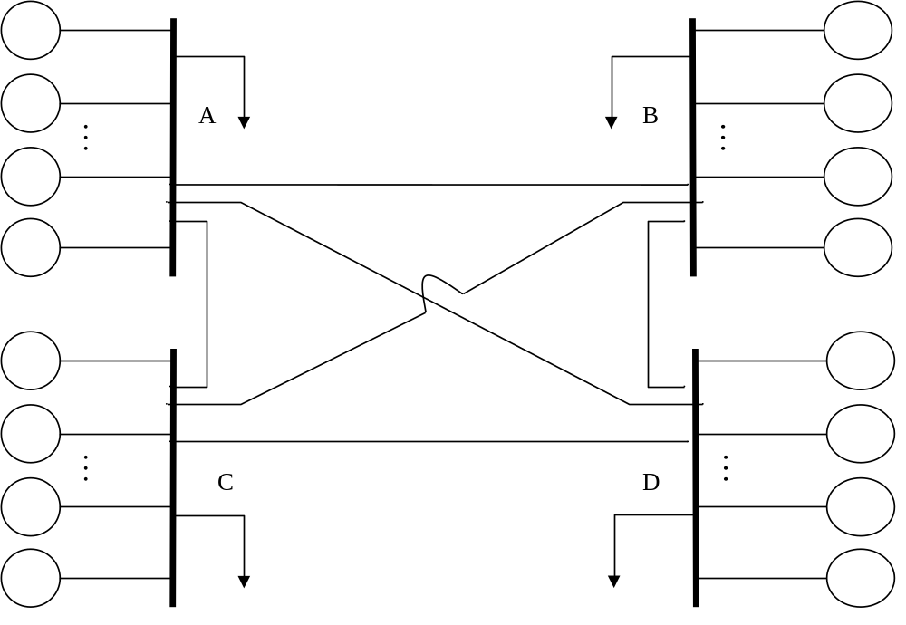
Fig. U21.1: Illustration of multiarea model

This problem has applicability whenever one or more generation units may be grouped together physically and contractually, and there exist backup agreements with one or more neighboring groups.
There are four main issues embedded in the last statement, as described in what follows:
- Physical grouping: Transmission within each group must be assumed perfectly reliable so that supply of load may be performed by any generator within the group with equal reliability, given the generator is in service.
- Contractual grouping: The generators within each group operate under the same contract (or set of contracts) to meet load obligations.
- Neighboring groups: Group B is a neighboring group to group A if there is available transmission capacity for power delivery from group B to group A.
- Backup agreements: Each group has backup agreements with neighboring groups that obligate the neighboring groups to provide power, if reserves exist, in the event the group is not able to serve its load from its own generation resources.
It is of interest to examine the basis for multiarea reliability analysis in light of the changes that have occurred in the industry since the early 1990’s.
In traditional power system operation, all generation within a single control area is usually physically and contractually grouped, and backup agreements are usually in place with neighboring groups physically interconnected through tie-lines. In fact, it was to provide reliability benefits that most tie lines were originally built, and one could typically assume that the entire tie-line capacity would be available for backup supply.
Today, very little, if any, transmission is dedicated to provide reliability benefits, but rather, most transmission is continuously utilized to provide economic benefits. This presents uncertainty in identifying available transmission capacity (ATC). The traditional multiarea reliability analysis approach did not treat this uncertainty. Such treatment is, however, a relatively simple extension of the traditional approach.

U21.2 Multiarea reliability failure states
The simplest situation to consider is a 2-area case; we begin from there. Denote the areas as A and B. Consider initially that there is no tie between the two areas such that they operate in an isolated fashion. Then we generate the capacity outage table for each area, and given the load level in each area, easily identify the capacity outage states for which no load is lost and for which load is lost. Denote the success and fail states for the two areas as A_{S}, A_{F}, and B_{S}, B_{F}, respectively. Figure U20.2 illustrates the different states, where we assume that areas A and B are comprised of 11 and 13 units, respectively, with each unit having 1 MW capacity.
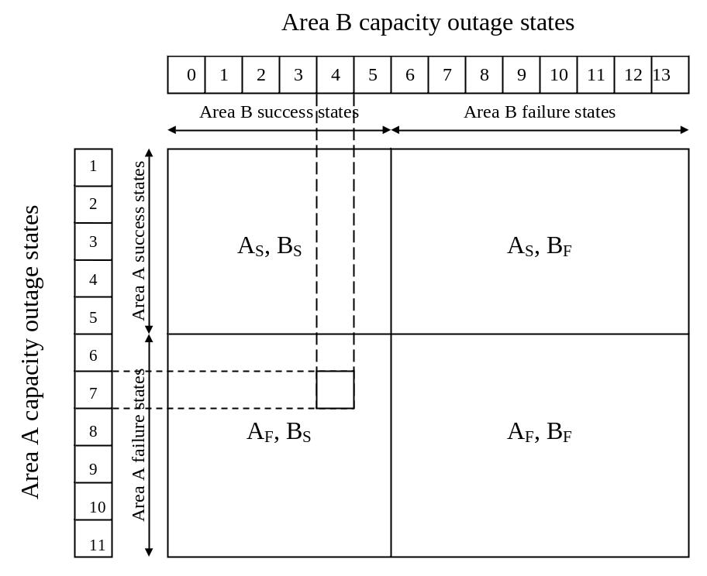
Fig. U21.2: Classification of 2-area capacity states without tie line
Areas A and B loads are 6 and 8, respectively. Failure states are identified as those for which the capacity outage exceeds the reserve, i.e., C>C_{T}-d (implying that the available generation is less than the load).
- For Area A, this would be states for which C>11-6=5, i.e., states with capacity outage of 6, 7, 8, 9, 10, and 11.
- For Area B, this would be states for which C>13-8=5, i.e., states with capacity outage of 6, 7, 8, 9, 10, 11, 12, and 13.
Note that we assume a state for which the capacity outage equals the reserve is a success state. An example is, for Area A, C=5, then available generation is 11-5=6 MW, which equals the load. It may be prudent in some cases to define this state as a failure state.
Consider adding a transmission circuit having infinite capacity, and assume that each area will provide additional power to the other area only insofar as it does not cause loss of load for itself.
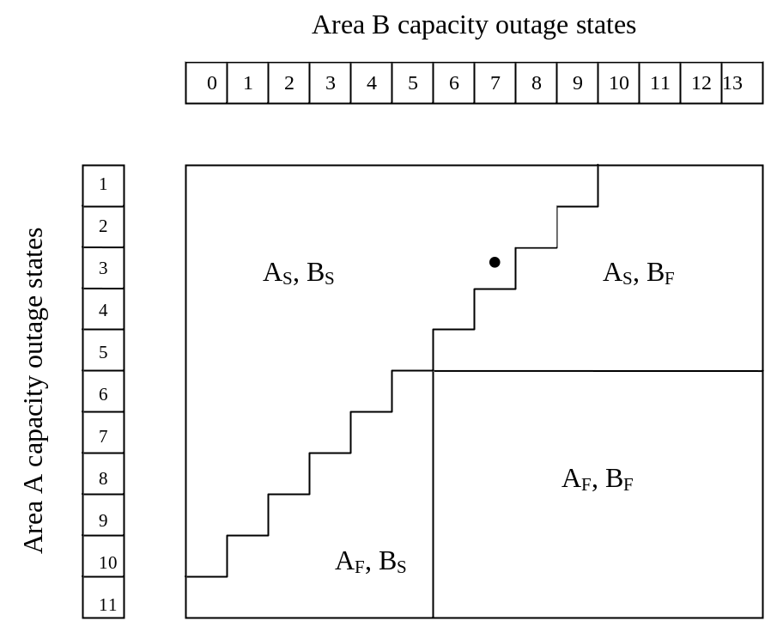
Fig. U21.3: Classification of 2-area capacity states with infinite interarea transmission capacity
We observe in Fig. U21.3 the hatched state corresponding to Area A capacity outage of 3 and Area B capacity outage of 6, which, for the case of no transmission, is a failure state, since the Area B available generation is 13-6=7 MW, not enough to supply the 8 MW of load.
However, with transmission, the hatched state is a success state. Let’s see why.
Since Area B has capacity outage of 6 MW, it has only 13-6=7 MW of generation available to supply a load of 8 MW. But since Area A has capacity outage of 3 MW, it has 11-3=8 MW to supply a load of 6 MW and therefore has 2 MW of reserve. If Area A supplies Area B with 1 MW, then area B has 7+1=8 MW of generation and is therefore no longer a failed state according to our criteria. In this case, the Area A generation will be 6+1=7 MW, and with capacity outage of 3 MW, leaves 11-7-3=1 MW of reserve.
A similar argument applies for the state just right of the hatched state (with the single dot in it), but in this case, Area B has capacity outage of 7 MW and therefore only 13-7=6 MW of generation to supply a load of 8 MW. Therefore, Area A must supply 2 MW to Area B, leaving Area A with no reserve. States having any more capacity outage in either Area A or Area B result in a failed state.
The dotted state above and right of the single dot state has Area B with an increased capacity outage of 8 MW and therefore only 13-8=5 MW of generation to supply a load of 8 MW. In this case, the capacity outage of Area A is only 2 MW, leaving Area A with 11-2=9 MW of generation to supply 6 MW of load. Therefore, Area A has 3 MW of reserve, which it can supply to Area B to prevent loss of load, making this a success state.
Comparison of Fig. U21.3 with Fig. U21.2 indicates the effect of increasing the number of success states that interarea transmission can have. One notes that infinite capacity transmission is only able to increase the number of success states insofar as available generation will allow.
Notice in Fig. U21.3 that the “boundary” between success and failed states is a climbing staircase to the right. The significance of this is that, with infinite transmission capacity, every decrease in Area A capacity outage (a step up) results in an additional MW being available to supply Area B (a step to the right).
Finally, consider that the transmission interconnecting the two areas has finite capacity of 2 MW, and that capacity is only used when one area is in need of assistance from the other area (i.e., transmission is not used simply for economic purposes, so that the full transmission capacity is always available to provide reliability backup). Fig. U20.4 illustrates the resulting capacity states.
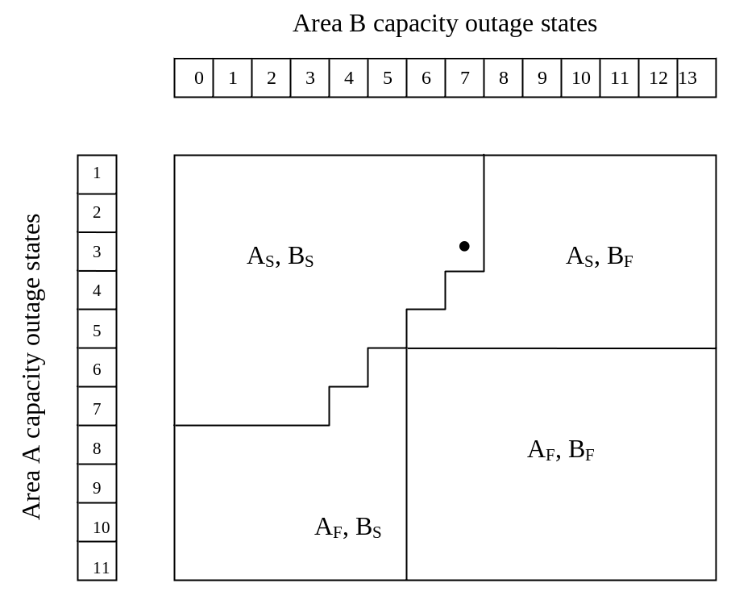
Fig. U21.4: Classification of 2-area capacity states with 2 MW interarea transmission capacity
Consider the hatched and single-dot states in Fig. U21.4. As before, we see that the effect of transmission is to turn both of these states into success states. However, notice that the dotted state, which was a success for the case of infinite transmission, is now a failure state. The reason is that, although Area A does have available generation to supply the additional 3 MW needed by Area B, the transmission capacity limits that supply to 2 MW, and Area B experiences loss of load.
Notice from Fig. U21.4 that the “boundary” between success and failure states is the same as in Fig. U21.3 in the middle of the diagram (i.e., for 3<C_{A}<7 and 4<C_{B}<7). The difference between the two boundaries, towards the edges of the diagram, is due to the limiting effect that transmission has on the ability to provide assistance from one area to another.

U21.3 Evaluation approaches for 2 area system
Section U21.2 only addresses the effect of transmission on the proportion of states that are failures vs. the proportion that are successes. However, we said nothing about the actual probability of these states. Once we get the probability of the states and their classification (success or failure), then we can compute the desired failure probability (loss of load probability in this case) simply as the summation of the probabilities of all failure states. There are two approaches: the all-failure states approach and the equivalent assisting unit approach. In both approaches, we assume that the transmission is limited, but perfectly reliable.

U21.3.1 All-failure states approach
One simple approach, at least conceptually, that is applicable to operating reserve evaluation when there is little uncertainty in the load, is the all-failure states approach, as follows:
- Compute the capacity outage table for each area, lumping identical capacity outage states together. This provides the probabilities of each state for each area.
- Identify the failure states F. Then
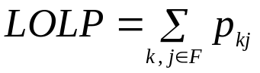 (U21.1)
where p_{kj}=p_{k}p_{j}, k∈A, j∈B, i.e., the probability of state kj is the product of the probability of state k in Area A and the probability of state j in Area A. We are assuming here that the Areas A and B states are independent.
If we want to account for the possibility of transmission failure, then we need to repeat the above algorithm for every distinct value of transmission line capacity. In this case, (U21.1) becomes
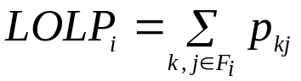 (U21.2)
where we see that the failure states, denoted by F_{i}, are a function of the transmission line capacity i, as they should be. Then, the total LOLP is computed as
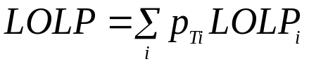 (U21.3)
where each transmission line capacity has a probability of p_{Ti}.
This approach can be quite computationally intense, however, due to the need to compute the probabilities of all failure states of both areas (which has an upper bound of N_{A}×N_{B}, where N_{A} and N_{B} are the number of capacity outage states in Areas A and B, respectively).

U21.3.2 Equivalent assisting unit approach
An alternative approach, called the equivalent assisting unit (EAU) approach, is described in this section. We draw heavily from reference [1] in describing this approach.
In the EAU approach, the benefits of the interconnection between the two systems is represented by an equivalent multi-state unit which describes the potential ability of one area to accommodate capacity deficiencies in the other area.
Here, we denote area A as the assisted area and area B as the assisting area. Some specifics of this method follow:
- The capacity assistance level for a particular outage state in Area B is given by the minimum of the transmission capacity and the available area reserve at that outage state.
- All capacity assistance levels greater than or equal to the transmission capacity are replaced by one assistance level which is equal to the tie capacity.
The resulting capacity assistance table can be converted into a capacity model of an equivalent multi-state unit which is added to the existing capacity model of Area A. Reliability indices may then be computed using the methods of Module U19 (for capacity evaluation) or the methods of Module U20 (for operating reserve evaluation).
Example 1: An example adapted from [1] will clarify. Consider the system data for a 2-area system as given in Table U21.1.
Table U21.1: System data for example [1]
Area | Number of units | Unit capacity (MW) | FOR  per unit | Installed capacity (MW) | Load (MW)
A | 5 | 10 | 0.02 | 75 | 50
A | 1 | 25 | 0.02 | 75 | 50
B | 4 | 10 | 0.02 | 60 | 40
B | 1 | 20 | 0.02 | 60 | 40
There is one transmission line interconnecting the two areas; it has capacity of 10 MW and is perfectly reliable (FOR=0).
The capacity outage table for both areas is given in Table U21.2. Probabilities less than 10⁻⁸ have been neglected in this table.
Table U21.2: Capacity outage tables for example [1]
Area A |  |  |  | Area B
State j | Cap out | State prob | Cum prob | State j | Cap out | State prob | Cum prob
1 | 0 | .8858424 | 1.0 | 1 | 0 | .9039208 | 1.0
2 | 10 | .0903921 | .1141576 | 2 | 10 | .0737894 | .096079
3 | 20 | .0036895 | .0237656 | 3 | 20 | .0207062 | .0222898
4 | 25 | .0180784 | .0200761 | 4 | 30 | .0015366 | .0015835
5 | 30 | .0000753 | .0019977 | 5 | 40 | .0000463 | .0000469
6 | 35 | .0018447 | .0019224 | 6 | 50 | .0000006 | .0000006
7 | 40 | .0000008 | .0000776 | 7 | 60 | .0000000 | .0000000
8 | 45 | .0000753 | .0000769
9 | 50 | .0000000 | .0000016
10 | 55 | .0000015 | .0000016
11 | 65 | .0000000 | .0000000
12 | 75 | .0000000 | .0000000

Note that “Cum prob” gives probability that capacity outage is greater than or equal to the corresponding value. This differs from what we called F_{Y (y)} in module 20, where there it was probability that capacity outage is greater than the corresponding value.

Area B has a reserve of 20 MW; this is the maximum assistance it can provide at this load level (assuming infinite transmission capacity). Therefore, any capacity outage of 20 MW or greater will have the same influence on the available capacity, as far as area A is concerned, limiting the assistance to zero. As a result, we merge all Area B capacity outage states greater than or equal to 20 MW into one state, accumulating the probabilities. Table U21.3 shows the Area B EAU capacity outage table.

Table U21.3: EAU capacity outage table for Area B [1]
Cap out (MW) | State prob
0 | .9039208
10 | .0737894
20 | .0222898
In Table U21.3, the first 2 capacity outage states (0, 10 MW) have state probabilities corresponding to the Area B state probabilities of Table U21. 2.
The last state probability in Table U21.3 (20 MW) has a state probability corresponding to the Area B cumulative probability of Table U21.2. This is because, as previously stated, all Area B states having capacity outage of 20 MW or greater have the same effect on Area A, since the Area B reserve is 20 MW and therefore will not be able to assist Area A if capacity outage is 20 or greater.
Now recall that the transmission has capacity of 10 MW; we see that the assistance available from Area B to Area A is 10 MW regardless of whether the Area B capacity outage is 0 MW constrained by transmission, or 10 MW constrained by transmission and generation.
As a result, we merge the 0 MW capacity outage state with the 10 MW capacity outage state. The result of this merging is effectively a 2- state unit, as indicated in Table U21.4.
Table U21.4: Transmission-constrained EAU capacity outage table
Cap out (MW) | State prob
0 | .9777102
20 | .0222898
One problem with Table U21.4 is, however, that it suggests an equivalent unit of 20 MW capacity. This is inconsistent with the fact that maximum assistance from Area B is 10 MW due to transmission limitation. Therefore we change the bottom capacity outage value in Table U21.4 from 20 MW to 10 MW, reflecting the fact that there is 1-0.0222898 probability that the available assistance from Area B to Area A will be 10 MW (and not 20 MW). Table U21.5 shows this change.
Table U21.5: Transmission-constrained EAU capacity outage table with adjustment for transmission capacity
The transmission-constrained EAU capacity outage table of Table U21.5 is now convolved into the Area A capacity outage table of Table U21.2, giving an equivalent Area A installed capacity of 75+10=85 MW. The result is given in Table U21.6, where, once again, probabilities smaller than 10⁻⁸ have been truncated.
Cap out (MW) | State prob
0 | .9777102
10 | .0222898
The load of Area A is 50 MW and therefore loss of load occurs when the capacity outage in Area A is greater than the reserve of 85-50=35 MW. The cumulative probability for a capacity outage of 35 MW is read from Table U21.6 as LOLP=.0023270.
Table U21.6: Area A modified capacity outage probability table
State | Cap out (MW) | State prob | Cum prob
1 | 0 | .8660972 | 1.0
2 | 10 | .1081225 | .1339028
3 | 20 | .0056221 | .0257804
4 | 25 | .0176755 | .0201583
5 | 30 | .0001559 | .0024829
6 | 35 | .0022066 | .0023270
7 | 40 | .0000024 | .0001204
8 | 45 | .0001147 | .0001180
9 | 50 | .0000000 | .0000033
10 | 55 | .0000032 | .0000032
11 | 60 | .0000000 | .00000005
12 | 65 | .00000005 | .00000005
13 | 75 | .00000000 | .0000000

Example 2: One can repeat this analysis for a transmission line having capacity of 15 MW (instead of 10 MW). One would expect, with increased transmission capacity, the influence of assistance to be greater and thus LOLP to be smaller.
The new EAU capacity outage table is identical to that of Table U21.3, with the exception of the last capacity outage value, as given in Table U21.7.
Table U21.7: EAU capacity outage table for Area B with 15 MW transmission capacity
Cap out (MW) | State prob
0 | .9039208
10 | .0737894
20 | .0222898
In comparing Table U21.7 to Tables U21.3 and U21.4, we observe:
- The 0 and 10 MW capacity outage states of Table U21.7 remain distinct since they have different effects on Area A. With 0 MW capacity outage, Area A receives 15 MW of assistance (limited by transmission). With 10 MW capacity outage, Area A receives 10 MW of assistance (limited by generation reserve).
- The largest capacity outage state is now 15, instead of 10 (as in Table U21.4), since the transmission capacity is 15.
Convolution of the Area B capacity outage data of Table U21.7 with the capacity outage data of Area A given in Table U21.2 results in Table U21.8, where installed capacity is 75+15=90. The load of Area A is 50; therefore loss of load occurs when the capacity outage in Area A equals or exceeds a reserve=90-50=40. The cumulative probability for a capacity outage of 40 is read from Table U21.8 as LOLP=.00066504, lower than the LOLP=.0023270 obtained for the case of transmission capacity=10.
It is interesting to compare the state probability for a capacity outage of 35 MW in the two cases. The 10 MW transmission capacity case yields .0022066 (Table U21.6) whereas the 15 MW transmission capacity case yields .0030837. It may be surprising to find the 35 MW outage capacity state probability is higher for the 15 MW transmission case whereas the LOLP is lower. In fact, individual state probabilities may go up or go down as we change unit capacities in a problem of this sort.
We can be sure, however, that whenever we increase the installed capacity of a unit (for a given load level), the number of states identified as failure (loss of load) states will decrease. In this case, we increased the installed capacity of the equivalent unit from 10 to 15 and therefore provided that we need not include the 35 MW capacity outage state in our LOLP calculation.
Table U21.8: Area A modified capacity outage probability table
State | Cap out (MW) | State prob | Cum prob
1 | 0 | .8007300 | 1.0
2 | 10 | .1470700 | .1992700
3 | 15 | .0197450 | .0521960
3 | 20 | .0100050 | .0324500
4 | 25 | .0183560 | .0224450
5 | 30 | .0000340 | .0004089
6 | 35 | .0030837 | .0037487
7 | 40 | .0004092 | .00066504
8 | 45 | .0002059 | .00025579
9 | 50 | .0000418 | .00004993
10 | 55 | .0000069 | .00000875
11 | 60 | .0000017 | .00000182
12 | 65 | .0000001 | .00000014
13 | 75 | .00000003 | .00000003

The below summarizes the steps taken in the above examples:
- Develop the capacity outage table for both areas.
- Develop the EAU capacity outage table by merging all capacity assisting area outage states for which the available assistance provided to the assisted area is the same. This can be done in the following 2-step process.
  - Effect of assisting area reserve: Merge all assisting area capacity outage states having 0 MW assistance capability. These states are those for which the assisting area capacity outage equals or exceeds the assisting area reserve. The new state has state probability equal to the sum of all merged states, which is the cumulative probability of the capacity outage state equal to or just greater than the assisting area reserve.
  - Effect of transmission capacity: Merge all capacity outage states having assistance capability equal to the transmission capacity. These states include those for which the assisting area reserve exceeds the capacity outage by the transmission capacity (or, one can say, the capacity outage is less than or equal to the reserve less transmission capacity). The new state has state probability equal to sum of all merged states.
- Decrease all non-zero capacity outage values by an amount equal to P_{R}-C_{Tr}. This will force the maximum capacity outage to be equal to the transmission line capacity.
- Convolve in the EAU capacity outage table with the assisted area capacity outage table.
- Compute the LOLP for the assisted area as the cumulative probability corresponding to the capacity outage state equal to or just greater than the reserve.
Figure U21.5 illustrates the various assisting area states to be merged in step 2, where the numbers simply enumerate the states in order of increasing capacity outage but do not correspond to any particular capacity outage values. Note that there may be no states in the “not merged” category, as in the 10 MW transmission capacity example, there may be 1 state, as in the 15 MW transmission capacity example, or there may be several states.
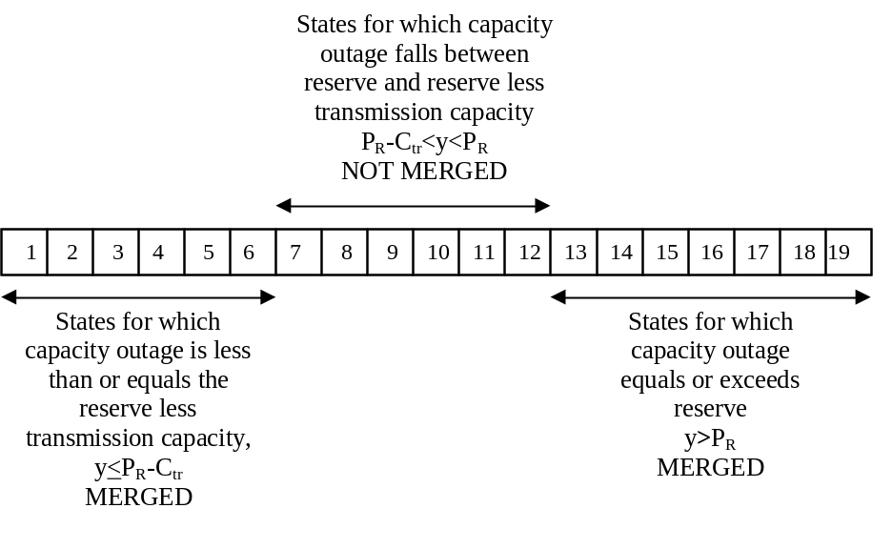
Fig. U21.5: Illustration of merged and not merged states

U21.4 Accounting for transmission reliability
In Section U21.3, we assumed that the transmission was perfectly reliable and developed a capacity outage table for a fictitious unit that, as far as the assisted area was concerned, was probabilistically equivalent to the assisting area. However, we assumed that the transmission interconnecting the two areas was perfectly reliable. This of course is not the case, so in this section, we show how to account for transmission unreliability.
The approach is tedious, but conceptually straightforward. The idea is to just compute the LOLP for each transmission capacity state as if there exists transmission of that capacity that is perfectly reliable. Then the composite LOLP is the weighted sum of these individual LOLP’s where the weights are the transmission capacity state probabilities. Two examples will illustrate.
Example 3: Consider the example with a 10 MW capacity transmission line, except now assume it has an outage probability of .00815217 so that its availability is 1−.00815217=.99184783.
There are 2 transmission capacity states: 0 and 10 MW with probabilities of .00815217 and .99184783, respectively.
The LOLP for the 0 MW case is obtained based on single (unassisted) analysis of area A, which comes from Table U21.2. Here, we see that the cumulative probability of the 75-50=25 MW capacity outage state is .0200761.
The LOLP for the 10 MW case is obtained based on Example 1 where we found the LOLP to be .0023270. Therefore,
LOLP=.00815217×.0200761+.99184783×.0023270=.0024716937
The LOLP is a little larger than the case with perfect transmission and a great deal smaller than the case with no transmission at all.
Example 4: Consider now the case of the two areas connected by 2 tie lines on different right-of-ways, one of which is 10 MW capacity and the other is 5 MW capacity. The outage probabilities of each line are identical to the outage probability used in the previous example, i.e., .00815217 and .99184783.
Because the lines are on different right-of-ways, they may not fail in a dependent or common mode fashion, so the line capacities and corresponding probabilities are given by as in Table U21.9.
Table U21.9: Transmission line capacity probabilities
Capacity | Probability
0 | .00006646
5 | .00808571
10 | .00808571
15 | .98376212
We have already found the LOLP for the 0, 10, and 15 MW capacity cases, and they were .0200761, .0023270, and .00066563, respectively. Therefore we need only find the LOLP for the 5 MW case.
Following step 2-a, we require the Area B capacity outage table with all states having Area B capacity outage equal to or exceeding the reserve, as given in Table U21.3, repeated below for convenience.
Cap out (MW) | State prob
0 | .9039208
10 | .0737894
20 | .0222898
Following step 2-b, we need to merge the states for which the Area B capacity outage is less than or equal to the Area B reserve less the transmission capacity, which in this case, is 20-5=15. So we merge the two top states in the above table, resulting in the following capacity outage table, identical to Table U21.4.
Cap out (MW) | State prob
0 | .9777102
20 | .0222898
Now, however, we need to adjust the maximum capacity outage value from 20 to 5 MW, to reflect that we have a probability of .9777102 of having 5 MW assistance and .0222898 of having 0 MW assistance, resulting in the EAU capacity outage data of Table U21.10.

Table U21.10: EAU capacity outage data for example
Cap out (MW) | State prob
0 | .9777102
5 | .0222898
This capacity outage table is convolved into that of Area A (given by Table U21.2), resulting in Table U21.11.
Table U21.11: Area A modified capacity outage probability table
State | Cap out (MW) | State prob | Cum prob
1 | 0 | .8661000 | 1.0
2 | 5 | .0197450 | .1339000
3 | 10 | .0883770 | .1141600
4 | 15 | .0020148 | .0257800
5 | 20 | .0036073 | .0237650
6 | 25 | .0177580 | .0201580
7 | 30 | .0004766 | .0024006
8 | 35 | .0018053 | .0019240
9 | 40 | .0000419 | .0001187
10 | 45 | .0000736 | .0000768
11 | 50 | .0000017 | .0000032
12 | 55 | .0000015 | .0000015
13 | 60 | .00000003 | .00000003
The installed capacity following convolution of the 5 MW EAU 75+5=80. The load of Area A is 50; therefore loss of load occurs when the capacity outage in Area A equals or exceeds a reserve=80-50=30. The cumulative probability for a capacity outage of 30 is read from Table U21.11 as LOLP=.0024006.
The composite LOLP is then given by:
LOLP=.0200761×.00006646+.0024006×.00808571
+.0023270×.00808571+.00066563×.98376212=.00069438

U21.5 Effect of contractual agreements
The section is adapted from [1].
Consider the situation where Areas A and B agree that Area B will provide firm capacity to Area A of z MW (of course, at a price). This means that Area B is guaranteeing that Area A receive z MW of capacity. The guarantee may come with or without conditions on transmission.

U21.5.1 Without conditions on transmission
If the guarantee is made without conditions on transmission, then it means that the capacity is perfectly reliable. From Area A’s point of view, this simply appears as an increase in its installed capacity by an amount equal to z.
Example 5: Consider Example 1, where we had a perfectly reliable transmission line of capacity 10 MW. We found that the Area B EAU had a probability of delivering at 0 MW capacity outage of .9777102, and that there is 1-.9777103=.0222898 probability of delivering at 10 MW capacity outage (see Table U21.5), implying that there is about a 2.2% chance that Area B cannot deliver the assistance (disregarding transmission unreliability).
When the Area B EAU capacity outage table was convolved into the capacity outage table of Area A, Table U21.6 resulted. Then, with an Area A load of 50 MW, loss of load occurs when the capacity outage in Area A is greater than the reserve of 85-50=35 MW, and the cumulative probability for a capacity outage of 35 MW is read from Table U21.6 as LOLP=.0023270.
However, in the case that Area B is willing to take all of the risk and guarantee the 10 MW of capacity, then Area A uses the original capacity outage table of Table U21.2 (without the Area B EAU capacity outage table convolved in), and simply increases the installed capacity from 75 MW to 85 MW. Again, loss of load occurs when the capacity outage in Area A is greater than the reserve of 85-50=35 MW, and the cumulative probability for a capacity outage of 35 MW is read from Table U21.2 as LOLP=.0019224. Note the improvement from the LOLP=.0023270 when we account for Area B unreliability. Of course, the contract does not change the unreliability of Area B; it simply requires that Area B take the risk by, for example, cutting its own load or paying penalties to Area A in the event it not be able to deliver the 10 MW. Whether Area B wants to sign such a contract depends on how much Area A is willing to pay for the additional capacity. Note that, without any assistance capacity, Area A’s LOLP, evaluated at the capacity outage of 25 MW is .0200761, so the assistance capacity provides an order of magnitude improvement in LOLP.

U21.5.2 With conditions on transmission
If the guarantee is made contingent upon there being sufficient transmission, then it means that Area B is only guaranteeing that it will always have reserve equal to at least the contracted capacity. The Area B EAU can then be formed as a two-state capacity outage table having probability 1.0 capacity outage of 0 and probability 0 of capacity outage of the contracted capacity. Then we account for the transmission unreliability as in Section U21.4, where we
- compute the LOLP for each transmission capacity state as if there exists transmission of that capacity that is perfectly reliable, and
- Compute the composite LOLP as the weighted sum of the individual LOLP’s where the weights are the transmission capacity state probabilities.
An example will illustrate.
Example 6: Now consider the case where Area B guarantees only the reserve of 10 MW but not the transmission capacity. It will have to cut its own load or pay a penalty if it does not have the capacity, but Area A accepts the risk brought on by unreliability in transmission capacity. The question is, in this case, what reliability level does Area A see?
Consider Example 3, with a 10 MW capacity transmission line, and an outage probability of .00815217 so that its availability is 1−.00815217=.99184783.
Therefore there are 2 transmission capacity states: 0 and 10 MW with probabilities of .00815217 and .99184783, respectively.
The LOLP for the 0 MW case is obtained based on single (unassisted) analysis of area A, which comes from Table U21.2. Here, we see that the cumulative probability of the 75-50=25 MW capacity outage state is .0200761.
The LOLP for the 10 MW case is obtained similarly to Example 1 where we used Table U21.5 as the Area B EAU capacity outage table for repeated below for convenience.
Cap out (MW) | State prob
0 | .9777102
10 | .0222898

Now, however, Area B is guaranteeing the reserve, therefore we will use the following capacity outage table:
Cap out (MW) | State prob
0 | 1.0
10 | 0.0

So now we convolve in this Area B EAU capacity outage table to the Area A capacity outage data of Table U21.2. This is equivalent to increasing the installed capacity of Area A by 10 MW. The resulting LOLP is read from Table U21.2 as .0019224 (corresponding to capacity outage of 35 MW). Therefore
LOLP=.00815217×.0200761+.99184783×.0019224=.002070392.

U21.6 Evaluation approach for three-area system
We have so far described and illustrated reliability analysis for two area systems, the most basic of the multi-area situations, and one with wide applicability. However, one would be interested in knowing whether the concepts have more general applicability. In this section, we extend our approaches to the three area situation.

U21.6.1 Radial interconnected three area systems
Figure U21.6 illustrates three areas interconnected radially.
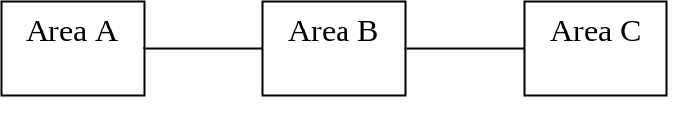
Fig. U21.6: Three areas interconnected radially
There are 2 situations of interest, described in what follows. In both cases, we assume perfectly reliable but capacitated transmission.
- Assistance to Area B: Here, we apply the two area case twice. The steps are as follows:
- Obtain the EAU capacity outage tables for the assisting areas A and C.
- Convolve the Area B EAU capacity outage table with the Area A capacity outage table. Denote the new capacity outage table as A’.
- Convolve the Area C EAU capacity outage table with the Area A’ capacity outage table. Denote the new capacity outage table as A’’.
- The LOLP is obtained by reading from the capacity outage table A’’ the cumulative probability corresponding to the capacity outage of installed capacity less the load.
Note that the order in which one convolves in the EAU capacity outage table does not matter in this case, i.e., one could either convolve in the Area B EAU and then the Area C EAU or one could convolve in the Area C EAU and then the Area B EAU. The answer would be the same in either case.
- Assistance to Area A: We again apply the two area case twice.
- Obtain the EAU capacity outage table for the assisting area C.
- Convolve the Area C EAU capacity outage table with the Area B capacity outage table. Denote the new capacity outage table as B’.
- Obtain the EAU capacity outage table for the assisting area B from the capacity outage table B’.
- Convolve the EAU capacity outage table for Area B with the Area A capacity outage table. Denote the new capacity outage table as A’.
- The LOLP is obtained by reading from the capacity outage table A’ the cumulative probability corresponding to the capacity outage of installed capacity less the load.
We do not address the situation of assistance to Area C since this is just like the case of assistance to Area A.
In either of the above cases, if transmission is not perfectly reliable, then all possible transmission states must be identified and the method repeated for each state. The composite LOLP is then the weighted average of LOLPs for all transmission states where the weights are the transmission state probabilities.
The difficulty of this approach for the case of unreliable transmission is that there could be several transmission states. Reference to Fig. U21.6 reveals that, minimally, there would be 4 states (assuming 2-state models for both the A-B and the B-C transmission, implying AB and BC have only 1 transmission circuit each). These 4 states would be (AB up, BC up), (AB up, BC down), (AB down, BC up), (AB down, BC down). LOLP would therefore need to be computed 4 times, one for each of these states.
There could be more states depending on how many transmission circuits comprise the AB and BC connections.

U21.6.2 Networked interconnected three area systems
Figure U21.7 illustrates three networked interconnected areas.
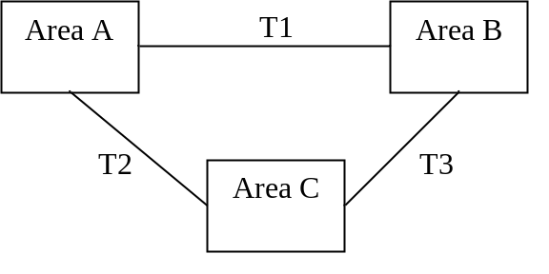
Fig. U21.6: Three networked interconnected areas
This situation is quite difficult to handle using our present techniques because of the following reasons:
- Two transmission paths: Each area can assist another area over 2 possible paths, the direct connection to the assisted area and the connection through the third area to the assisted area. This presents two basic problems.
  - Controlled flows: Here, we assume that each area may specify the amount of assistance flowing over a particular path. Although this is the simplest case, we see that it is probabilistically complex, as the amount of assistance over a transmission path depends not only on the reserve in the assisting area and the path’s transmission capacity but also the extent to which the other area is using that path.
  - Uncontrolled flows: Here, we must recognize that, unless special flow-control devices (FACTS devices) are available, it is not possible to assign a particular amount of assistance to a specific transmission path since Kirchoff’s laws dictate that any assistance from one area to another will actually divide and flow along both paths. This is called loop flow. As a result, any assistance will utilize transmission capacity in all three paths.
- Contractual agreements:
  - On reserve: There are numerous possible agreements that bear on the problem. If only one area is deficit, then that deficit area gets as much assistance as it needs, (up to what is available of course) from the other two areas. However, the issue is not so clear if there are two deficit areas. For example, if Area A and Area C are both supply-deficit, how do they share the Area B assistance? Area A may have priority over Area C such that Area C only receives assistance when Area A’s needs are met. Or Areas A and C may share Area B’s assistance according to some specified proportion.
  - On transmission: Transmission agreements need to be consistent with reserve agreements so that transmission contracts do not constrain assistance levels beyond that of the reserve agreements. This is generally possible if the transmission and generation are owned by the same organization, but if not, it can be quite complicated.
We will study a new method in the next section which addresses some of these issues.

U21.7 Multiarea analysis by network flows
The material in this section is adapted from [3] and [4].
An area of systems engineering has grown from the numerous systems that can be thought of in terms of physical movement within a network. Such systems include
- Transportation systems, e.g., bus, rail, airlines, shipping.
- Communication systems, e.g., telephone and internet.
- Energy systems, e.g., electricity, gas, coal, and water.
One approach for analysis of such systems is generally referred to as “network flows.” We will find network flows theory to be useful in multiarea reliability analysis.

U21.7.1 Preliminaries: some graph-theoretic definitions and concepts
The essential notion on which a network flow problem is based is the graph. We define some related notation below.
Graph: G(V,Γ) consists of a set of elements called nodes, denoted V, and a set of pairs of elements called arc (or branches), denoted Γ. G can be a directed graph, where flow on each arc may only occur in one direction, or G can be an undirected graph. G may also have both directed and undirected arcs. A particular node is denoted V_{i}. Each arc is denoted (i,j) if it is directed or [i,j] if it is undirected. A graph is another name for a network.
Flow: With each arc (i,j) or [i,j], we associated a weight f(i,j) or f[i,j] which is called the flow of arc (i,j) or [i,j].
Capacity: With each arc we associate another weight c(i,j) or c[i,j] which is called the capacity of branch (i,j) or [i,j]. It represents the maximum flow that the branch can carry.
Source node: Each graph has a source node, denoted s, which produces all the flow that is flowing through the network.
Sink node: Each graph has a sink node, denoted t, which consumes all the flow that is flowing through the network.
Flow pattern: The flow pattern is a set of flows associated with the branches in a graph and is denoted F.
Feasible flow pattern: Define f_{s,t} as the total flow between s and t. Then a flow pattern F is said to be feasible if it satisfies:
Directed graph:
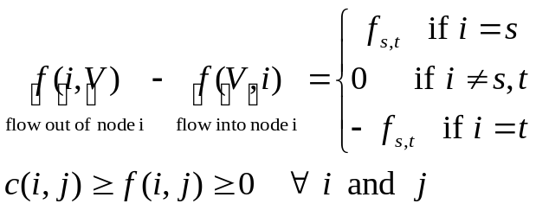 (U21.4)
Undirected graph:
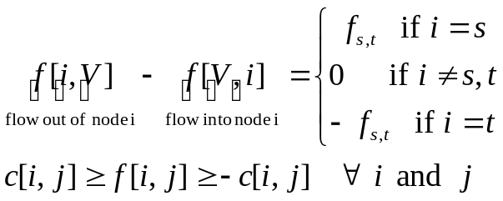 (U21.5)
In the above, V represents all nodes in the graph. Therefore, the above represents the conservation of flow at each node. For example, in the below figure, we may have
f[5,V]-f[V,5]=
[ f(5,6)+f(5,7)+f(5,8) ] - [ f(2,5)+f(3,5)+f(4,5) ]
= [ 1 + 1 + 4 ] - [ 2 + 3 + 1 ] = 0

i=s
i=t
i=5
2
3
4
6
7
8
Sets of branches: Let A and B be sets of nodes contained in V, i.e., A⊆V and B⊆V. Denote the set of all branches which are incident out of (connected from) a node in A and incident into (connected to) a node in B. That is,
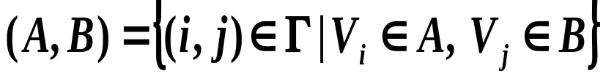 (U21.6)
Set theoretic complement: Denoting a subset V₁ of nodes of G(V,Γ), the set theoretic complement of V₁ in V is denoted by 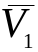 and defined by 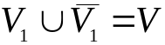.
Cut: Combining the last two definitions, we define that for any V₁⊆V, the set of branches identified by 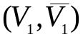 is a cut. In this definition, remember that 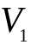 and 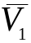 represent sets of nodes, not sets of branches, and that 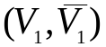 therefore represents a certain group of branches that connects a node in the node-set with a node in the complementary node-set . Figure U21.7 illustrates a cut, where ={1,2,3,4} and ={5,6}, such that ={[4,5], [3,5], [4,6]}.
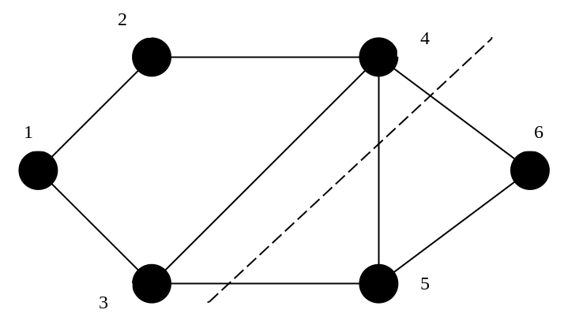
Fig. U21.7: Illustration of a cut

Note that this definition of a cut is consistent with the definition (given in Module U15) of a cutset, which was, “A cutset K is a set of components whose failure results in system failure. The removal of the corresponding set of blocks in the logic diagram interrupts the continuity between the input and output of the diagram [1]. Removal of all components in any cutset ‘disconnects’ the ‘input’ from the ‘output’ in the logical diagram.”
s-t cut: An s-t cut is a cut where s∈V₁ and t∈. We will denote the K^{th} s-t cut as 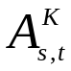.
Capacity of a cut: The capacity of a cut, denoted by 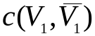 or 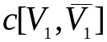, is the maximum total flow that may cross the cut when connected in the graph. It is given by:
Directed graph:
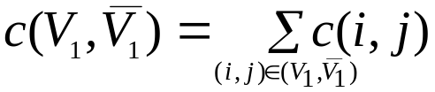 (U21.7)
Undirected graph:
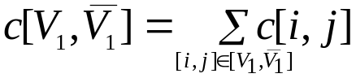 (U21.8)
Minimal cut: The minimal cut is the cut with the smallest capacity.
MaxFlow-MinCut theorem: This theorem, developed by Ford and Fulkerson [5], is the basis for determining the maximal flow from source to sink within a network. In words, the theorem says that the maximal flow from source to sink in any network is equal to the capacity of the minimal cut. Mathematically, the theorem is:
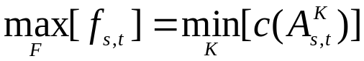

Example 7: Determine the maximal flow of the network in Fig. U21.8.
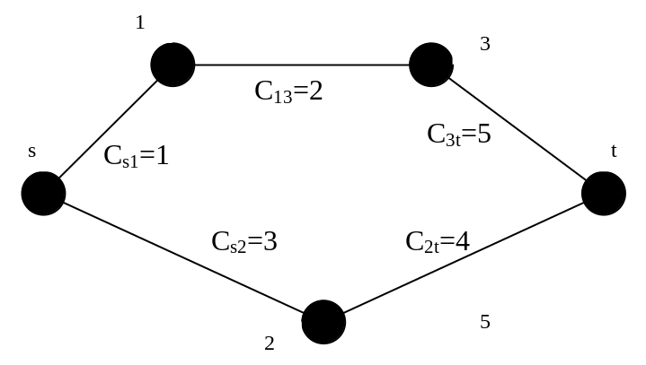
Fig. U21.8: Example to illustrate maximal flow calculation
The s-t cuts for the network of Fig. U21.8, their node sets, their complementary node-sets, and their capacities, are listed in Table U21.12.
Table U21.12: Summary of s-t cuts for example
s-t cut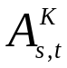 | Node-set 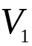 | Node-set 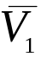 | Cut-capacity  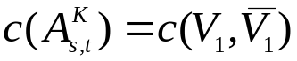
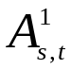 | (s) | (1,2,3,t) | 4
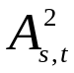 | (s,1) | (2,3,t) | 5
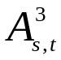 | (s,1,3) | (2,t) | 8
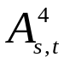 | (s,1,2) | (3,t) | 6
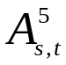 | (s,1,2,3) | (t) | 9
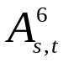 | (s,2) | (1,3,t) | 5

From Table U21.12, we see that the minimal cut, and therefore the maximal flow, is 4.
We need to be able to articulate an algorithm for identifying the maximal flow. We present such an algorithm in what follows.
One important observation is that this approach adheres to only Kirchoff’s first law (sum of flows into a node must be zero), otherwise known as flow conservation, but not Kirchoff’s second law (sum of voltages around a closed loop must be zero). One must be aware of this very significant approximation when applying network flow theory to electric power grids.

We need three more definitions.
Path: A sequence of branches starting at the source node and ending at the sink node such that no node is visited more than once.
Forward and backwards arcs: A directed arc (i,j) in a path is a forward arc if in traversing from s to t, i comes before j; otherwise it is a backwards arc in the path.
Flow augmentation path: For a given flow pattern F, a flow augmentation path is a path (i.e., from source to sink) for which there exists unused capacity.
The max-flow (also called Ford-Fulkerson) algorithm follows:
- Initialization: Initialize the graph with a feasible flow (capacity restrictions and flow conservation must be satisfied). One flow that is always feasible is 0 flow on all branches.
- Labeling: Use the labeling routine to find a flow augmentation path (i.e., a path (from s to t) for which flow may be increased). The labeling routine is:
  - Starting with s, node j can be labeled if a positive flow can be sent from s to j. If no node can be labeled, proceed to step 5.
  - Find a node to label. From node j, any node i can be labeled if:
- the j to i arc is a forward arc and flow in this arc is less than its capacity.
- the j to i arc is a backward arc and flow in this arc is greater than zero.
- Three things may happen at this point.
- A node i is found such that i≠t. Repeat step b.
- No node i can be labeled. This means that no augmentation path can be found. Proceed to step 5.
- Node i is found such that i=t. We have found an augmentation path and should proceed to step 3.
- Augmentation:
  - Identify the maximal flow increase δ that can be sent along the augmentation path identified in step 2.
  - Augment flow on all arcs in the augmentation path by δ. Forward arc flows are increased. Backward arc flows are decreased. Undirected arc flows are increased if the flow augmentation is in the same direction as the original flow. Undirected arc flows are decreased if the flow augmentation is in the opposite direction as the original flow.
- Repeat: Go to step 2.
- Stop: The maximal flow is the flow out of the source node (or into the sink node) resulting from the last augmentation path found.
We repeat Example 7 but this time we use the algorithm.
Example 8: Figure U21.9 shows the initialized graph of Fig. U21.8. Numbers in parentheses indicate (capacity, flow). All arcs are undirected.
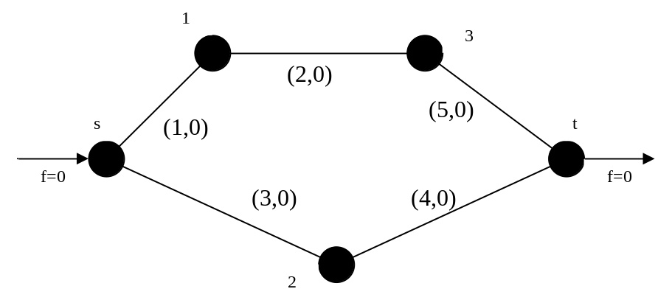
Fig. U21.9: Example to illustrate maximal flow calculation
Application of step 2 (labeling) to the network of Fig. U21.9 results in the augmentation path illustrated in Fig. U21.10.
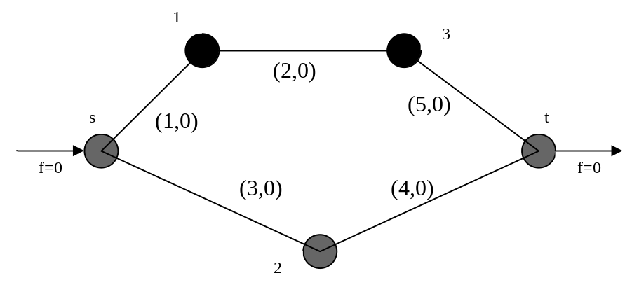
Fig. U21.10: Results of first step 2 iteration
Application of step 3 (augmentation) to the network of Fig. U21.10 results in the network of Fig. U21.11.
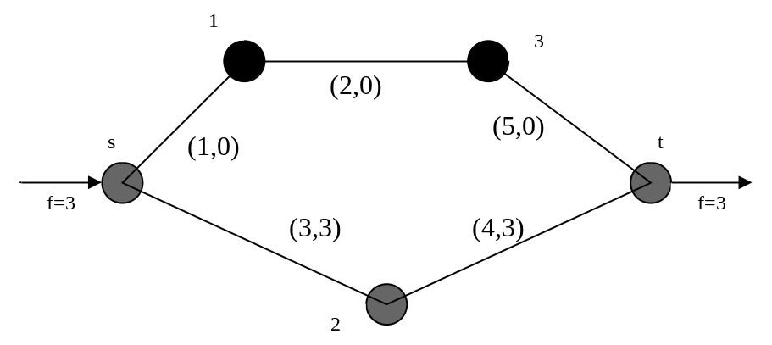
Fig. U21.11: Results of first step 3 iteration
We now apply step 2 again (labeling), this time to the network of Fig. U21.11, resulting in the augmentation path of Fig. U21.12.
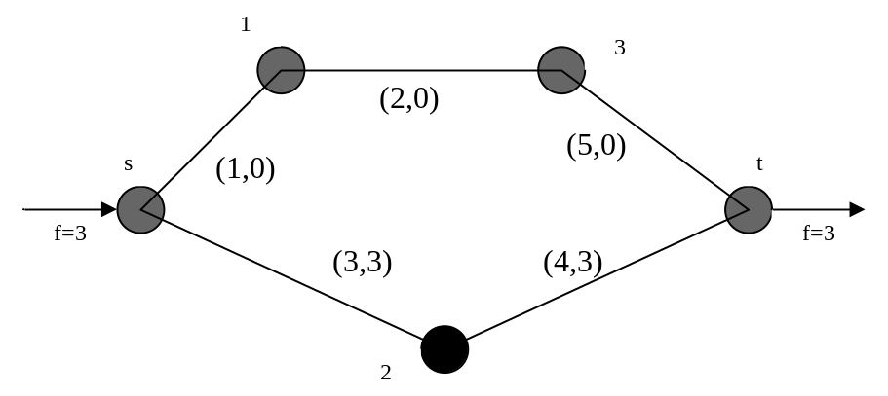
Fig. U21.12: Results of second step 2 iteration
We now apply step 3 (augmentation) again, this time to the network of Fig. U21.12, resulting in the network of Fig. U21.13.
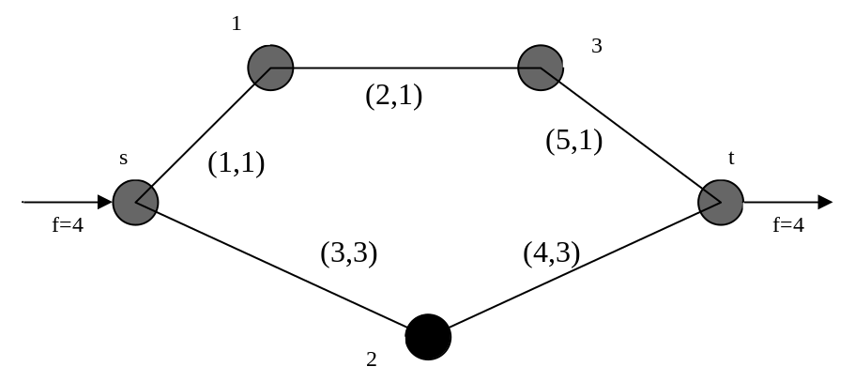
Fig. U21.13: Results of second step 3 iteration
When we try to apply step 2 again, we find that, beginning with the source node s, we are unable to label any other node since all arcs leaving s are at capacity. There we go to step 5, where we terminate the algorithm, with the maximal flow recognized as 4.
Example 9: Figure U21.14 shows another example. Use the algorithm to determine the maximal flow for this network for the case of:
- All arcs are undirected. The correct answer is 16. Try it!
- All arcs are undirected except for [1,2] which may have flow only in the direction 1 to 2. The correct answer is 15.
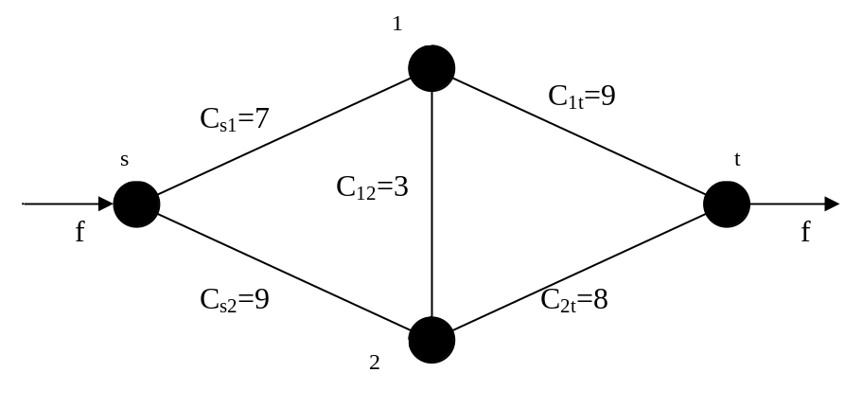
Fig. U21.14: Example to illustrate maximal flow algorithm

Below is the answer to part (b). This is taken from [4].

The two problems have different answers because of the last step below (called “Fig. 14) where, with a directed arc in the center, we may reduce the flow on (1,2) to only 0, and thus take only capacity of the (1,n) arc to 7. With undirected arc in the center, we can push the flow on (1,2) to -1 (thus flowing +1 from node 2 to node 1) and thus take advantage of one more unit of capacity in (1,n) where it goes to 8.
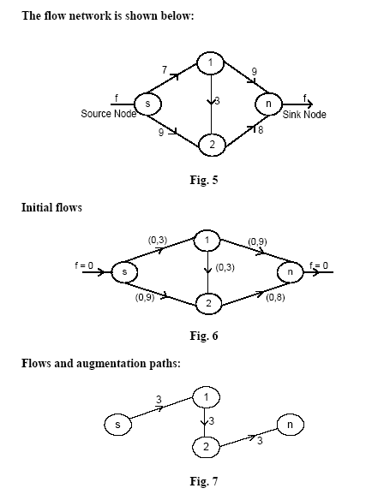
(0,7)
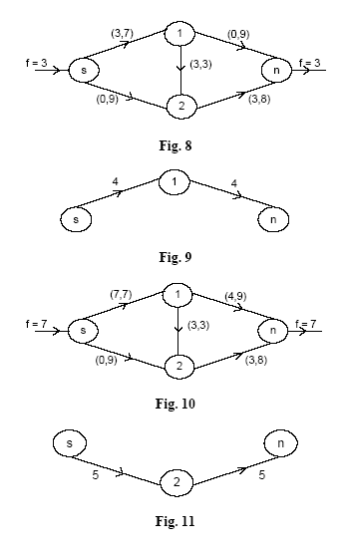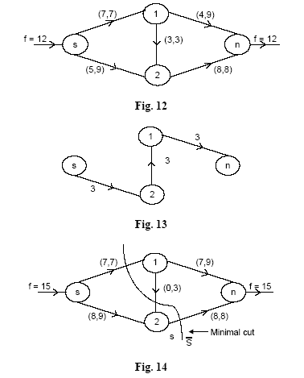

U21.7.2 Representation of multiarea system as a network flow problem
The material in this subsection is adapted from [4].
Consider again the networked three area interconnected system illustrated in Fig. U21.6, repeated here for convenience, where we have changed the area designation from A, B, C to 1, 2, 3.

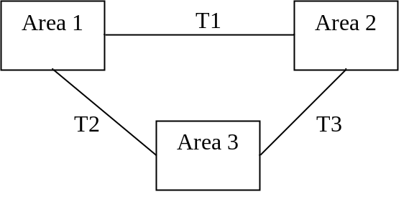
Fig. U21.15: Three networked interconnected areas
Assume the following data for this multiarea system:
Area 1: installed capacity = 500 MW, Load=400 MW.
Area 2 installed capacity=600 MW, Load=500 MW.
Area 3 installed capacity=500 MW, Load=400 MW.
Transmission capacity T1=T2=T3=100 MW.
Problem: Determine whether the system with all components up is a loss of load state or not. This means that we want to determine whether a particular system state is a failure state or not.
How can we represent this as a network flow problem?
Represent all possible generation as originating from the source node and all possible load at the sink node. The other elements are represented as follows:
- Generation arc: A directed arc from source node s to node i, with capacity c(s,i) represents a particular discrete capacity state for area i (these capacity states can be obtained from the capacity outage table for area i). Of course, these capacity states have their corresponding probabilities.
- Transmission arc: A undirected arc between nodes i and j having capacity c(i,j) represents a particular discrete capacity state of the transmission between areas i and j. The transmission states also have their corresponding probabilities.
- Load arcs: A directed arc between node i and the sink node t represents the load in area i. We will assume these loads to be fixed.
Note that generation and load are represented using directed arcs and transmission is represented using undirected arcs. This is a result of the fact that generation and load flow is in one direction only, whereas transmission flow can be in either direction.
The particular state of interest for the three area system in Fig. U21.15 and the data provided (in terms of the generation capacity in each area, the transmission capacity in each area, and the load in each area) are represented using the network flow problem in Fig. U21.16, where values beside each arc represent (capacity, flow)/100.
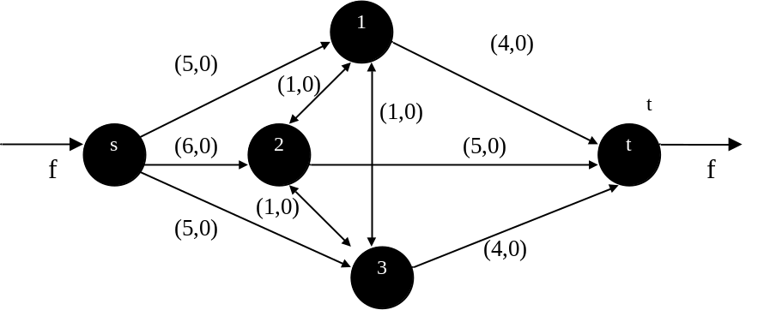
Fig. U21.16: Example to illustrate maximal flow algorithm
We can detect whether the state is failure or not by performing max-flow and then checking whether the max flow equals the sum of the load arc capacities. In this case, that would be 4+5+4=13.
Fig. U21.17 provides a sequence of max-flow algorithm steps for the network flow problem of Fig. U21.16. The dark lines indicate the augmentation path at each step.

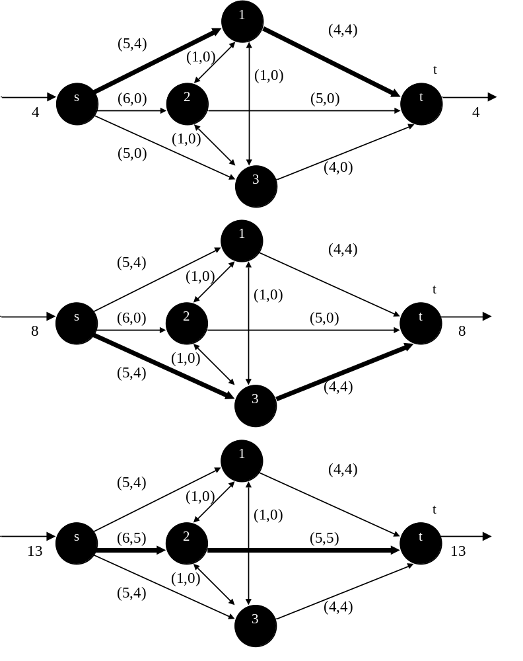
Fig. U21.17: Example to illustrate maximal flow algorithm
Notice that our first three augmentation paths were intentionally chosen to force the load of each area to be served by generation in that area, if possible.
However, the flow pattern for a particular max-flow problem is not unique (the max flow value itself is unique). This can be observed by repeating the above max-flow problem but choosing a different sequence of augmentation paths. Fig. U21.18 illustrates.
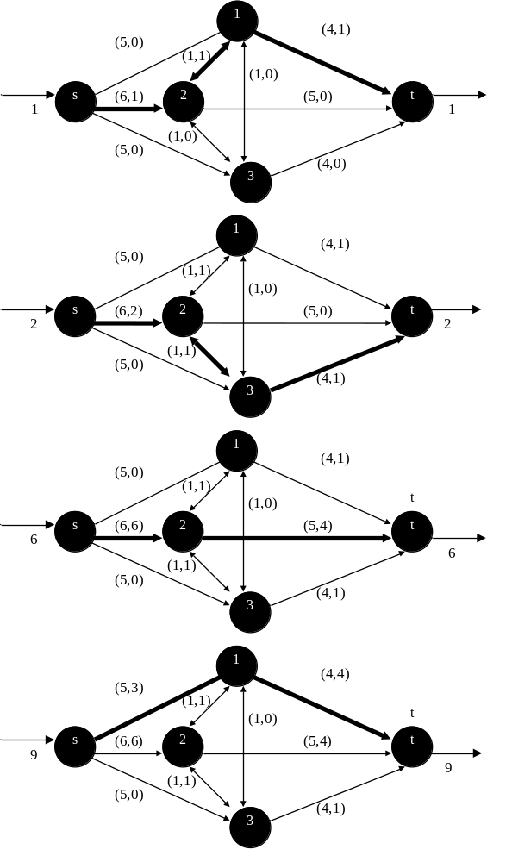
Fig. U21.18: Example to illustrate maximal flow algorithm

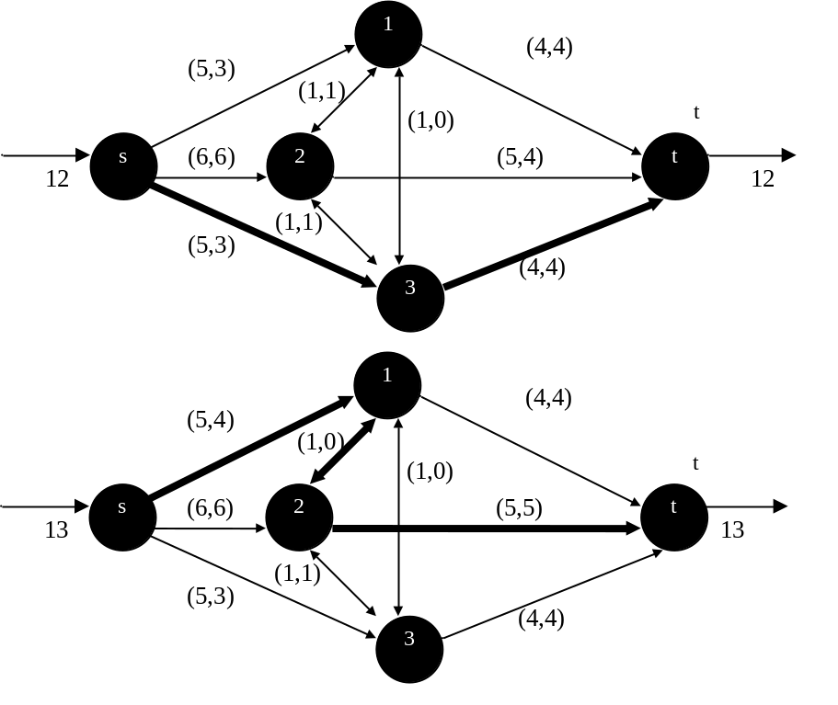
Fig. U21.18: (Continued from previous page)
In the case of Fig. U21.18, the max-flow is still 13 but the final flow pattern has Area 2 assisting Area 3.
In any case, we have determined that the system state corresponding to all components in service is not a failure state.
If each area has only a single 2-state unit (up or down) and if each transmission circuit between areas is represented as a 2-state component (up or down), then we have a total of 6 components, each with 2 possible states. Therefore the total number of states to evaluate is 2⁶=64 states.
To obtain the system LOLP, then, we must determine whether each state is a failure state or not. A straightforward enumeration approach would be to perform a max-flow calculation for each and every state and then add the probabilities corresponding to the states where the max-flow did not each the total load. This is probably do-able for a 64 state system.
But let’s consider a slightly more realistic situation where the installed capacity of each area is actually comprised of multiple units. We would then need to use our convolution technique to identify each capacity (or capacity outage) level for each area. In this case, the total number of system states can be very large, even for a three area system.
For example, consider characterizing our 3-area system using the data of Table U21.13. This data was generated using 100 MW generator units, each with availabilities of 0.8 (FOR=0.2). Note that it is a capacity table (rather than a capacity outage table). The data for each area in this table was generated by simply convolving the vector (0.2, 0.8) a number of times equal to the number of units in each area.
Table U21.13: Generation data for 3-area system
Area 1 |  | Area 2 |  | Area 3
Cap | Prob | Cap | Prob | Cap | Prob
 |  | 600 | .262140
500 | .32768 | 500 | .393220 | 500 | .32768
400 | .40960 | 400 | .245760 | 400 | .40960
300 | .20480 | 300 | .081920 | 300 | .20480
200 | .05120 | 200 | .015360 | 200 | .05120
100 | .00640 | 100 | .001536 | 100 | .00640
0 | .00032 | 0 | .000064 | 0 | .00032

Each of the three transmission lines have availabilities of 0.99 (FOR=0.01).
Possible capacities for the various arcs in our network are given in Table U21.14. We have also identified each arc capacity with a number.
Table U21.14: Possible capacities of each arc & capacity designations
capacity designations, x_{j} | Possible capacities for each arc j
capacity designations, x_{j} | j=1 | j=2 | j=3 | j=4 | j=5 | j=6
7 |  | 600
6 | 500 | 500 | 500
5 | 400 | 400 | 400
4 | 300 | 300 | 300
3 | 200 | 200 | 200
2 | 100 | 100 | 100 | 100 | 100 | 100
1 | 0 | 0 | 0 | 0 | 0 | 0
So we can see from Table U21.14 that:
x₂=7➔C₂=600.
x₁=6➔C₁=500; x₂=6➔C₂=500; x₃=6➔C₃=500;
x₁=5➔C₁=400; x₂=5➔C₂=400; x₃=5➔C₃=400;
x₁=4➔C₁=300; x₂=4➔C₂=300; x₃=4➔C₃=300;
x₁=3➔C₁=200; x₂=3➔C₂=200; x₃=3➔C₃=200;
x₁=2➔C₁=100; x₂=2➔C₂=100; x₃=2➔C₃=100; x₄=2➔C₄=100;
x₅=2➔C₅=100; x₆=2➔C₆=100;
x₁=1➔C₁=0; x₂=1➔C₂=0; x₃=1➔C₃=0; x₄=1➔C₄=0;
x₅=1➔C₅=0; x₆=1➔C₆=0;
We may also tabulate the cumulative probabilities, which are Pr[X_{j}<x_{j}] for each arc j and each value it may take. These cumulative probabilities are given in Table U21.15 and will prove helpful in computing state probabilities.
Table U21.15: Possible capacities of each arc & capacity designations
capacity designations, x_{j} | Cumulative probabilities for each arc j
capacity designations, x_{j} | j=1 | j=2 | j=3 | j=4 | j=5 | j=6
7 |  | 1.0
6 | 1.0 | .737860 | 1.0
5 | .67232 | .344640 | .67232
4 | .26272 | .098880 | .26272
3 | .05792 | .016960 | .05792
2 | .00672 | .001600 | .00672 | 1.0 | 1.0 | 1.0
1 | .00032 | .000064 | .00032 | .01 | .01 | .01

The capacity designations of Table U21.14 allows us to define the system state, x as
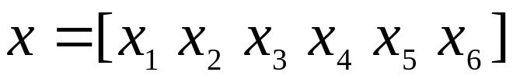
For example, the system state corresponding to maximum capacity of all elements would be
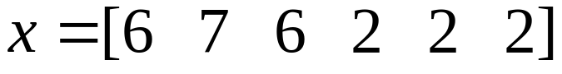
which also happens to indicate the number of possible values for each arc, from which we can identify that there are 6×7×6×2×2×2=2016 system states.
How do we obtain the probability of a particular system state? Assuming that the capacity of element i is independent of the capacity of element j, the probability of a particular state is given by:
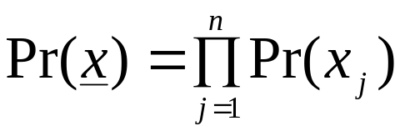 (U21.9)
For example, the probability of the state corresponding to maximum capacity x=[6 7 6 2 2 2] is given by:
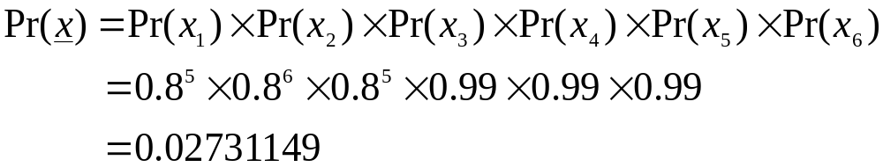This indicates it is not very likely that at any given moment, we will find all of the components up in this system! Systems with a large number of not-very reliable components are always like this (the 16 generators have availabilities of only 80%).
On the other hand, the probability of the state corresponding to minimum capacity x=[1 1 1 1 1 1] is given by:
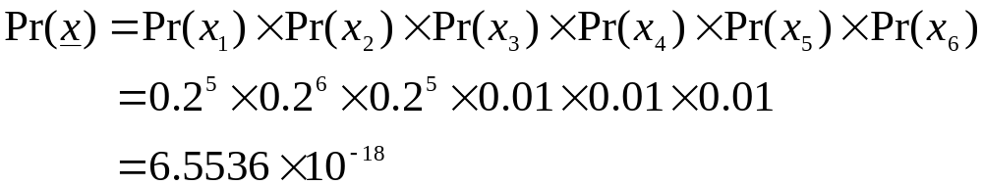and so we see that it is extremely unlikely that at any given moment, we will find all of the components down in this system.
Notice that the above calculations are according to the binomial distribution, as given in Module U10, according to:
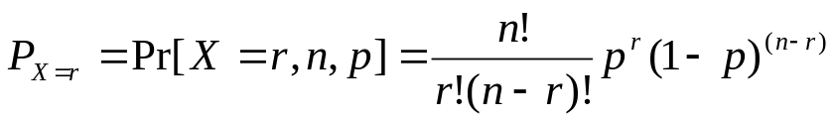 (U21.10)
for r failures out of n components where each component has failure probability of p.
Just for illustration, we may also compute the probability of a general state, say, x=[2 4 6 1 2 2], according to:
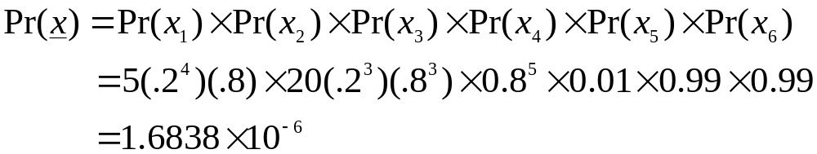Note that the convolution technique used to generate Table U21.13 is a more general way to get the individual probabilities Pr[x_{j}] used in the above calculations (the binomial distribution only works when all components have the same failure probability).
We define the states corresponding to the maximum and minimum capacities as M and m, respectively, i.e.,
M=[6 7 6 2 2 2] and m=[1 1 1 1 1 1]
We may then enumerate all 2016 states from the minimum state to the maximum state as follows:
State 1: m= [1 1 1 1 1 1]
State 2: [2 1 1 1 1 1]
State 3: [2 2 1 1 1 1]
…
State n: M= [6 7 6 2 2 2]
It is clear that we can obtain the probability for any particular system state that we like. This fact motivates the following algorithm for computing loss of load probability.
LOLP=0
For j=1,n,
Perform max flow for state j
If failed state, LOLP=LOLP+Pr(state j)
End
However, it is obviously extremely computationally intensive, since we must perform a max-flow computation for every single state. We refer to this approach as “enumeration.” Clearly, we need a better way!
There are 3 alternatives to enumeration, as follows:
- Decomposition: This method treats groups of states rather than individual states by decomposing the states into sets.
- Monte-Carlo Simulation: Here, states are sampled from the state-space and indices are computed by statistical inference.
- Hybrid: Here, a combination of decomposition and simulation methods are employed, leading to the so-called decomposition-simulation approach.
We will discuss only the decomposition approach.

U21.7.3 The decomposition approach
The decomposition approach proceeds by dividing all of the states into sets of three different types, described as follows:
- Sets of acceptable states, A_{k}: These sets consist of states that have the load satisfied in every area.
- Sets of system loss of load states, L_{k}: These sets consist of states that have at least one area loss of load (also called unacceptable states).
- Sets of unclassified states, U_{k}: The states in these sets have not been classified into acceptable or unacceptable states.
Initially, of course, all states are unclassified and therefore are contained in Set U. The approach is to decompose this initial set into A, L, and U subsets, and then repeat the procedure on the remaining U subset until a desired level of decomposition is achieved.
Consider an unclassified set S consisting of states {x₁, x_{2,…}} (note that x₁ denotes “state 1” where as x₁ denotes “the capacity designation of arc 1”) defined by a maximum state M and a minimum state m such that
S={x_{j} : m ≤ x_{j} ≤ M} (U21.11)
The notion of what it means for one set to be less than or equal to another set deserves some clarification. The above means that, for all i,
- the i^{th} element of m must be less than or equal to the i^{th} element of x_{j}, and
- the i^{th} element of x_{j} must be less than or equal to the i^{th} element of M.
Mathematically, we say that:
m ≤ x_{j} ≤ M➔ m_{i} ≤ x_{ji} ≤ M_{i} ∨ i (U21.12)
So if m=[1 1 1 1 1 1] and M=[6 7 6 2 2 2], then the set defined by S={x_{j} : m ≤ x_{j} ≤ M}
- would include, for example,
[1 1 1 1 1 1],
[2 1 1 1 1 1], …,
[6 7 6 2 2 1],
[6 7 6 2 2 2]
- but would not include, for example,
[1 1 1 1 1 0] and
[6 7 5 2 2 3]
With this definition, we can describe the first step of the decomposition approach where we identify the A-set.
Identification of the A-set
Suppose we set all the arcs of the network model equal to the capacities in the max state and make a max flow calculation such that the max flow is equal to the sum of the area loads and is therefore an acceptable state (if the max state is unacceptable, then LOLP=1.0). Then the max state is obviously a success state, i.e., no area suffers loss of load.
This information can be even more useful, however, if we have arcs for which the flows are not at maximum capacity, because, for such arcs,
- another acceptable state can be identified immediately as the one corresponding to the max state with each arc capacity reduced to the flow level of the max state max flow.
- and all states between this state and the max state are also acceptable.
Let’s give some notation to this idea. Let f_{k}(M) denote the flow through arc k for this max flow condition. Then a vector u can be so defined that its k^{th} element is given by:
u_{k}=capacity designation of arc k that has capacity equal
to or just greater than the flow through arc k, f_{k}(M).
To illustrate, recall that Figure U21.17 gives the capacities and flows corresponding to the max state for our example system, repeated below for convenience:

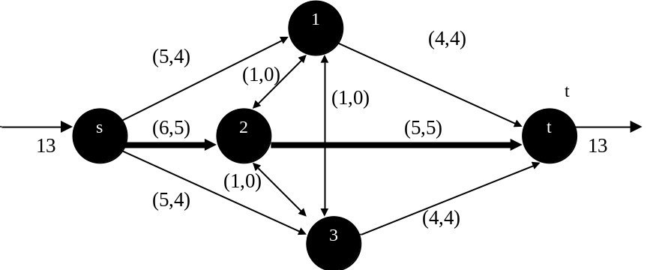
Fig. U21.19: Max flows for max state
Here, we observe that no generation or transmission arc is at maximum capacity, but rather f₁[M]=4<5, f₂[M]=5<6, f₃[M]=4<5, f₄[M]=0<1, f₅[M]=0<1, and f₆[M]=0<1. The capacity designations for these arcs corresponding to capacities equal to or just greater than the flows are u₁=5, u₂=6, u₃=5, u₄=1, u₅=1, u₆=1, so that the vector u is:
u=[5 6 5 1 1 1]
If a state is such that capacities of all the arcs are higher than those corresponding to u, then that state will also be acceptable. Therefore all states between u and the max state constitute an A-set, that is,
A={x_{j} : u ≤ x_{j} ≤ M} (U21.13)
More explicitly,
A={x_{j} : [5 6 5 1 1 1] ≤ x_{j} ≤ [6 7 6 2 2 2]}
There are, for each arc, two possible capacities. Therefore, the number of acceptable states in this A-set is 2×2×2×2×2×2=64.
Thus, we can see that just by making one max-flow calculation, we have been able to classify 64 states as acceptable. In the straightforward enumeration scheme, this would have required 64 max-flow calculations. So we have made a considerable computational savings. This is good progress, but we still have 2016-64=1952 states left to evaluate.
What about the total probability corresponding to this A-set. Clearly the brute-force approach is to simply compute the probability of each and every state in the set and then sum these state probabilities.
However, a simpler approach results from observing that we want to obtain the joint probability of all the events u_{j}≤x_{j}≤M_{j} for all j. If we assume these are independent events (which is reasonable for components that fail independently), then we have:

Pr[A]=Pr[(u₁≤x₁≤M₁)∩(u₂≤x₂≤M₂)∩(u₃≤x₃≤M₃)
∩(u₄≤x₄≤M₄)∩ (u₅≤x₅≤M₅)∩(u₆≤x₆≤M₆)]
=Pr[u₁≤x₁≤M₁]×Pr[u₂≤x₂≤M₂]×Pr[u₃≤x₃≤M₃]×Pr[u₄≤x₄≤M₄] ×Pr[u₅≤x₅≤M₅]×Pr[u₆≤x₆≤M₆]=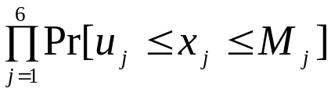
(U21.14)
Now what is Pr[u_{j}≤x_{j}≤M_{j}]? This is nothing more than
Pr[u_{j}≤x_{j}≤M_{j}]=Pr[(x_{j}=u_{j})∪… ∪(x_{j}=M_{j})]=Pr[x_{j}=u_{j}]+…+Pr[x_{j}=M_{j}]
(U21.15)
Substitution of (U21.15) into (U21.14) yields:
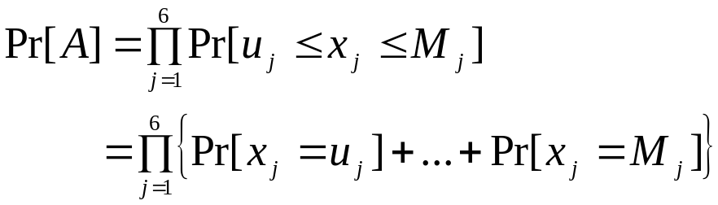 (U21.16)
Thus, we see that to compute the probability of the A-set (or any specified range of sets), we first calculate the sum of probabilities of all states between the max and min state for a given arc. Then we multiple these cumulated arc probabilities to find the set probability. In actual practice, the sum can be found more readily by taking the difference in the cumulative probabilities, i.e.,
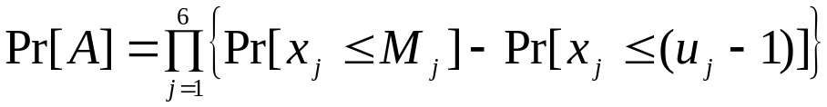 (U21.17)
For our example problem, we have 6 arcs, so we must compute 6 cumulated probabilities. Recalling that the A-set is specified by
A={x_{j} : [5 6 5 1 1 1] ≤ x_{j} ≤ [6 7 6 2 2 2]}
we see that:
- The arc 1 cumulated probability is given by:
Pr[x₁=5]+Pr[x₁=6]
which are the probabilities of having 1 or 0 Area 1 generation units out of service, respectively. Using cumulative probabilities results in (from Table U21.15)
Pr[x₁<6]-Pr[x₁<4]=1.0-.26272=.73728
(Notice Pr[x₁<6]-Pr[x₁<4]=Pr[x₁=6,5,4,3,2,1]-Pr[x₁=4,3,2,1]
=Pr[x₁=6,5]).
- The arc 2 probabilities are:
Pr[x₂=6]+Pr[x₂=7]=Pr[x₂<7]-Pr[x₂<5]=1.0-.34464=.65536
- The arc 3 probabilities are:
Pr[x₃=5]+Pr[x₃=6]=Pr[x₃<6]-Pr[x₃<4]=1.0-.26272=.73728
- The arc 4 probabilities are:
Pr[x₄=1]+Pr[x₄=2]=Pr[x₄<2]-Pr[x₄<0]=1.0-0=1.0
- The arc 5 probabilities are:
Pr[x₅=1]+Pr[x₅=2]=Pr[x₅<2]-Pr[x₅<0]=1.0-0=1.0
- The arc 6 probabilities are:
Pr[x₆=1]+Pr[x₆=2]=Pr[x₆<2]-Pr[x₆<0]=1.0-0=1.0
The probability of the A-set then becomes:
.73728×.65536×.73728×1.0×1.0×1.0=.356242
Identification of the L-set
Recall that an L-set is a set of failure states.
The essential idea for identifying L-sets is as follows. For any particular component j, it may be possible to identify a capacity v_{j} for which any lower capacity x_{j}<v_{j} results in loss of load. If this is the case, then all states with x_{j}<v_{j} are members of the L-set.
Therefore, if m and M are the minimum and maximum states, then, if we can find v₁ for one of the components 1, then
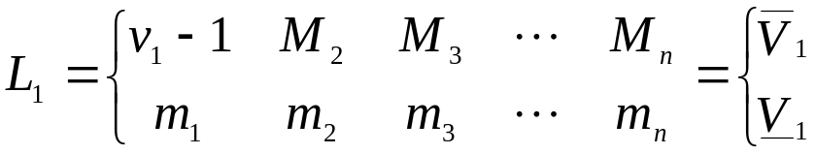 (U21.18)
where the L₁ set is comprised of all states between the lower state, denoted 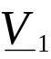, and the upper state, denoted 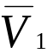, i.e.,
L₁={x_{j} : ≤ x_{j} ≤ } (U21.19)
The significance of this L₁ set is, if the arc 1 is between m₁ and v₁-1 (inclusive), we have loss of load irrespective of other arc values.
The probability of this L-set, Pr[L₁], is computed in the same fashion as we computed the probability of the A-set from (U21.17), i.e.,
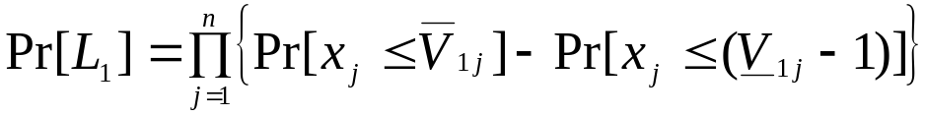 (U21.20)
Expanded, (U21.20) becomes,
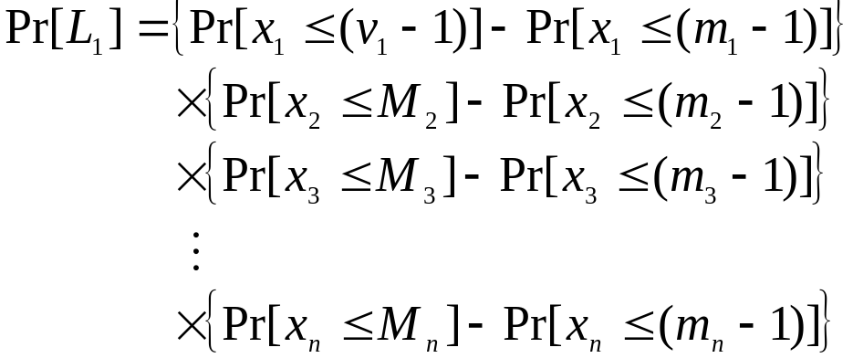 (U21.21)
The 2nd probability in each term is 0 since no state may be <m_{j}.
A similar idea holds for the other arcs as well. For example, we need to find v₂ such that there is no failure but if the system goes to the next lower state v₂-1, there will be loss of load. This also identifies an L-set.
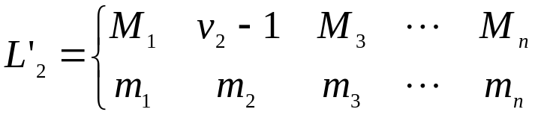 (U21.22)
Now this is a legitimate L-set, i.e., all states are loss of load states. However, there is overlap between L₁ and L’₂ that include the following states:
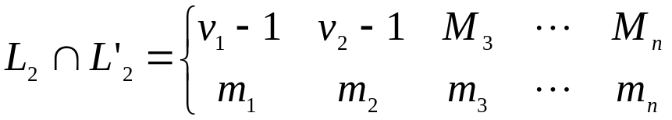 (U21.23)
It is easier to compute probabilities that we can use in the final LOLP calculation if we maintain disjoint (nonintersecting) L-sets. Therefore, we define the second L-set as:
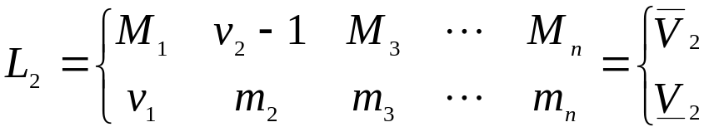 (U21.24)
where it is clear that component j=1 is constrained to take on only values that are outside of the L₁ set. Therefore, this set is comprised of failed states that are not included in L₁.
The probability of this set is given similar to (U21.20):
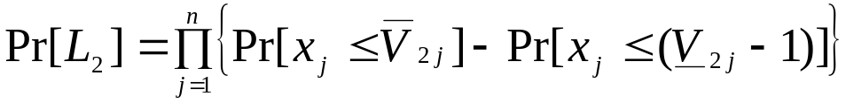 (U21.25)
Similarly, the third L-set is given by:
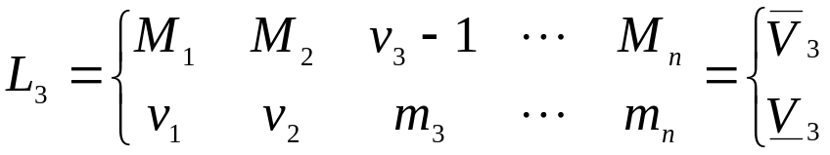 (U21.26)
and its probability given by
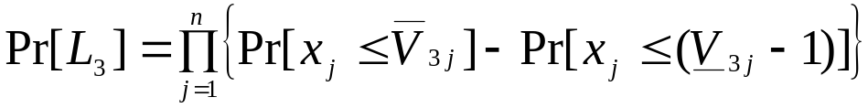 (U21.27)
In general, if there are n arcs, there will be n L-sets generated, and the k^{th} set is given by:
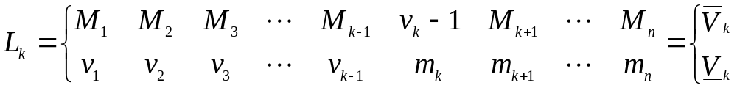(U21.28)
An important question is, at this point:
How to find v_{k}, the capacity of the k^{th} component such that there is no failure but if the system goes to the next lower state v_{k}-1, there will be loss of load?
The obvious approach is, beginning with the maximum state M, decrease the k^{th} component capacity by 1, and run the max flow to see if the tested state is a failure state. If we repeat this over and over, we are guaranteed to identify v_{k}, or, alternatively, to identify that changes to the k^{th} component’s capacity cannot cause system failure. However, the computational cost of doing so is significant, since it requires that we run a max flow for every tested capacity of the k^{th} component’s arc.
Another method that would decrease this computational cost would be the so-called bisection approach where our first capacity tested is halfway between M_{k} and m_{k}. If it is a failed state, then we test the one halfway between it and M_{k}. If it is not a failed state, then we test the one halfway between it and m_{k}, continuing in this manner until we identify v_{k} or until we identify that changes to the k^{th} component’s capacity cannot cause system failure.
Yet, there is a better method that only requires a single max flow. It is based on the following premise.
Let arc k be connected from node i to node j.
- If, in the max flow calculation of the maximum state, arc k carries flow f_{k} to its terminating node j, and
- if, without arc k, the network has e_{k} residual capacity to carry flow from the source to that terminating node j,
- then the state with greatest capacity of arc k (and all other arcs at maximum capacity) that is a failure state is when arc k capacity is decreased by more than e_{k}.
The implication is that if the flow in arc k is reduced by e_{k}, this much flow can be sent through the unused capacity of the remaining network without having system loss of load. Thus, v_{k} (which indicates the capacity just higher than the capacity necessary for failure) corresponds to the state with capacity equal to or just greater than f_{k}-e_{k}.
We summarize the steps for identifying v_{k} as follows. Assume that arc k connects node i to node j.
- Set all states of the network to the maximum capacities of the U set being decomposed (initially, this would be M).
- Find the max flow using the max flow algorithm.
- If the max flow found is less than the total demand, then there is loss of load in at least one area and thus the entire set U is an L set.
- Identify v_{k} as follows:
  - Remove the k^{th} arc. Retain the flows found in step 2 on all other arcs (or, equivalently, let new capacities of all remaining arcs equal to their original capacities less their flows).
  - Find the maximum additional flow from node s to node j (or, equivalently, find the maximum flow from node s to node j with all arcs at their new capacities). This is done by simply identifying node j as the sink node and running the max-flow algorithm. Denote the maximum additional flow from node s to node j as e_{k}.
  - Identify the component k capacity designation such that the corresponding capacity is equal to or just greater than f_{k}-e_{k}. This is v_{k}.
To illustrate, recall that Figure U21.20 gives the capacities and flows corresponding to the max state for our example system, repeated below for convenience:
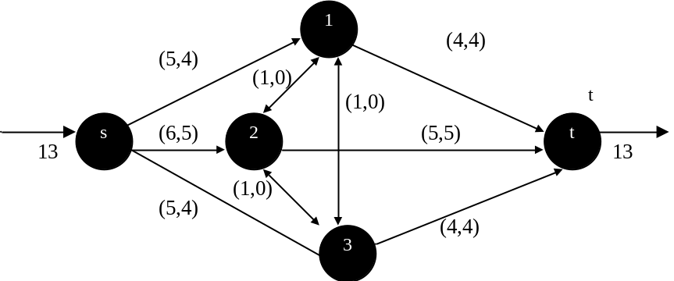
Fig. U21.20: Max flows for max state
Also, recall that m=[1 1 1 1 1 1] and M=[6 7 6 2 2 2]. Thus, by (U21.18), L₁ is given by:
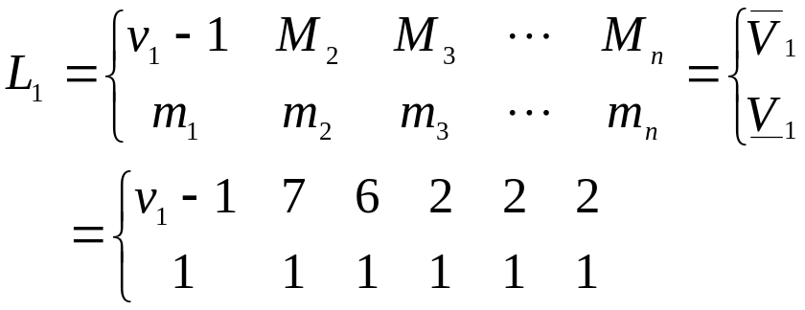 (U21.29)
Applying step 4 to find v₁, we remove arc 1 (generation for Area 1). Fig. U21.21 shows the network with arc 1 removed and other flows as in the solution to the max-state max-flow problem given in Fig. U21.20.
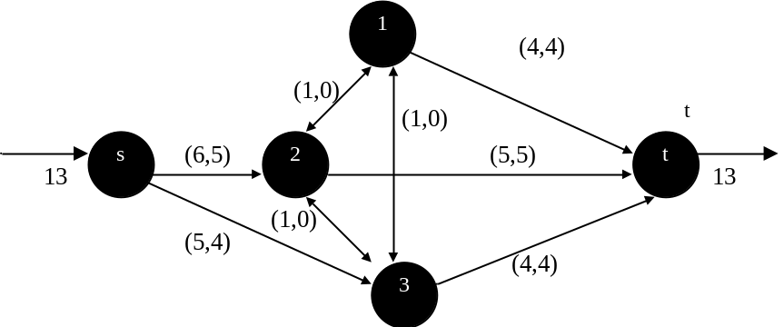
Fig. U21.21: Max flows for max state with arc 1 removed
Fig. U21.22 shows the arc capacity values adjusted to the new values corresponding to the difference between the flows in the max-flow solution and the old capacities, i.e., the residual capacities. Note that all load arcs have zero capacity, and the sink node is now modeled as node 1, the terminating node for arc 1.
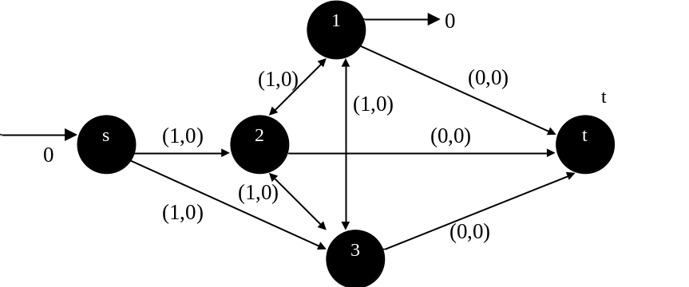
Fig. U21.22: Network with arc 1 removed using residual capacities

Applying the max-flow algorithm to the network of Fig. U21.22, we obtain the flows indicated in Fig. U21.23.
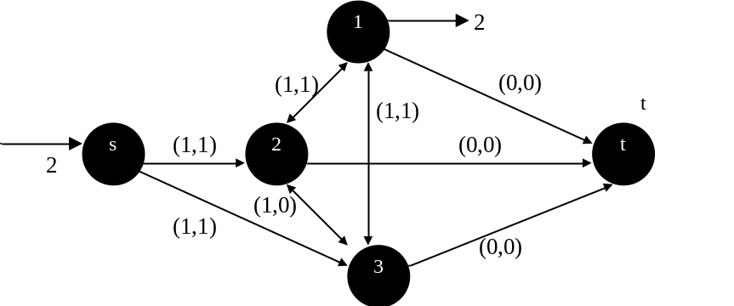
Fig. U21.22: Network with arc 1 removed using residual capacities

Thus, we see that the residual capacity in the network is e₁=2. Since from Fig. U21.20, the arc 1 flow in the max-state max flow condition was f₁=4, we can conclude that with arc 1 capacity at f₁-e₁=4-2=2, the state will be just acceptable (any additional capacity decrease in arc 1 will result in a failure state). This means that v₁ corresponds to the arc 1 capacity of 2 (or 200 MW). Reference to Table U21.14 indicates that the 200 MW capacity designation for arc 1 is 3, thus, v₁=3. Therefore, (U21.18) is
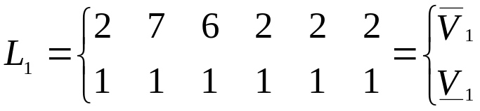 (U21.30)
Similarly, we may repeat the step 4 procedure for arcs 2 and 3, obtaining e₂=2 and e₃=2. It is unnecessary to repeat the procedure for arcs 4, 5, and 6 (the transmission arcs) since their flows in the max-state max flow are zero, implying that it is not possible to change their capacity in a way that will cause a failure state. Effectively, this means that the L-sets for these arcs, L₄, L₅, and L₆, are empty.
Since from Fig. U21.20, the arcs 2 and 3 flows in the max-state max flow condition were f₂=5 and f₃=4, we can conclude that with arcs 2 and 3 capacities at f₂-e₂=5-2=3 and f₃-e₃=4-2=2 in their respective states, these states will be just acceptable (any additional capacity decrease in arc 2 in its state or in arc 3 in its state will result in a failure state). This means that v₂ corresponds to the arc 2 capacity of 3 (or 300 MW) and v₃ corresponds to the arc 3 capacity of 2 (or 200 MW).
Reference to Table U21.14 indicates that the 300 MW capacity designation for arc 2 is 4, thus, v₂=4. Therefore, (U21.21) is
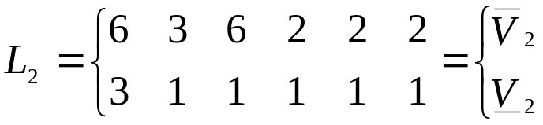 (U21.31)
Note that the element corresponding to the component 1 in the lower state was set to v₁ so as to maintain disjoint sets.
Reference to Table U21.14 indicates that the 200 MW capacity designation for arc 3 is 3, thus v₃=3. Therefore, (U21.26) is
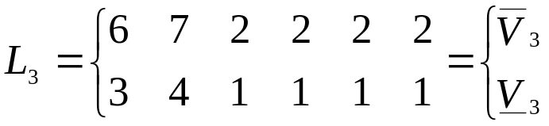 (U21.32)
Now compute the probabilities. The probability of the L₁ set is given by (U21.20) or (U21.21). Using the appropriate cumulative probabilities from Table U21.15, we find:
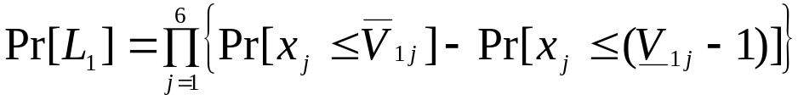
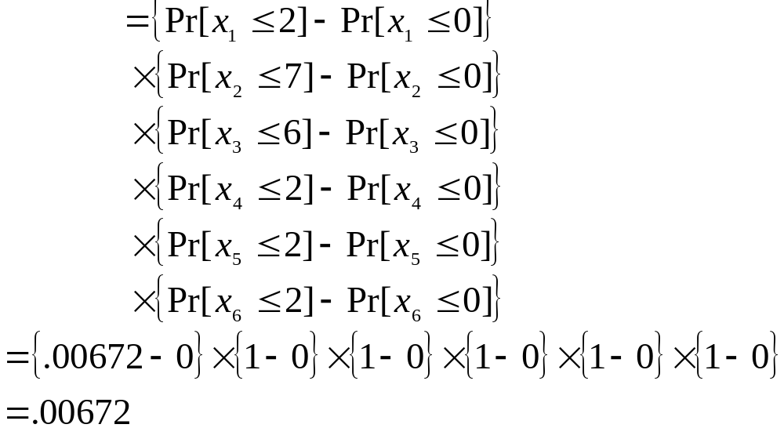
The probability of the L₂ set is given by (U21.22). Using the appropriate cumulative probabilities from Table U21.15, we find:

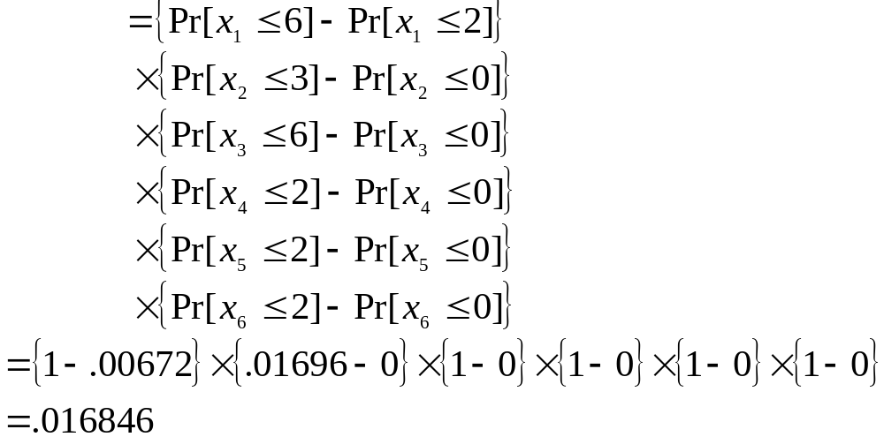The probability of the L₃ set is given by (U21.27). Using the appropriate cumulative probabilities from Table U21.15, we find:
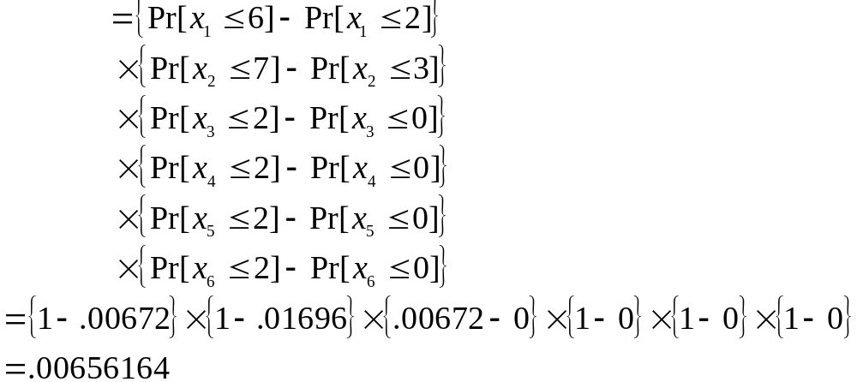The total probability of the L-sets is given by
Pr[L]=Pr[L₁]+Pr[L₂]+Pr[L₃]=.00672+.016846+.00656164
=.03012764
If we had no unclassified states, this would be the LOLP. However, we do need to check the unclassified states. This is particularly important because it provides us with an accuracy indication of using the total probability of the L-sets that have been identified so far as the LOLP.
Identification of the U-set
We need to determine which states are unclassified. Recall that we have identified:
- Acceptable (A) states as those between u and M. The basic criteria here, for an acceptable state, is to say that all arcs must be equal to or above their u-state capacity.
- Loss of load (L) states as those between 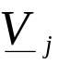 and 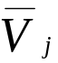 for j=1,…,n. The basic criteria here, for a loss of load state, is to say that at least one arc must be below its v-state capacity.
This, we can say that a state remains unclassified if:
- At least one arc is below its u-state capacity and
- All arcs are equal to or above their v-state capacity.
With these criteria, we may immediately write down a set of unclassified states as:
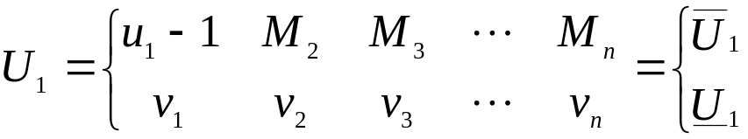 (U21.33)
Similarly, we may write down another one as
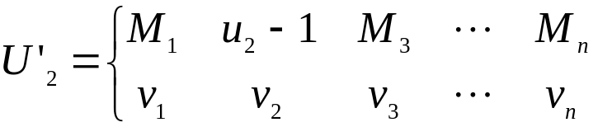 (U21.34)
However, U’₂ would not be disjoint with U₁, i.e., the following states would be included in both sets:
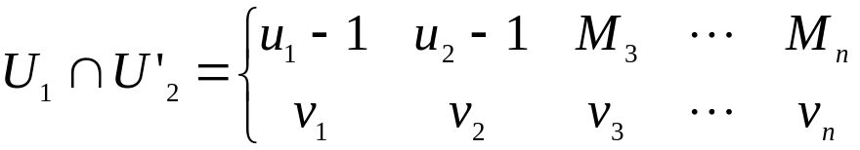 (U21.35)
As indicated in identifying L-states, this would create difficulties in computing the total probability of the unclassified states. Therefore, the second U-state should be:
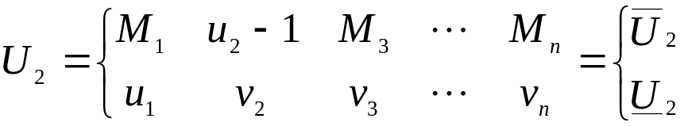 (U21.36)
The third U-state is:
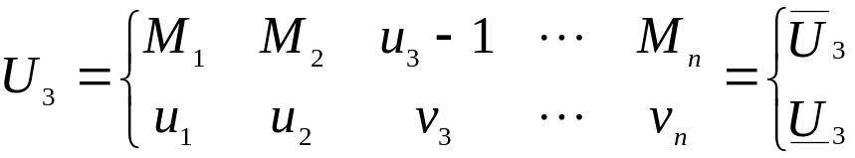 (U21.37)
In general, there will be n U-sets generated, with the k^{th} U-set given by:
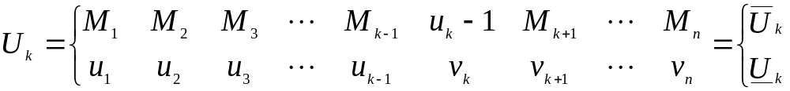(U21.38)
The probabilities computed as usual.
For our example, we have:
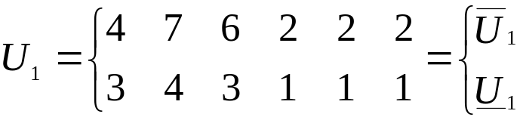
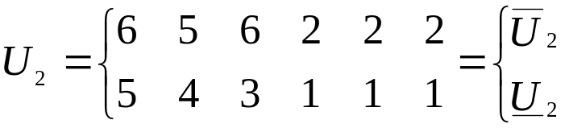
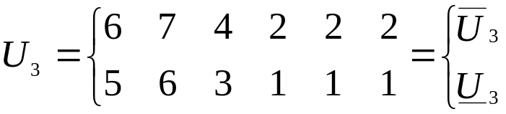
Note that U₄, U₅, and U₆ would have arcs 1, 2, and 3 above or equal to their u-capacities of u₁, u₂, and u₃, respectively, according to (U21.34). Any states for which this is true have already been classified as acceptable, since the max-state max flow indicated 0 flow on arcs 4, 5, and 6. Therefore, U₄, U₅, and U₆ are empty sets and we can obtain Pr[U] as the sum of probabilities of U₁, U₂, and U₃. The appropriate calculations are given below:
Pr(U₁)=(.26272-.00672)×(1-.01696)×(1-.00672)×1×1×1=.24997
Pr(U₂)=(1-.26272)×(.34464-.01696)×(1-.00672)×1×1×1=.23997
Pr(U₃)=(1-.26272)×(1-.34464)×(.26272-.00672)×1×1×1=.1237
Pr(U)=Pr(U₁)+Pr(U₂)+Pr(U₃)=.61337
This completes the first stage of decomposition. At this stage, we know that LOLP≥P(L)=.03012764.
It is of interest to note the sum of probabilities for the three identified sets, i.e.,
Pr(A)+Pr(L)+Pr(U)=.356242+.03012764+.61337=.99974
This probability should be 1.0, as all states have been classified; the small difference can be attributed to round-off error.
However, we see that Pr(U) is quite large. This indicates that we need to do some more work by decomposing the identified U-sets into their resulting A-sets, L-sets, and U-sets. This should continue until either no U set remains or the total probability of all U-sets is below a certain threshold.
It is also possible to obtain area indices. This is done by decomposing the L-sets into sets having identical area load loss characteristics. Reference [4] addresses this issue together with several other issues, including:
- Use of Monte-Carlo sampling for estimating contribution to reliability indices from remaining nondecomposed U-sets.
- Analysis including load uncertainty.
- Composite system analysis

References
- R. Billinton and R. Allan, “Reliability Evaluation of Power Systems, 2nd edition, Plenum Press, 1996.
- J. Endrenyi, “Reliability modeling in electric power systems,” Wiley and Sons, New York, 1978.
- H. Puttgen, “Transmission reliability evaluation,” Class notes.
- C. Singh, “Electric Power System Reliability, Class Notes,” available at http://ee.tamu.edu/people/csnotes/csnotes.html.
- L. Ford and D. Fulkerson, “Flows in Networks,” Princeton University Press, Princeton, NJ, 1962.

