Stability 1
1.0 Introduction
We now begin Chapter 14.1 in your text.
Our previous work in this course has focused on analysis of currents during faulted conditions in order to design protective systems necessary to detect and clear faults. Now we turn our attention to the generator response, in terms of speed, during and for a few seconds after a fault. This response is called “electromechanical” because it involves the interaction of rotor dynamics (mechanical) with the dynamics of the generator armature and field winds together with the state of the external network.

The basic requirement for generators is that they must operate “in synchronism.” This means that their mechanical speeds must be such so as to produce the same “electrical speed” (frequency).

You know for EE 303 that electrical speed for a generator equals the mechanical speed times the number of poles, per eq. (1).
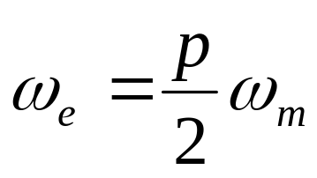 (1)
where ω_{m} is the mechanical speed and ω_{e} is the electrical speed (frequency), both in rad/sec, and p is the number of poles on the rotor.

Equation (1) reflects that the electrical quantities (voltage and current) go through 1 rotation (cycle) for every 1 magnetic rotation.

If p=2, then there is 1 magnetic rotation for every 1 mechanical rotation. In this case, the stator windings see 1 flux cycle as the rotor turns once. But if p=4, then there are 2 magnetic rotations for every mechanical rotation. In this case, the stator windings see 2 flux cycles as the rotor turns once. Figure 1 illustrates a 2 and a 4 pole machine (salient pole construction).

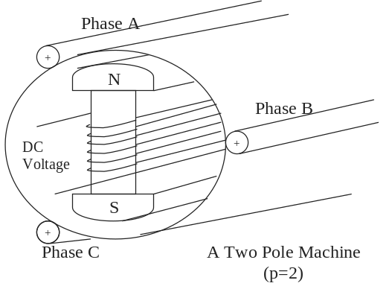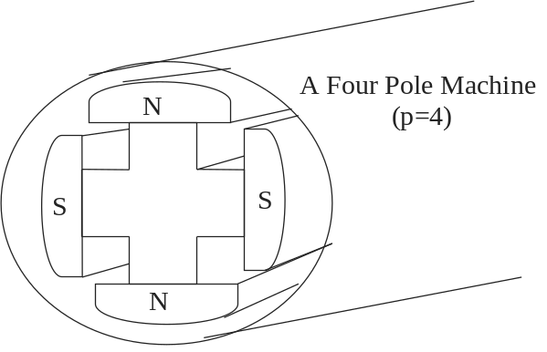
Fig. 1

The point of the above discussion is that to maintain synchronized “electrical speed” among all generators, each machine must maintain a constant mechanical speed as well. That is….
- All 2-pole machines must maintain ω_{m}=377 rad/sec
- All 4-pole machines must maintain ω_{m}=188.5 rad/sec
- Etc.

So we are concerned with any conditions that will cause a change in rotational velocity.

Question: What is “change in rotational velocity”?

Answer: Acceleration (or deceleration).

Question: What kind of conditions cause change in rotational velocity (acceleration)?

To answer this question, we must look at the mechanical system to see what kind of “forces” there are on it.

Recall that with linear motion, acceleration occurs as a result of a body experiencing a “net” force that is non-zero. That is,
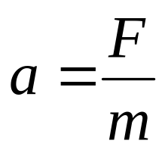 (2)
where F is the net force acting on the body of mass m, and a is the resulting acceleration. It is important to realize that F represents the sum of all forces acting on the body. This is Newton’s second law of motion (first law is any body will remain at rest or in uniform motion, i.e., no acceleration, unless acted upon by a net non-zero force).
The situation is the same with rotational motion, except that here, we speak of torque and inertias instead of forces and masses. Specifically,
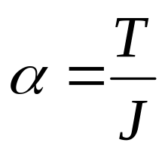 (3)
where T represents the “net” torque acting on the body, J is the moment of inertia of the body (the rotational masses) in kg-m². Again, it is important to realize that T represents the sum of all torques acting on the body.

Let’s consider that the rotational body is a shaft connecting a turbine with a generator, as shown in Fig. 2.
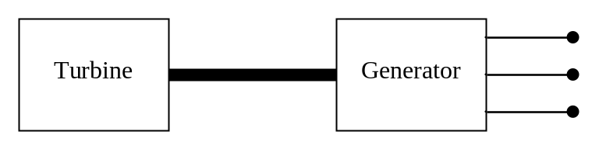
Fig. 2a
Assumptions:
- The shaft is rigid (inelastic).
- There are no frictional torques.

What are the torques on the shaft?
- The turbine exerts a torque in one direction which causes the shaft to revolve. This torque is mechanical. Call this torque T_{m}.
- The generator exerts a torque in the opposite direction which retards this motion. This torque is electromagnetic acting on the field windings that are located on the rotor. Call this torque T_{e}.
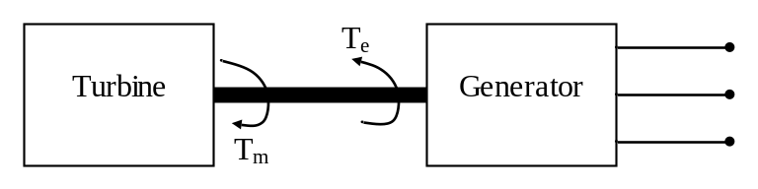
Fig. 2b
So these two torques are in opposite directions. If they are exactly equal, then Newton’s first law tells us that this system is not accelerating. This is the case when the machine is in synchronism, i.e.,
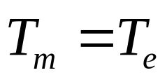 (4)
Let’s define the accelerating (or net) torque as:
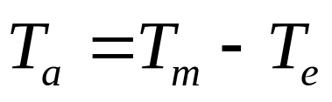 (5)
Note that T_{a}≠0 when T_{m}≠T_{e}.

Given that the machine is initially operating in synchronism (T_{m}=T_{e}), what kinds of changes can occur to cause T_{a}≠0?
There are basically two types of changes that can cause T_{a}≠0.
- Changes in T_{m}.
  - Intentionally through steam valve, with T_{m} either increasing or decreasing and generator either accelerating or decelerating, respectively.
  - Disruption to steam flow, typically a decrease in T_{m}, with generator decelerating.
- Changes in T_{e}.
  - Increase in load or decrease in generation of other units; in either case, T_{e} increases, and the generator decelerates.
  - Decrease in load or increase in generation of other units; in either case, T_{e} decreases, and the generator accelerates.

But all of the above changes are typically slow. Therefore the turbine-governor, together with the automatic generation control (AGC) loop (will study AGC later in this course), can re-adjust as necessary to bring the speed back.
But there is one more type of change that should be listed under #2 above.
- Faults. This causes T_{e} to decrease. We will see why in the next section.

2.0 Effect of faults

Recall, from EE 303, the following circuit diagram representing a synchronous generator.
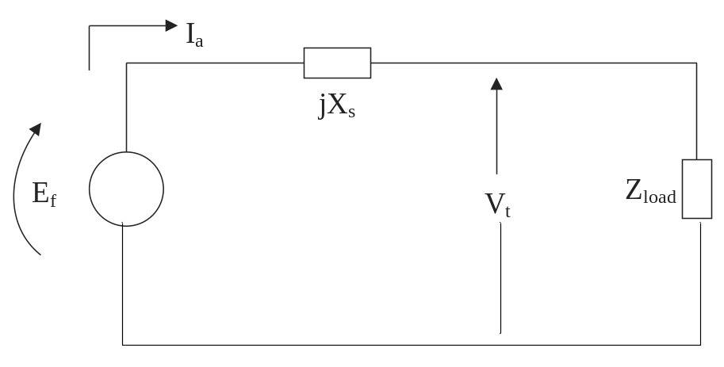
Fig. 3
You may also recall that the power output of the synchronous generator is given by
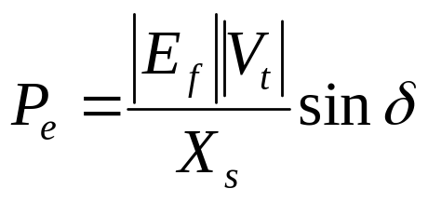 (6)
where δ is the angle by which the internal voltage E_{f} leads the terminal voltage V_{t}.

Now consider a three-phase fault at the generator terminals. Then, |V_{t}|=0. According to (6), if |V_{t}|=0, then P_{e}=0.

Now the electrical torque is related to the electrical power through
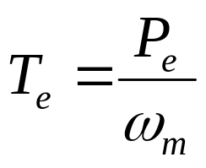 (7)
Therefore, when P_{e}=0, T_{e}=0. By (5), then, this causes
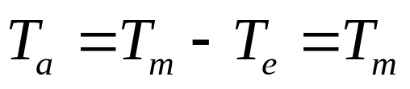 (8)
In other words, when a three-phase fault occurs at the terminals of a synchronous generator, none of the mechanical torque applied to the generator (through the turbine blades) is offset by electromechanical torque.
This means that ALL of the mechanical torque is used in accelerating the machine. Such a condition, if allowed to exist for more than a few cycles, would result in very high rotational turbine speed and catastrophic failure.
So this condition must be eliminated as fast as possible, and this is an additional reason (besides effect of high currents) why protective systems are designed to operate fast.

Of course, most faults are not so severe as a three-phase fault at a generator’s terminals. Nonetheless, we know from our previous work in fault analysis that faults cause network voltages to decline, which result in an instantaneous decrease in the electrical power out of the generator, and an initial acceleration of the machine. The questions are:
- How much of a decrease in electrical power occurs and
- How much time passes before the faulted condition is cleared.

This discussion leads us to study the relationship between the mechanical dynamics of a synchronous machine and the electric network.

3.0 Analytical development

The relationship between the mechanical dynamics of a synchronous machine and the electric network begins with (3)
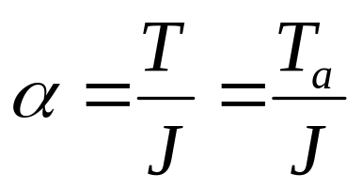 (3)
where T is the net torque acting on the turbine-generator shaft, which is the same as what we have called the accelerating torque T_{a}.

Let’s define the angle θ as the absolute angle between a reference axis (i.e., fixed point on stator) and the center line of the rotor north pole (direct rotor axis), as illustrated in Fig. 4. (Ignore the angle α in this picture). It is given by
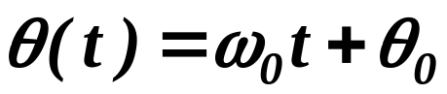 (9a)
Here, ω₀ is the shaft rated mechanical angular velocity, in rad/sec, and θ₀ is the initial angle (at t=0). When we account for deviations of the rotor position due to changes in speed, we get
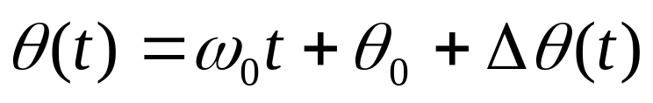 (9b)
where Δθ(t) is the deviation of the rotor position due to changes in speed. This is (14.1) in your text.
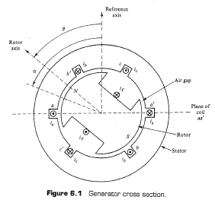
Fig. 4

The angle θ clearly describes the position of the rotor. If the rotor is moving, then ω=dθ/dt≠0. If the rotor is accelerating, then α=d²θ/dt²≠0. Using the “dot” notation for differentiation, we can write this expression for acceleration as
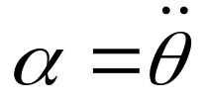 (10)
But by eq. (3), we have that:
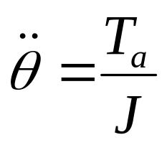 (11)
In the appendix of these notes, I derive (A-15) which shows that the internal voltage of a synchronous machine is given by
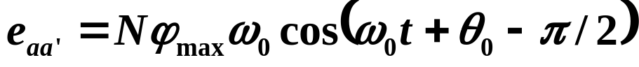 (A-15)
This is also derived in Section 6.3 of your text, resulting in (6.6) of your text:
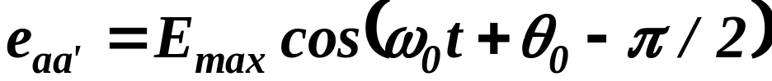 (6.6)
which is the same as (A-15), where
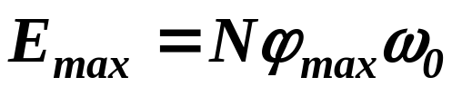
When we account for deviations in the rotor position due to changes in speed, then (A-15) becomes
Here, we will define the phase angle of the internal voltage of a synchronous machine as δ(t), given by
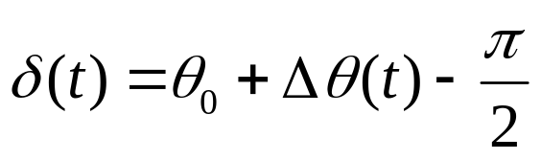 (12)
Comparing (12) to (9b), we see that if we subtract off ω₀t-π/2 from (9b), that we get
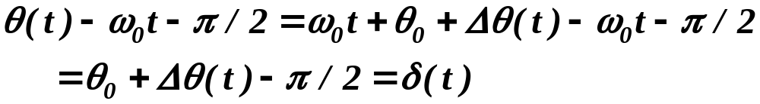 (13)
What this says is that whereas θ(t) is an absolute angle, δ(t) is a relative angle, where the reference frame to which it is relative is a frame rotating at synchronous speed ω₀.

From (9b), we have that
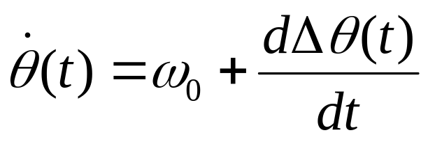 (14)
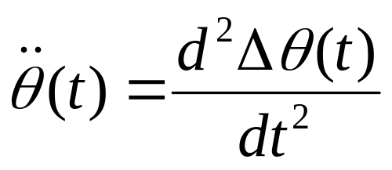 (15)
From (12), we have
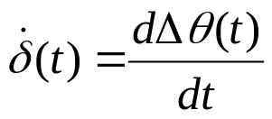 (16)
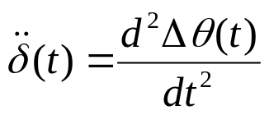 (17)
From (15) and (17), we have that
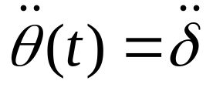 (18)
Substitution of (18) into (11) results in
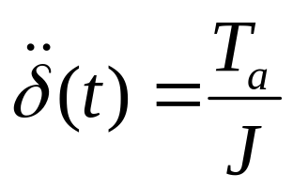 (19)
or, multiplying by J, we obtain:
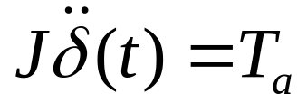 (20)
Recall that torque and power are related via
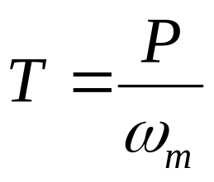 (21)
Therefore we can write (20) in terms of power as
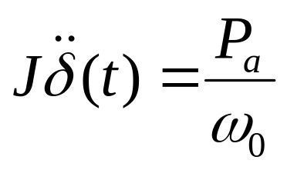 (22)
Recall here that ω₀ is the rated mechanical speed of the machine.

Multiply both sides by ω₀, we get
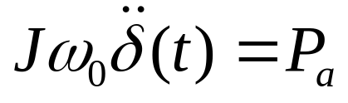 (23)
The angular momentum of the machine at rated speed is:
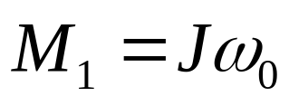 (24)
Substitution of (24) into (23) results in
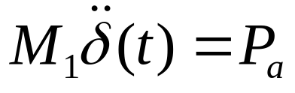 (25)
Let’s per-unitize by the machine MVA base.
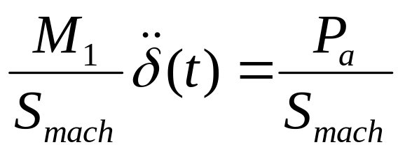 (26)
Notice that the right hand-side is the accelerating power in per-unit. Therefore:
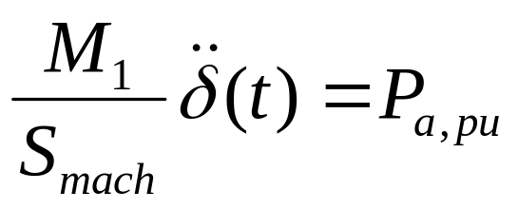 (27)
Now multiply and divide the left-hand-side by 2/ω₀ to get:
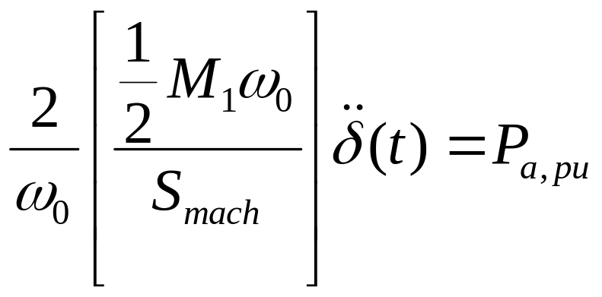 (28)
We define what is in the brackets as H.
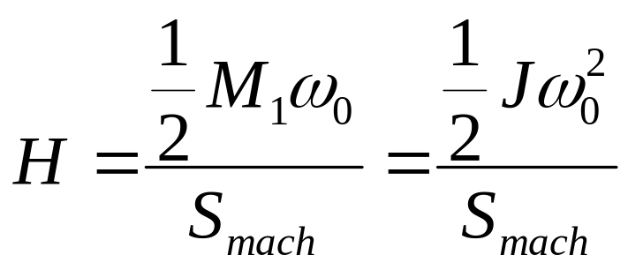 (29)
What is in the numerator on the right-hand-side?
It is the stored kinetic energy when the machine is rotating at synchronous speed ω₀. If J is given in units of 1E6 kg-m², then the numerator on the right-hand-side of (29) has units of MWsec, i.e.,
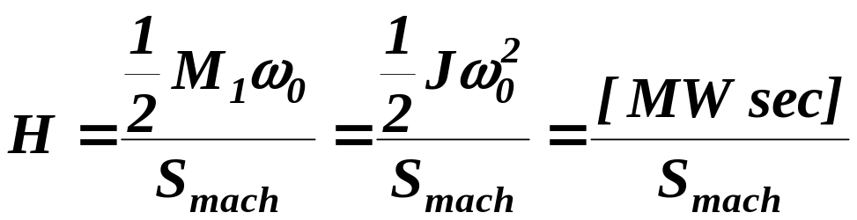 (30)
where [MWsec] denotes a machine parameter called “the MWsec of the machine” in units of MWsec (called W_{kenetic} in your text).
Some comments about H:
- Some transient stability programs require input of the MW-sec of each machine, but some also require input of the H for each machine.
- If a program requires H, you need to make sure that you provide it on the proper MVA base.
  - Equation (30) expresses H on the machine MVA base. When expressed on the machine MVA base, H tends to be between 1 and 10 with low end for synchronous condensers (no turbine!), high-end for steam generators (high ω₀➔very fast), and middle range for hydro generators (low ω₀➔very slow).
  - H may also be given on any other base, e.g., 100 MVA. In this case,
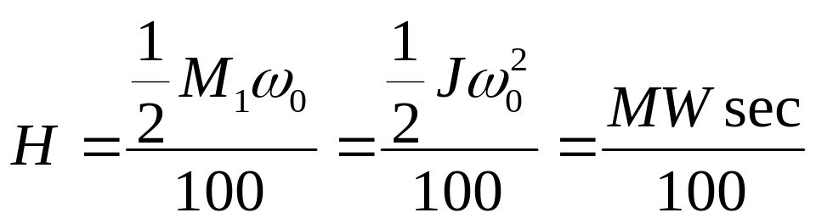(31)
When performing transient stability studies for multi-machine systems, you have to represent H on the system MVA base, and in this case, it is typical to use 100 as the base.
  - To convert H from one base to another,
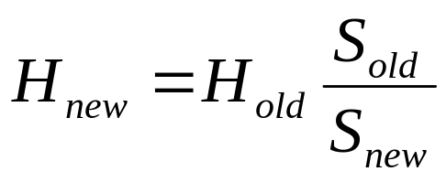 (32)
The table below provides some typical values of H on different bases.
Unit | S_{rated} (MVA) | MWsec | H_{mach}=MWsec/S_{rated} | H_{sys}=MWsec/100
H1 | 9 | 23.5 | 2.61 | 0.235
H9 | 86 | 233 | 2.71 | 2.38
H18 | 615 | 3166 | 5.15 | 31.7
F1 | 25 | 125.4 | 5.02 | 1.25
F11 | 270 | 1115 | 4.13 | 11.15
F21 | 911 | 2265 | 2.49 | 22.65
CF1-HP | 128 | 305 | 2.38 | 3.05
CF1-LP | 128 | 787 | 6.15 | 7.87
N1 | 76.8 | 281.7 | 3.67 | 2.82
N8 | 1340 | 4698 | 3.51 | 47.0
SC1 | 25 | 30 | 1.2 | 0.3
SC2 | 75 | 89.98 | 1.2 | 0.9

Note finally that from
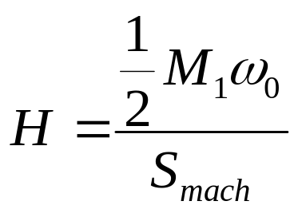
we can write
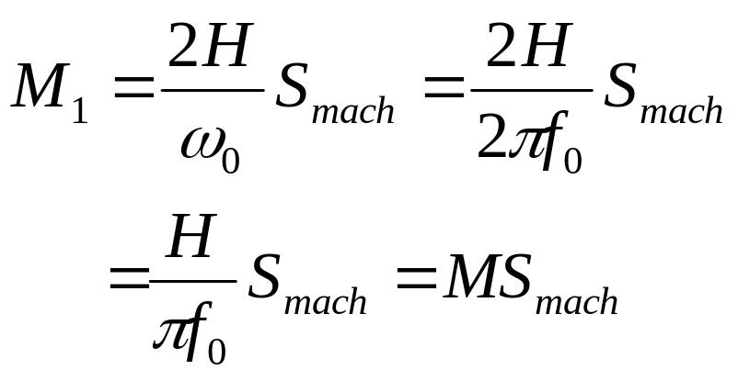 (33)
where M is a parameter used in your book (see pg. 534), and defined as
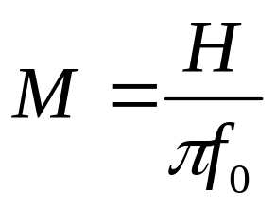 (34)
Last comment about representing machine inertia is that if you order a new machine from GE, then you will most likely obtain the machine inertia as WR², which is
[weight of rotating parts][radius of gyration]²
in units of lb(m)*ft². Conversion is:
MWsec=2.31E-10(WR²)(n_{R})²
where n_{R} is the rated speed of rotation of the machine in units of rev per minute.

Substituting H into eqt. (28), we obtain:
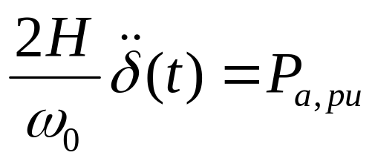 (35)
Equation (35) is given for a two-pole machine where angular measure is the same as electrical measure.
But if we want to use eq. (35) for machines that have more than 2 poles, then we need to convert from mechanical measure to electrical measure according to:
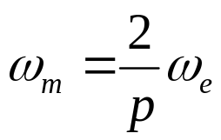 (36)
Likewise,
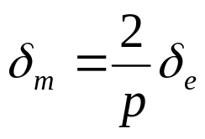 (37)
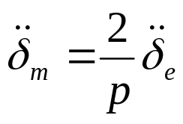 (38)
We prefer to work in electrical angular measure, because it is easier then to compare angular measures from one machine to another.

Substitution of (38) into (35) yields:
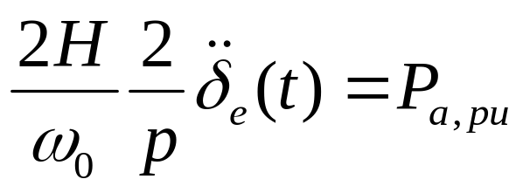 (39)
Then use eq. (36) to substitute for ω₀:
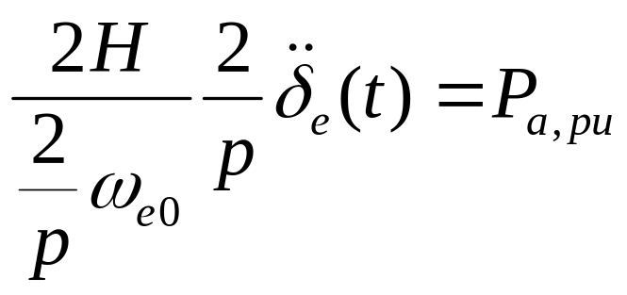 (40)
which simplifies to
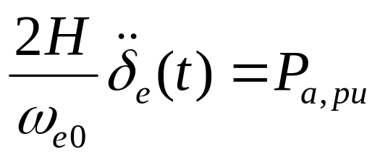 (41)
From now on, we will drop the “e” subscript on the angle, understanding that we are always working in electrical angles. But we will retain it on ω_{eo} to distinguish from ω₀ (the mechanical rated speed of rotation). This results in:
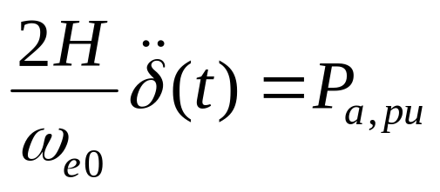 (42)
Let’s compare eq. (42) to (14.19) in your text.
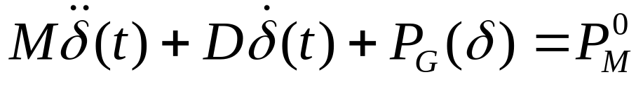 (14.19)
From eq. (34), M=H/πf₀=2H/ω_{e0}, and so we see that the first terms are the same, and eq. (42) may be expressed as
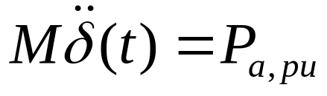 (43)
The accelerating power P_{a,pu} on the right-hand-side of eq. (43) is just
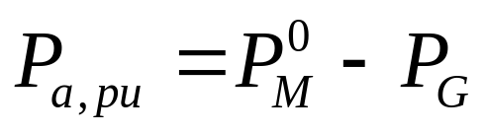 (44)
and so eq. (43) may be expressed as
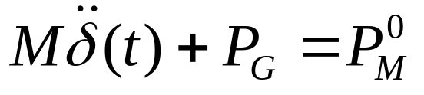 (45)
Now we can see that eq. (45) and (14.19) are almost exactly the same, with the only significant difference being the term 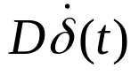. This term is one that we did not include in our development and captures the effect of windage and friction, which is proportional to speed.
One question is how to express P_{G}. This is the pu electrical power out of the generator.

Your textbook provides eq. (14.7), which is
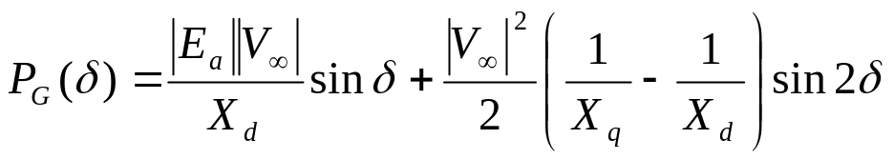 (14.7)
The first term in this equation is familiar from EE 303, but the second term is not. The second term is actually a term that is necessary when the reactance associated with flux path along the main rotor axis (the d-axis) differs from that along the perpendicular axis (the q-axis). This is the case for salient pole machines but is not the case for smooth rotor machines. But for salient pole machines, we can use just the first term as a reasonable approximation. Therefore we will represent the power out of the machine as
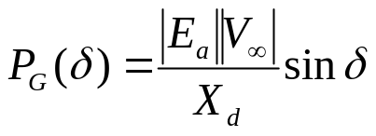 (46)
Therefore, our eq. (45) becomes:
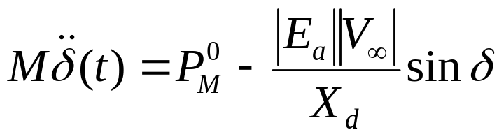
Appendix
- Analytical model: open circuit voltage

We will develop an analytical model for the open circuit voltage of a synchronous generator. We begin with Fig. A-1 (Fig. 6.1 from text).
Fig. A-1
In this figure, note the following definitions:
- θ: the absolute angle between a reference axis (i.e., fixed point on stator) and the center line of the rotor north pole (direct rotor axis).
- α: the angle made between the reference axis and some point of interest along the air gap circumference.
Thus we see that, for any pair of angles θ and α, α-θ gives the angular difference between the centerline of the rotor north pole and the point of interest.

We are using two angular measurements in this way in order to address
- variation with time as the rotor moves; we will do this using θ (which gives the rotational position of the centerline of the rotor north pole)
- variation with space for a given θ; we will do this using α (which gives the rotational position of any point on the stator with respect to θ)
We want to describe the flux density, B, in the air gap, due to field current i_{F} only.

Assume that maximum air gap flux density, which occurs at the pole center line (α=θ), is B_{max}. Assume also that flux density B varies sinusoidally around the air gap (as illustrated in Figs. 9 and 10). Then, for a given θ,
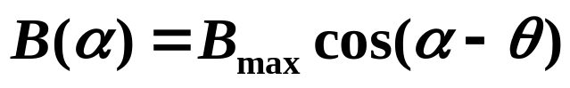 (A-1)
Keep in mind that the flux density expressed by eq. (A-1) represents only the magnetic field from the winding on the rotor.

But, you might say, this is a fictitious situation because the currents in the armature windings will also produce a magnetic field in the air gap, and so we cannot really talk about the magnetic field from the rotor winding alone.

We may deal with this issue in an effective and forceful way: assume, for the moment, that the phase A, B, and C armature windings are open, i.e., not connected to the grid or to anything else. Then, currents through them must be zero, and if currents through them are zero, they cannot produce a magnetic field.

So we assume that i_{a}=i_{b}=i_{c}=0.

So what does this leave us to investigate? Even though currents in the phases are zero, voltages are induced in them. So it is these voltages that we want to describe. These voltages are called the open circuit voltages.

Consider obtaining the voltage induced in just one wire-turn of the a-phase armature winding. Such a turn is illustrated in Fig. A-2 (Fig. 6.2 of the text). We have also drawn a half-cylinder having radius equal to the distance of the air-gap from the rotor center.
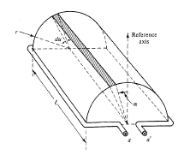
Fig. A-2
Note in Fig. A-2 that the current direction in the coil is assumed to be from the X-terminal (on the right) to the dot-terminal (on the left).

With this current direction, a positive flux direction is established using the right-hand-rule to be upwards. We denote a-phase flux linkages associated with such a directed flux to be λ_{aa’}. Our goal, which is to find the voltage induced in this coil of wire, e_{aa’}, can be achieved using Faraday’s Law, which is:
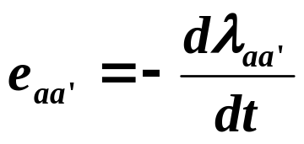 (A-2)
So our job at this point is to express the flux linking the a-phase λ_{aa}, which comes entirely from the magnetic field produced by the rotor, as a function of time.

An aside: The minus sign of eq. (A-2) expresses Lenz’s Law [, pp. 27-28], which states that the direction of the voltage in the coil is such that, assuming the coil is the source (as it is when operating as a generator), and the ends are shorted, it will produce current that will cause a flux opposing the original flux change that produced that voltage. Therefore
- if flux linkage λ_{aa’} is increasing (originally positive, meaning upwards through the coil a-a’, and then becoming larger),
- then the current produced by the induced voltage needs to be set up to provide flux linkage in the downward direction of the coil,
- this means the current needs to flow from the terminal a to the terminal a’
- to make this happen across a shorted terminal, the coil would need to be positive at the a’ terminal and negative at the a terminal, as shown in Fig. A-3.

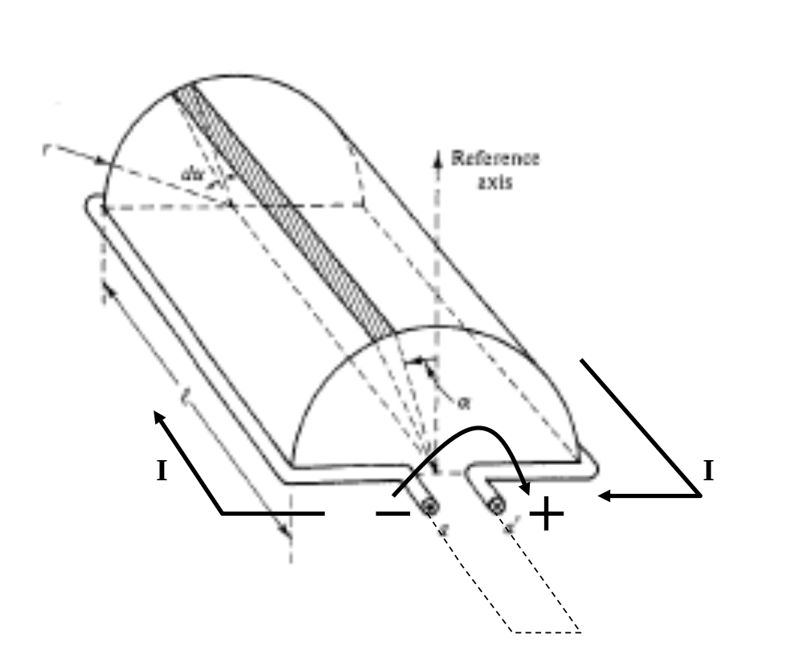
Fig. A-3
To compute the flux linking with the coil of wire a-a’, we begin by considering the flux passing through the small slice of the cylinder, dα. The amount of flux through this slice, denoted by dφ_{aa’}, will be the flux density at the slice, as given by eq. (A-1), multiplied by the area of that slice, which is (length) × (width) = (l) × (r dα), that is:
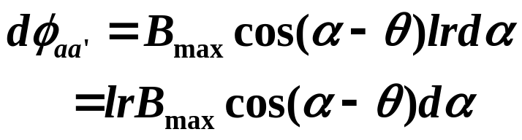 (A-3)
We can now integrate eq. (A-3) about the half-cylinder to obtain the flux passing through it (integrating about a full cylinder will give 0, since we would then pick up flux entering and exiting the cylinder).
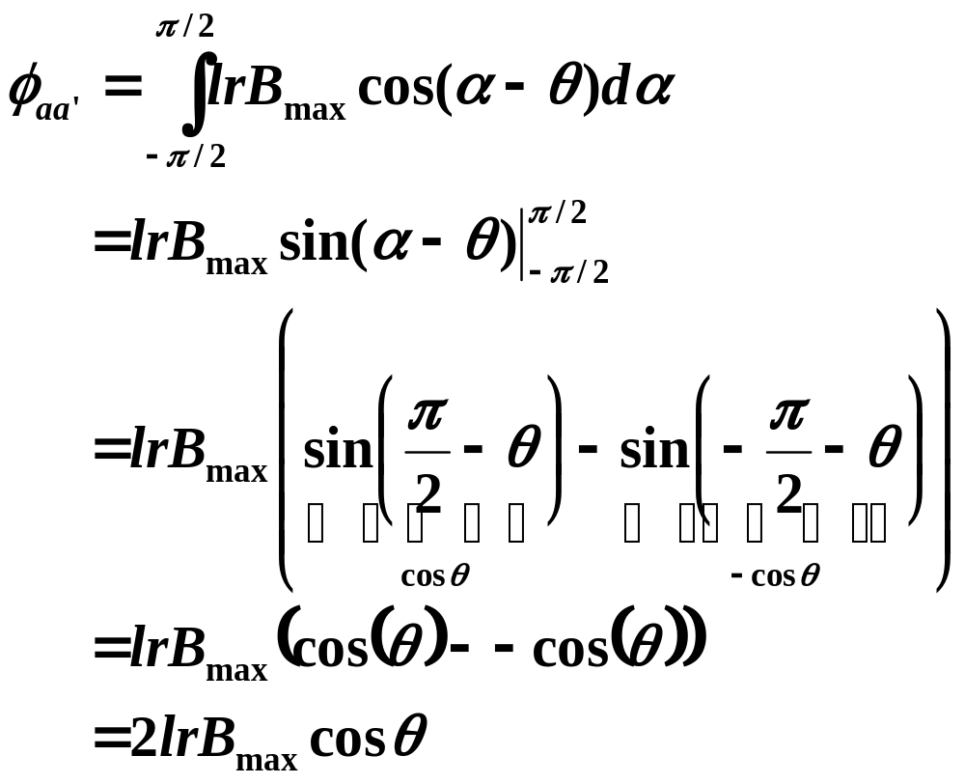(A-4)
Define φ_{max}=2lrB_{max}, and we get
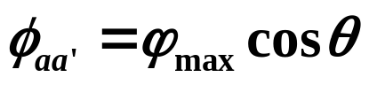 (A-5)
which is the same as eq. (6.2) in the text.

Equation (A-5) indicates that the flux passing through the coil of wire a-a’ depends only on θ. That is,
- given the coil of wire is fixed on the stator, and
- given that we know the flux density occurring in the air gap as a result of the rotor winding,
- we can determine how much of the flux is actually linking with the coil of wire by simply knowing the rotational position of the centerline of the rotor north pole (θ).

But eq. (A-5) gives us flux, and we need flux linkage. We can get that by just multiplying flux φ_{aa’} by the number of coils of wire N. In the particular case at hand, N=1, but in general, N will be something much higher. Then we obtain:
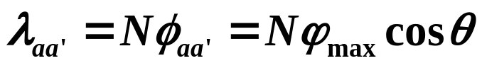 (A-6)
Now we need to understand clearly what θ is. It is the centerline of the rotor north pole, BUT, the rotor north pole is rotating!

Let’s assume that when the rotor started rotating, it was at θ=θ₀, and it is moving at a rotational speed of ω₀, then
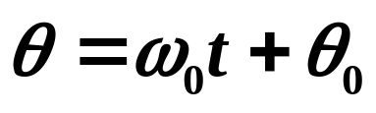 (A-7)
Substitution of eq. (A-7) into eq. (A-8) yields:
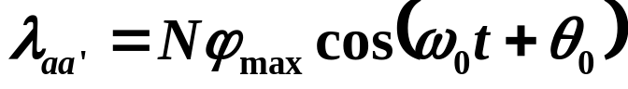 (A-8)
Now, from eq. (A-2), we have
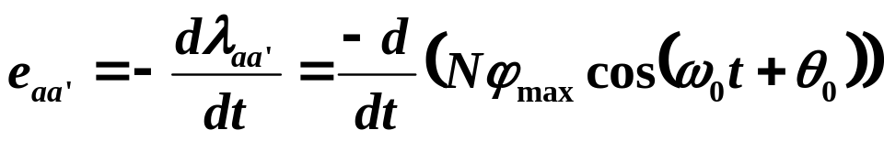 (A-9)
We get a –sin from differentiating the cos, and thus we get two negatives, resulting in:
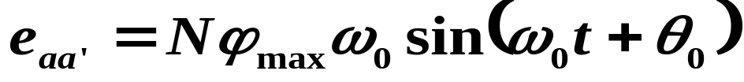 (A-10)
Define
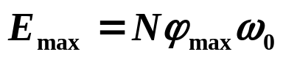 (A-11)
Then
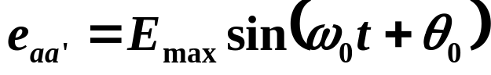 (A-12)
We can also define the RMS value of e_{aa’} as
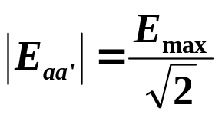 (A-13)
which is the magnitude of the generator internal voltage.

We have seen internal voltage before, in EE 303, where we denoted it as |E_{f}|. In EE 303, we found it in the circuit model we used to analyze synchronous machines, which appeared as in Fig. A-4.

Note that internal voltage is the same as terminal voltage on the condition that I_{a}=0, i.e., when the terminals are open-circuited. This is the reason why internal voltage is also referred to as open-circuit voltage.
Fig. A-4
We learned in EE 303 that internal voltage magnitude is proportional to the field current i_{f}. This makes sense here, since by eqs. (A-11) and (A-13), we see that
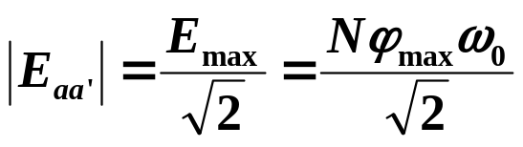 (A-14)
and with N and ω₀ being machine design parameters (and not parameters that can be adjusted once the machine is built), the only parameter affecting internal voltage is φ_{max}, which is entirely controlled by the current in the field winding, i_{f}.

One last point here: it is useful at times to have an understanding of the phase relationship between the internal voltage and the flux linkages that produced it. Recall eqs. (A-8) and (A-10):
(A-8)
(A-10)
Using sin(x)=cos(x-π/2), we write (A-10) as:
(A-15)
Comparing eqs. (A-8) and (A-15), we see that the internal voltage lags the flux linkages that produced it by π/2=90° (1/4 turn).

This is illustrated by Fig. A-5 (same as Fig. E6.1 of Example 6.1). In Fig. A-5, the flux linkage phasor is in phase with the direct axis of the rotor.
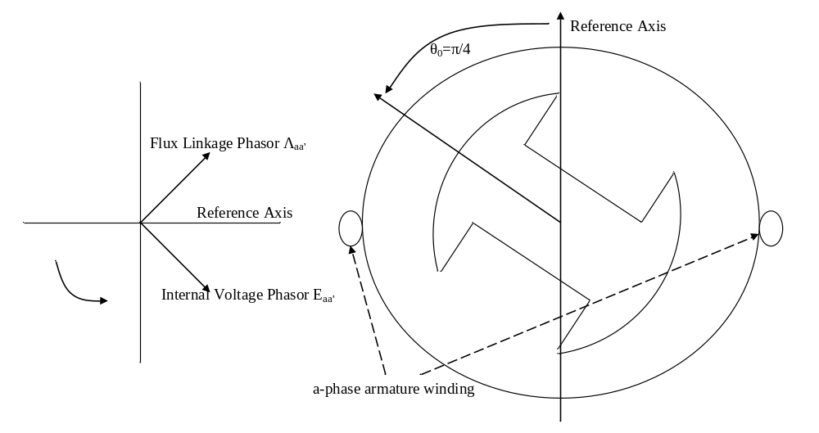
Fig. A-5
Therefore, the flux linkages phasor is represented by
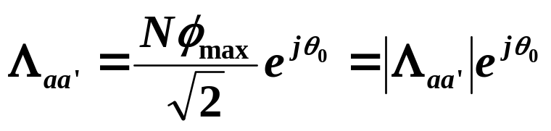 (A-16)
and then the internal voltage phasor will be
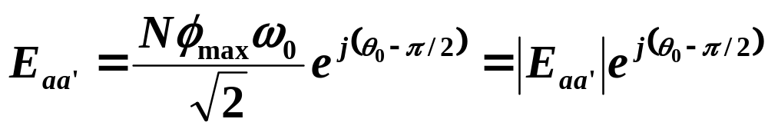 (A-17)
Let’s drop the a’ subscript notation from E_{aa’}, just leaving E_{a}, so that:
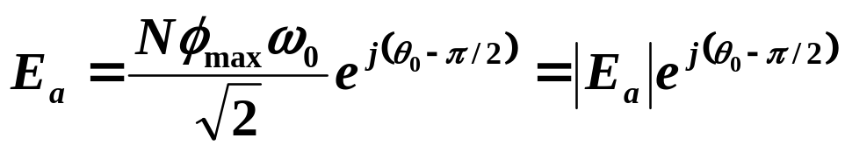 (A-18)
Likewise, we will get similar expressions for the b- and c-phase internal voltages, according to:
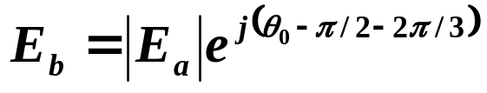 (A-19)
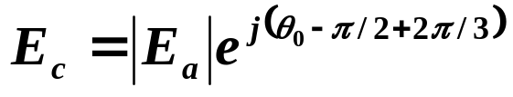 (A-20)

[?] S. Chapman, “Electric Machinery Fundamentals,” 1985, McGraw-Hill.

