AGC 1 (Chapter 11)
1.0 Introduction
We have seen in the last set of notes (on stability) that synchronous generators respond to load-generation imbalances by accelerating or decelerating (changing speeds). For example, when load increases, generation slows down, effectively releasing some of its inertial energy to compensate for the load increase. Likewise, when load decreases, generation speeds up, effectively absorbing the oversupply as increased inertial energy.

Because load is constantly changing, an unregulated synchronous generator has highly variable speed which results in highly variable system frequency, an unacceptable situation because:
- NERC penalties for poor-performance (CPS)
- Load performance can be frequency-dependent
  - Motor speed (without a speed-drive)
  - Electric clocks
- Steam-turbine blades may lose life or fail under frequencies that vary from design levels.
- Some relays are frequency-dependent:
  - Underfrequency load shedding relays
  - Volts per hertz relays
- Frequency dip may increase for given loss of generation
The fact that frequency changes with the load-generation imbalance gives a good way to regulate the imbalance: use frequency (or frequency deviation) as a regulation signal.

A given power system will have many generators, so we must balance load with total generation by appropriately regulating each generator in response to frequency changes.

As a result of how power systems evolved, the load-frequency control problem is even more complex. Initially, there were many isolated interconnections, each one having the problem of balancing its load with its generation. Gradually, in order to enhance reliability, isolated systems interconnected to assist one another in emergency situations (when one area had insufficient generation, another area could provide assistance by increasing generation to send power to the needy area via tie lines).

For many years, each area was called a control area, and you will still find this term used quite a lot in the industry. The correct terminology now, however, is balancing authority area, which is formally defined by the North American Electric Reliability Council (NERC) as []:
Balancing authority area: The collection of generation, transmission, and loads within the metered boundaries of the Balancing Authority. The Balancing Authority maintains load-resource balance within this area.

This definition requires another one [Error: Reference source not found]:
Balancing authority: The responsible entity that integrates resource plans ahead of time, maintains load-interchange-generation balance within a Balancing Authority Area, and supports Interconnection frequency in real time.

The interconnection of different balancing authority area creates the following complexity:
Given a steady-state frequency deviation (seen throughout an interconnection) and therefore a load-generation imbalance, how does an area know whether the imbalance is caused by its own area load or that of another area load?

Each balancing authority will have its own AGC. The basic functions of AGC are identified in Fig. 1a below.
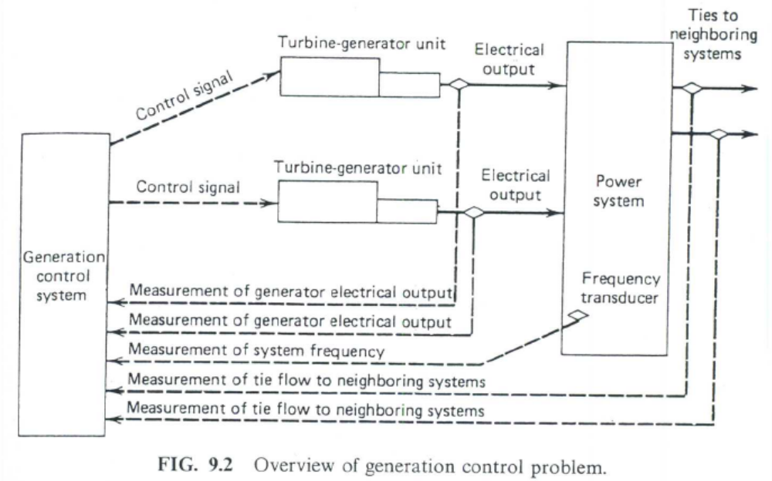
Fig. 1a

Figure 1a should also provide a “local” loop feeding back a turbine speed signal to the inputs of the generators. An alternative illustration showing this “local” loop is given in Fig. 1b.

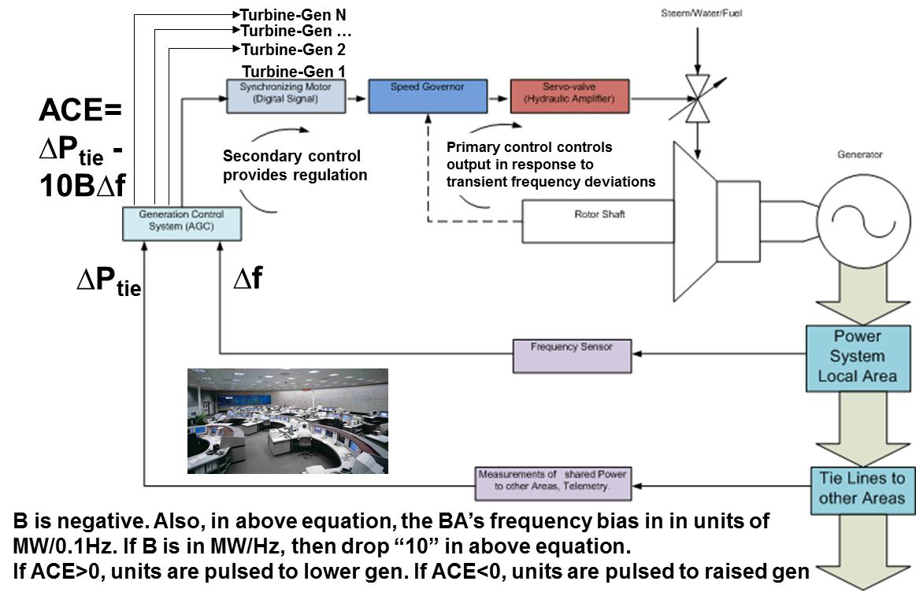
Fig. 1b
2.0 Historical View
The problem of measuring frequency and net tie deviation, and then redispatching generation to make appropriate corrections in frequency and net deviation was solved many years ago by engineers at General Electric Company, led by a man named Nathan Cohn. Their solution, which in its basic form is still in place today, is referred to as Automatic Generation Control, or AGC. We will study their solution in this section of the course. Dr. Cohn wrote an excellent book on the subject [].

3.0 Overview
There are two main functions of AGC:
- Load-frequency control (LFC). LFC must balance the load via two actions:
  - Maintain system frequency
  - Maintain scheduled exports (tie line flows)
- Provide signals to generators for two reasons:
  - Economic dispatch via the real-time market
  - Security control via contingency analysis
Below, Fig. 1c, illustrates these functions.
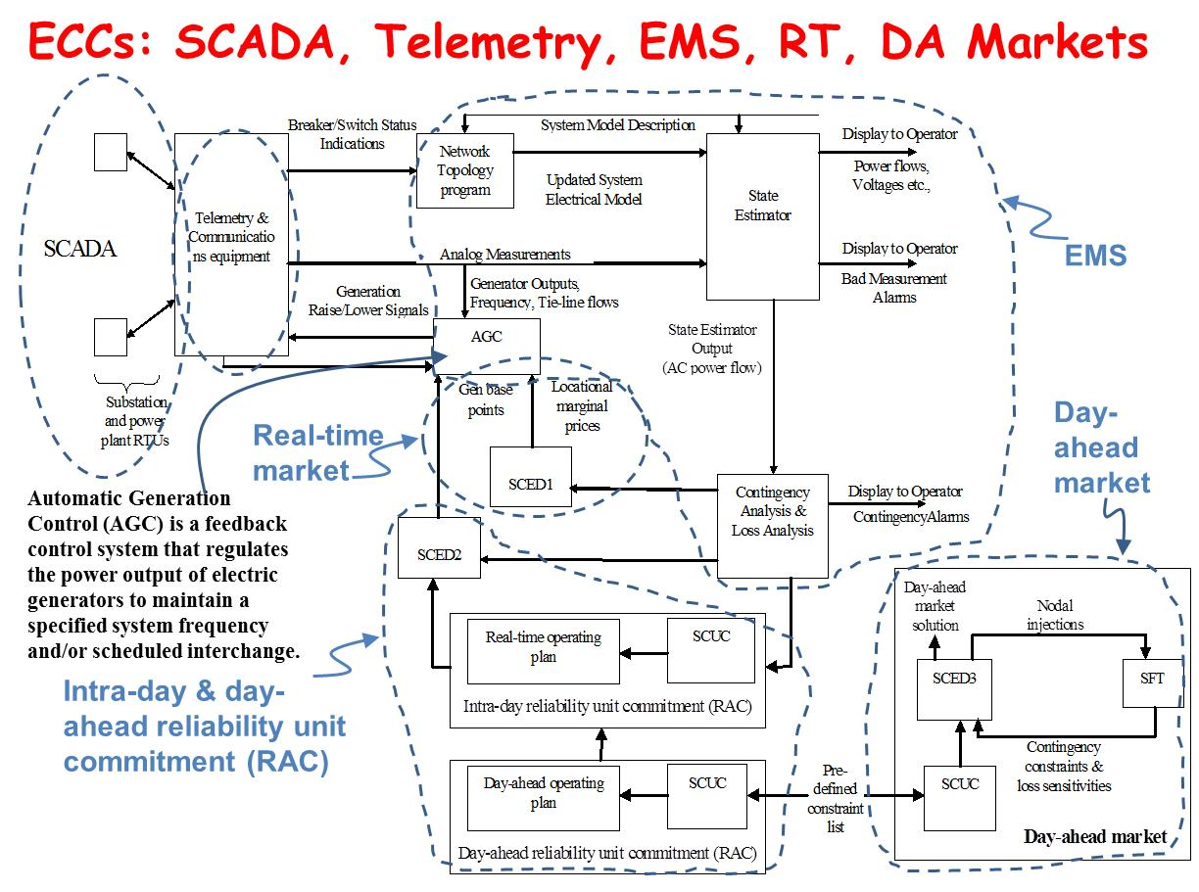
Fig. 1c
As its name implies, AGC is a control function. There are two main levels of control:
- Primary control
- Secondary control
We will study each of these in what follows.

To provide you with some intuition in regards to the main difference between these two control levels, consider a power system that suddenly loses a large generation facility. The post-contingency system response, in terms of frequency measured at various buses in the power system, is shown in Figs. 2b and 2c. This is understood in the context of Figs 2a and 2d.
T, Electromagnetic torque
T_{m}, Mechanical torque (from turbine)
Mechanical energy
Electrical
energy
Fig. 2a
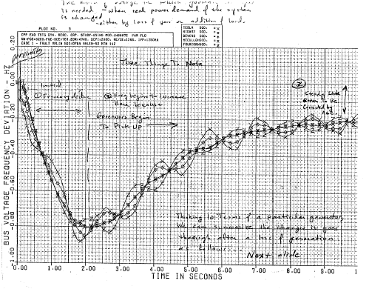
Fig. 2b: transient time frame
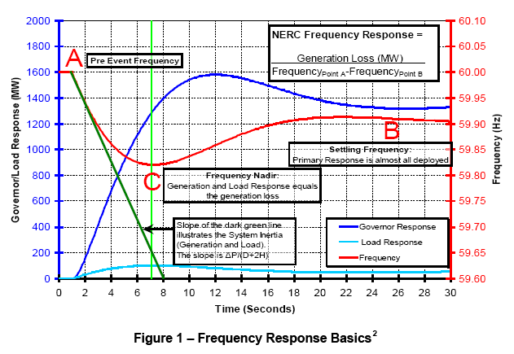
Fig. 2c: transient time frame
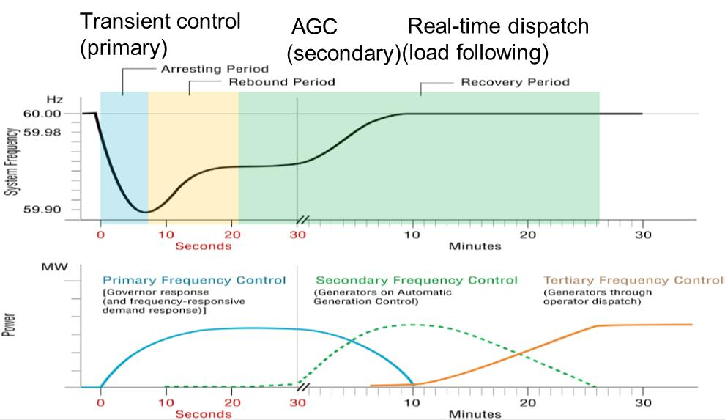
Fig. 2d: Transient & post-transient time frames
Question: Why is it important to maintain frequency?
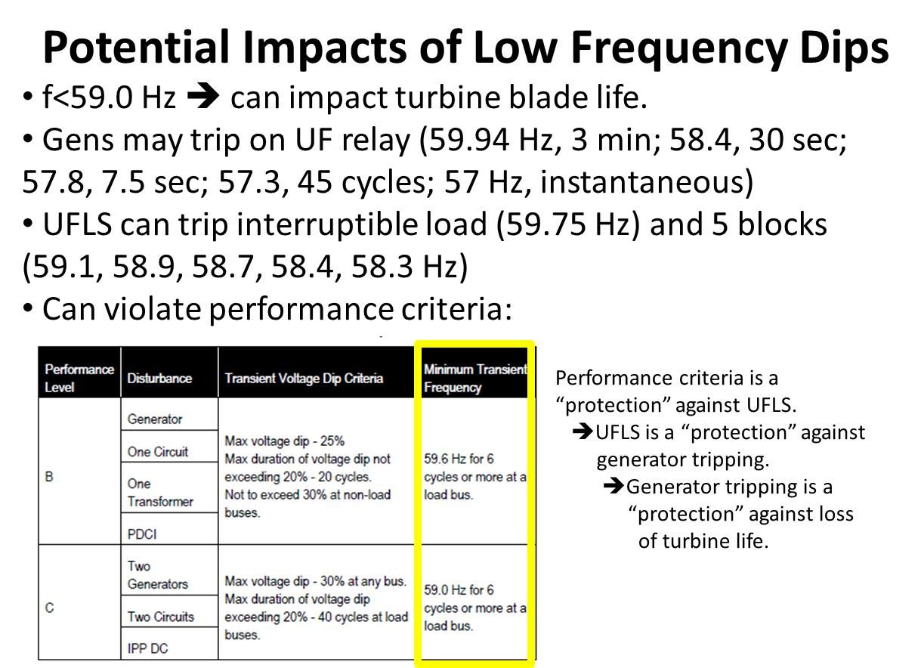

Question: What is the frequency response trend today?
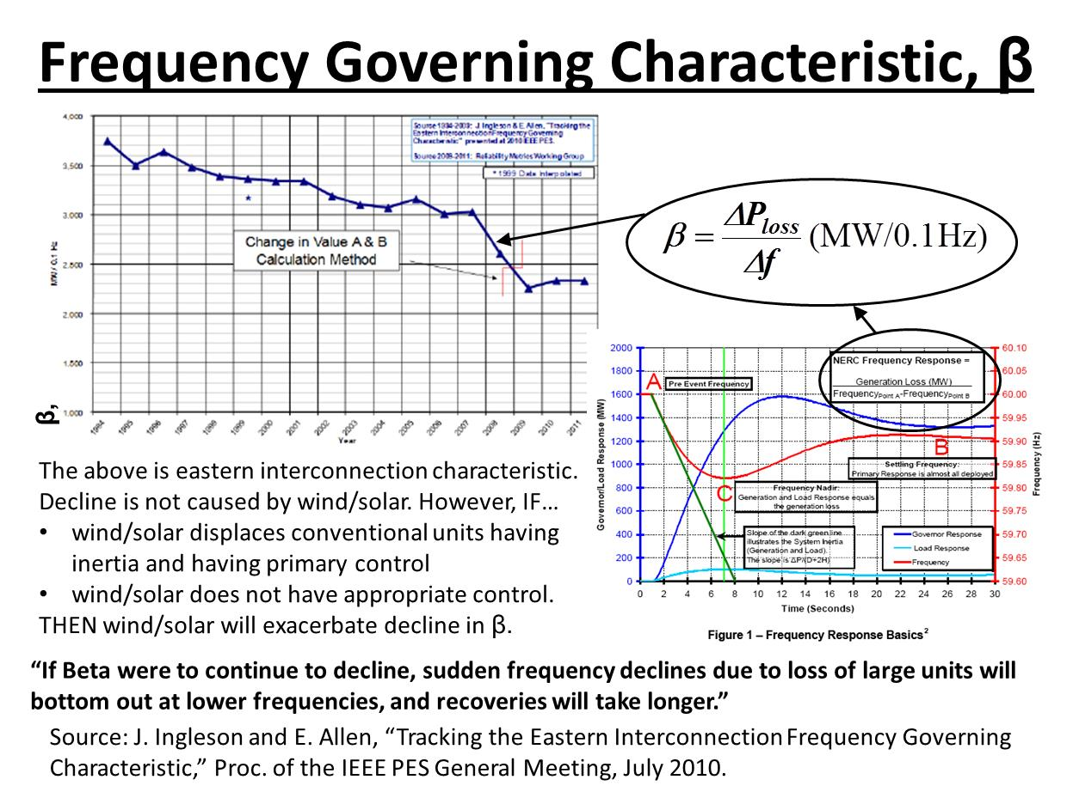

4.0 Interchange

To address the load frequency control issue, it is necessary to provide some definitions [Error: Reference source not found]:
Net actual interchange: The algebraic sum of all metered interchange over all interconnections between two physically Adjacent Balancing Authority Areas.
Net scheduled interchange: The algebraic sum of all Interchange Schedules across a given path or between Balancing Authorities for a given period or instant in time.
Interchange schedule: An agreed-upon Interchange Transaction size (MW), start & end time, beginning & ending ramp times & rate, & type required for delivery/receipt of power/ energy between Source & Sink Balancing Authorities involved in the transaction.

We illustrate the notion of net actual interchange and net scheduled interchange in Fig. 1 below.
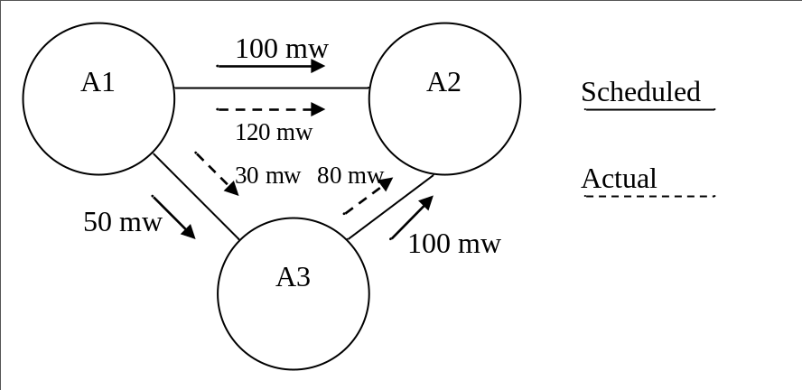
Fig. 1
The net actual interchange between areas:
The word “net” is used with actual and scheduled interchange because there may be more than one interconnection between two areas.
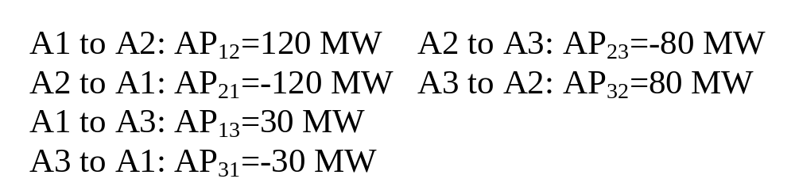
The net scheduled interchange between areas:
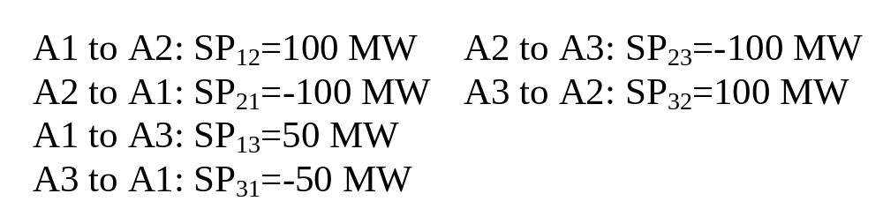
The interchange deviation between two areas is
Net Actual Interchange-Net Scheduled Interchange
This is defined in the text (page 396) as ΔP_{ij}, so:
ΔP_{ij}=AP_{ij}-SP_{ij} (1)
In our example:

Area 1:
ΔP₁₂=AP₁₂-SP₁₂=120-100=20 MW
ΔP₁₃=AP₁₃-SP₁₃=30-50=-20 MW

Area 2:
ΔP₂₁=AP₂₁-SP₂₁=-120-(-100)=-20 MW
ΔP₂₃=AP₂₃-SP₂₃=-80-(-100)=20 MW

Area 3:
ΔP₃₁=AP₃₁-SP₃₁=-30-(-50)=20 MW
ΔP₃₂=AP₃₂-SP₃₂=80-(100)=-20 MW

Some notes:
- The net actual interchange may not be what is scheduled due to loop flow. For example, the balancing authorities may schedule 50 MW from A1 to A3 but only 30 MW flows on the A1-A3 tie line. The other 20 MW flows through A2. This is called “loop flow” or “inadvertent flow.”
- We may also define, for an area i, an “actual export,” a “scheduled export,” and a “net deviation” as:
Actual Export: 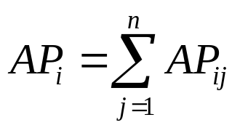 (2)
Scheduled Export: 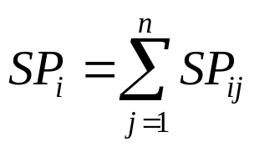 (3)
Net Deviation: 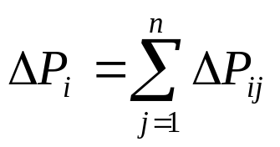 (4)
Observe that
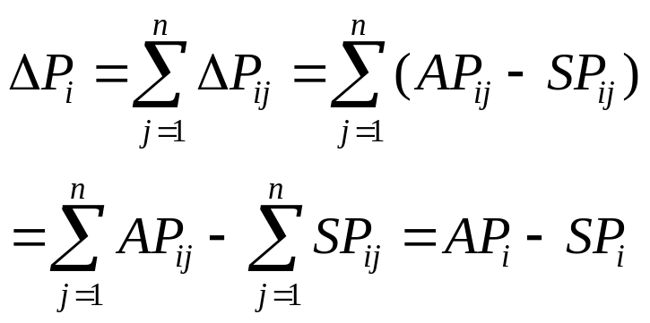 (5)
This says that the net deviation is just the difference between the actual export and the scheduled export.
- Note that net deviation is unaffected by loop flow. What affects net deviation is the continuously varying load. For example, Fig. 2 shows a new set of flows.

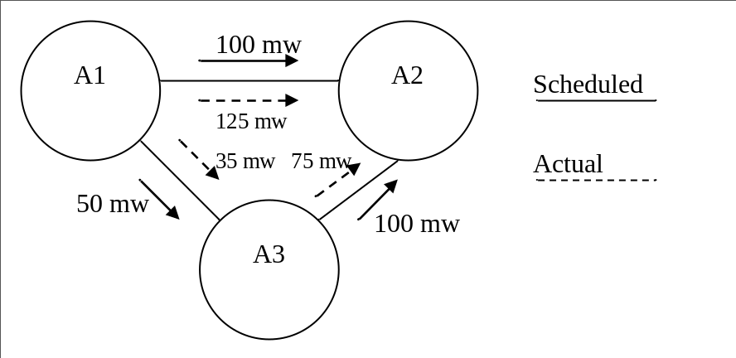
Fig. 2
Here we see that the A1 actual export is 160 MW instead of the scheduled export of 150 MW.

Likewise, the A3 actual export is 40 MW instead of the scheduled 50 MW.

The area A2 actual export is still the same as the scheduled export of -200 MW.

Conclusion: Area A1 has corrected for a load increase in Area A3 when it should not have. So we need to signal Area A1 generators to back down and Area A3 generators to increase.
Overall conclusion: In order to perform load-frequency control in a power system consisting of multiple balancing authorities, we need to measure two things:
- Frequency to determine whether there is a generation/load imbalance in the overall system.
- Net deviation to determine whether the actual exports are the same as the scheduled exports.

5.0 Primary speed control

Primary speed control is “local” to a generator and is also referred to as governor control or as speed control. Since we know that
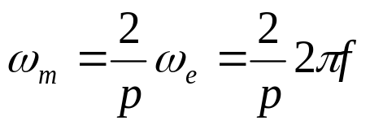 (6)
where ω_{m} is the mechanical speed of the turbine, ω_{e} is the electrical frequency in rad/sec, p is the number of machine poles, and f is the electrical frequency in Hz, we can see that control of speed is equivalent to control of frequency.

Speed governing equipment for steam and hydro turbines are conceptually similar. Most speed governing systems are one of two types; mechanical-hydraulic or Electro-hydraulic. Electro-hydraulic governing equipment use electrical sensing instead of mechanical, and various other functions are implemented using electronic circuitry. Some Electro-hydraulic governing systems also incorporate digital (computer software) control to achieve necessary transient and steady state control requirements. The mechanical-hydraulic design, illustrated in Fig. 4, is used with older generator units. We review this older design here because it provides good intuitive understanding of the primary speed loop operation.

Basic operation of this feedback control for turbines operating under-speed (corresponding to the case of losing generation or adding load) is indicted by movement of each component as shown by the vertical arrows.
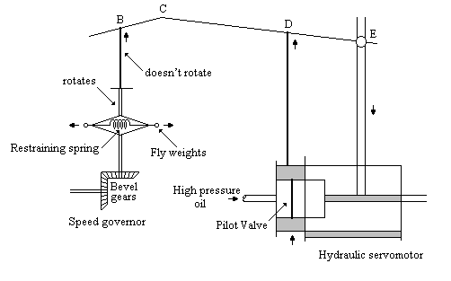
Fig. 4
- As ω_{m} decreases, the bevel gears decrease their rotational speed, and the rotating flyweights pull together due to the change in centripetal force. This causes point B and therefore point C to raise.
- Assuming, initially, that point E is fixed, point D also raises causing high pressure oil to flow into the cylinder through the upper port and release of the oil through the lower port.
- The oil causes the main piston to lower, which opens the steam valve (or water gate in the case of a hydro machine), increasing the energy supply to the machine in order to increase the speed.
- To avoid over-correction, Rod CDE is connected at point E so that when the main piston lowers, and thus point E lowers, Rod CDE also lowers. This causes a reversal of the original action of opening the steam valve. The amount of correction obtained in this action can be adjusted. This action provides for an intentional non-zero steady-state frequency error.

There is really only one input to the diagram of Fig. 4, and that is the speed of the governor, which determines how the point B moves from its original position and therefore also determines the change in the steam-valve opening.

However, we also need to be able to set the input of the steam-valve opening directly, so that we can change the MW output of the generator in order to achieve economic operation. This is achieved by enabling direct control of the position of point C via a servomotor, as illustrated in Fig. 5 (pg 378, Fig. 11.1 in your text). For example, as point A moves down, assuming constant frequency, point B remains fixed and therefore point C moves up. This causes point D to raise (with point E initially fixed), opening the valve to increase the steam flow.
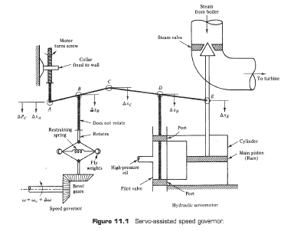
Fig. 5
6.0 A model for small changes
We desire an analytic model that enables us to study the operation of the Fig. 5 controller when it undergoes small changes away from a current state. We will utilize the variables shown in Fig. 5, which include ΔP_{C}, Δx_{A}, Δx_{B}, Δx_{C}, Δx_{D}, Δx_{E}. We provide statements indicating the conceptual basis and then the analytical relation. In each case, we express an “output” or dependent variable as a function of “inputs” or independent variables of a certain portion of the controller.
- Basis: Points A, B, C are on the same rod. Point C is the output. When A is fixed, C moves in same direction as B. When B is fixed, C moves in opposite direction as A.
Relation: 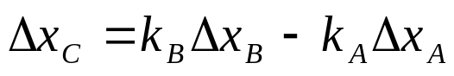 (7)
- Basis: Change in point B depends on the change in frequency Δω.
Relation: 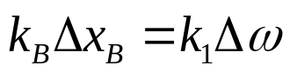 (8)
- Basis: Change in point A depends on the change in set point ΔP_{C}.
Relation: 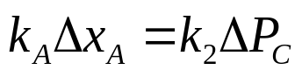 (9)
Substitution of (8) and (9) into (7) result in
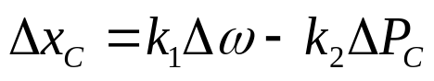 (10a)
- Basis: Points C, D, and E are on the same rod. Point D is the output. When E is fixed, D moves in the same direction as C. When C is fixed, D moves in the same direction as E.
Relation: 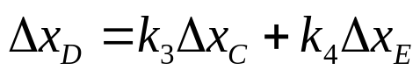 (11a)
- Basis: Time rate of change of oil through the ports determines the time rate of change of E.
Relation: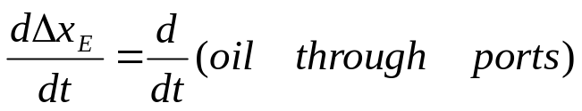 (12)
- Basis: A change in D determines the time rate of change of oil through the ports.
Relation: 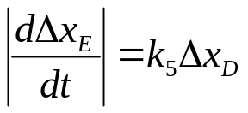 (12)
- Basis: The pilot valve is positioned so that when position D is moved by a positive Δx_{D}, the rate of change of oil through the ports decreases.
Relation: 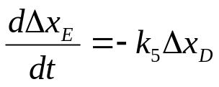 (13a)
(More generally, when position D is moved by a positive Δx_{D}, the rate of change of oil through the ports becomes more negative).

Now we will take the LaPlace transform of eqs. (10a), (11a), and (13a) to obtain:
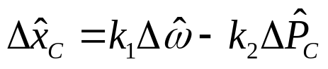 (10b)
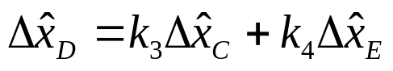 (11b)
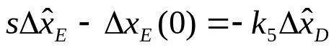 (13b)
where the circumflex above the variables is used to indicate the LaPlace transform of the variables.

Note in eq. (13b) that we have used the LaPlace transform of a derivative which depends on the initial conditions. We will assume that the initial condition, i.e., the initial change, is 0, so that Δx_{E}(t=0)=0. Therefore, eq. (13b) becomes:
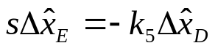 (13c)
and solving for 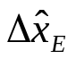results in
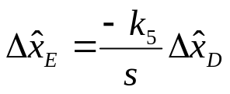 (13d)

Let’s” draw block diagrams for each of the equations (10b), (11b), and (13d).

Starting with (10b), which is, we can draw Fig. 6.
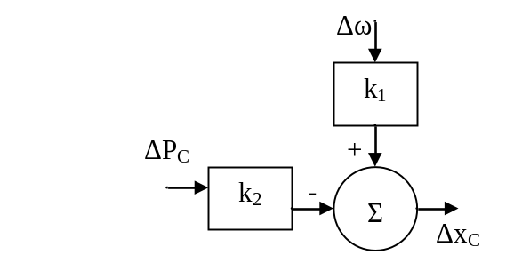
Fig. 6
Moving to (11b), which is , we can draw Fig. 7.
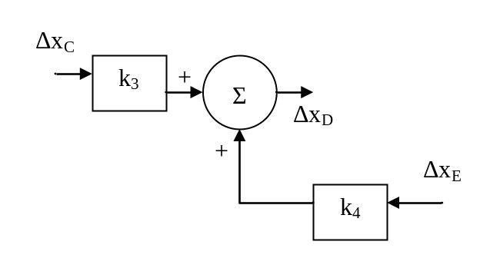
Fig. 7
Finally, considering (13d), which is, we can draw Fig. 8.
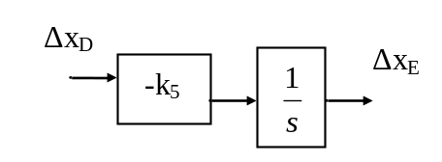
Fig. 8
Combining Figs. 6, 7, and 8, we have Fig. 9 (which is Fig. 11.2 in text):
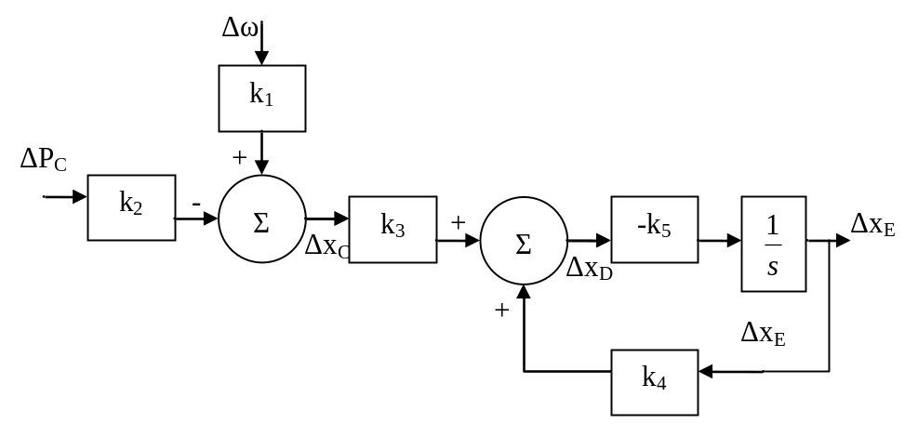
Fig. 9: Speed governor block diagram

We can derive the relation between the output which is Δx_{E} and the inputs which are ΔP_{C} and Δω using our previously derived equations. Alternatively, we may observe from the block diagram that
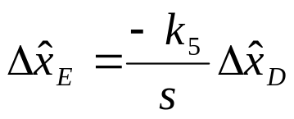 (14)
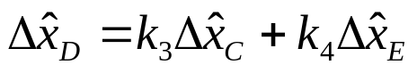 (15)
Substitution of (15) into (14) yields:
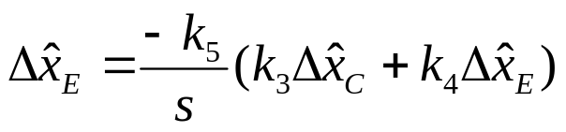 (16)
Expanding (16) results in:
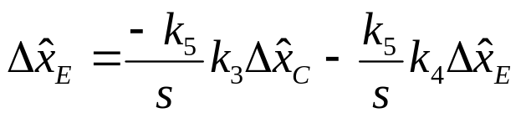 (17)

Moving terms in Δx_{E} to the left-hand-side gives:
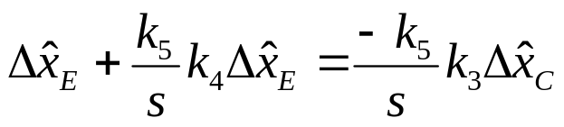 (18)
Factoring out the Δx_{E} yields:
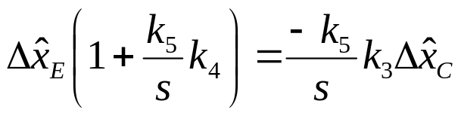 (19)
Dividing both sides by the term in the bracket on the left-hand-side provides:
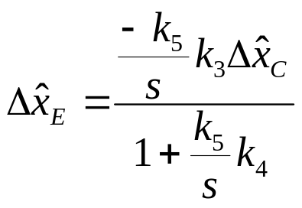 (20)
Multiplying top and bottom by s gives:
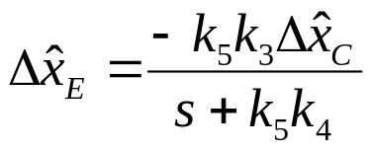 (21)
Now recognizing from Fig. 9 or eq. (10b), that
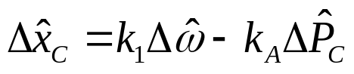, we may make the appropriate substitution into eq. (21) to get:
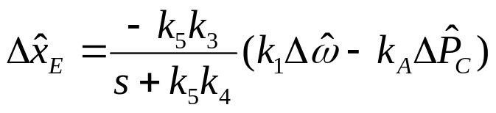 (22)
Distributing the negative sign through:
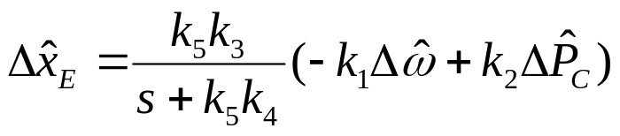 (23)
Now factor out k₂ to obtain:
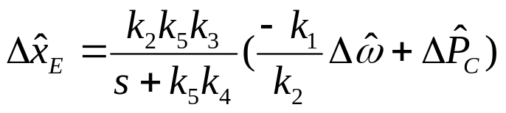 (24)
Simply switching the order of the terms in the parentheses:
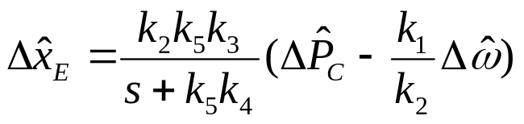 (25)
Divide top and bottom by k₅k₄ to get:
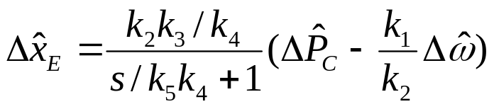 (26)
Now we make three definitions:
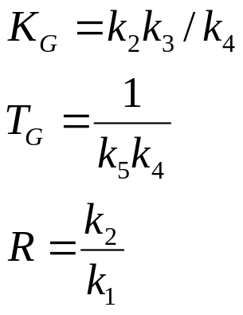 (27)
where K_{G} is the controller gain, T_{G} is the controller time constant, and R is the regulation constant. Using these parameters in (26) gives:
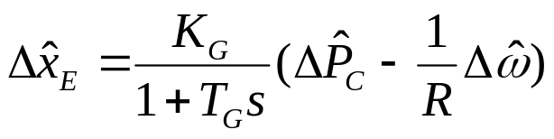 (28)
The text indicates (page 380) that T_{G} is typically around 0.1 second. Since T_{G} is the time constant of this system, it means that the response to a unit step change in ΔP_{C} achieves about 63% of its final value in about 0.1 second. Figure E11.1 in your text illustrates this.

[?] ftp://www.nerc.com/pub/sys/all_updl/standards/sar/Glossary_Clean_1-07-05.pdf
[?] N. Cohn, “Control of Generation and power flow on interconnected systems,” second edition, Wiley,

