Notes 17: Use of Shunt Capacitors

17.0 Motivation

Figures 1 and 2 show shunt capacitor banks.
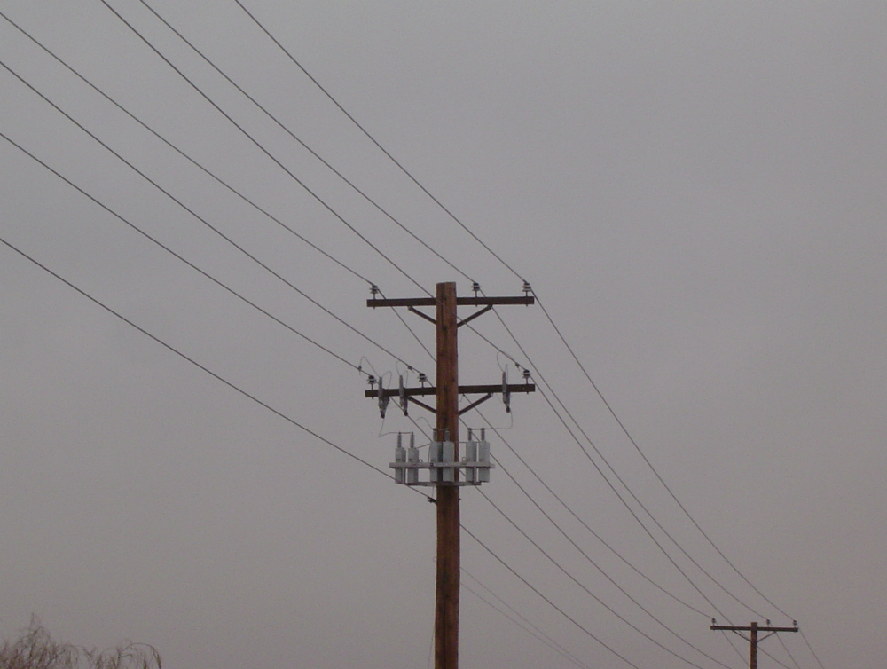
Fig. 1 [1]
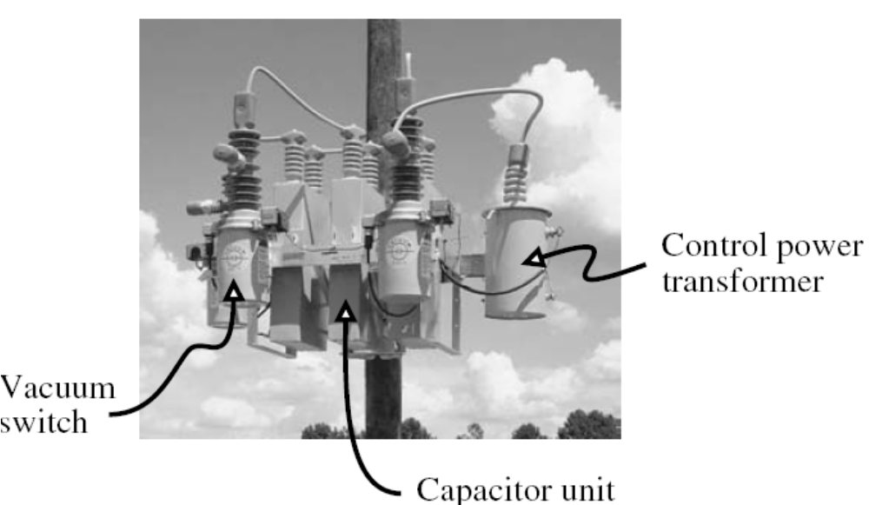
Fig. 2 [1]

Use of shunt capacitors has two positive effects.
- Raising the voltage
- Causes power factor to be less lagging
We have already seen the importance of maintaining voltage, in terms of proper and efficient operation of different kinds of loads.

As we know from EE 303, when the power factor is lagging (implying a reactive load), making it less lagging (closer to 1.0 power factor) results in supply of the same real power (MW) with less current from the source. Installation of a capacitor effectively provides that the reactive power is supplied by the capacitor (at or closer to the load) instead of the source. Since this causes current reduction, we obtain:
- Reduced I²R losses in the conductors
- Increased available capacity in the conductors (since conductors are current limited) so that we may supply higher demand

The problem of power factor correction is an important one, but it is well addressed in EE 303, so we will say no more about it here.

The problem faced by a distribution engineer is to decide for a given feeder
- How much capacitance is necessary
- Should the capacitance be fixed or switchable?
- Where should the capacitance be located?
This problem is complex and often, there is no method that will provide a single solution. Identifying the most desirable solution results from assessment of operational effects in relation to investment levels.
What we will do in the remainder of these notes is to provide certain evaluation strategies that give the distribution engineer a means to assess the operational effects.

To be clear, we define operational effects in terms of
- Voltage regulation and
- Reduced power losses

In these notes, we will first discuss the issue of raising the voltage, then the issue of fixed vs. switchable capacitors (both of these are voltage regulation issues), and finally the issue of reduced power losses.

17.1 Voltage rise from capacitors

Let’s consider the simple circuit on shown in Fig. 3.
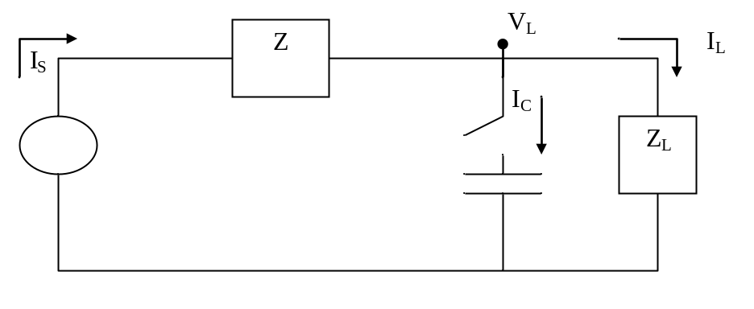
Fig. 3

Without the capacitor (switch open), the load voltage 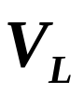 is given by:
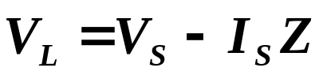 (1)

With the capacitor (switch closed), the load voltage 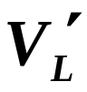(note the primed notation to denote that this is the voltage with the capacitor in) is:
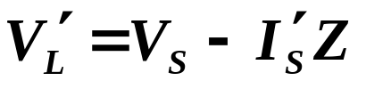 (2)

Define the voltage rise obtained from switching in the capacitor as ΔV_{L}, given by:
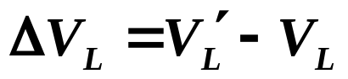 (3)

Substituting eqs. (1) and (2) into (3),
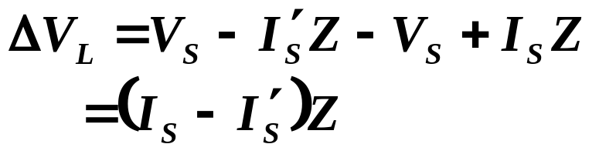 (4)

When the capacitor is switched out, the source current equals the load current, so
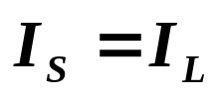 (5)
But when the capacitor is switch in, the source current equals the load current plus the capacitor current, so:
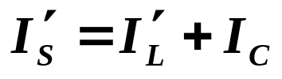 (6)
Now we make an approximation, and that is that the load current with and without the capacitor is the same (this is true for constant current loads but not true for constant power or constant impedance loads). Under this assumption,
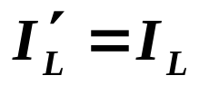 (7)
and eq. (6) becomes:
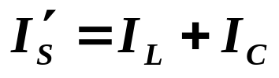 (8)
We can now express 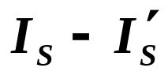 of eq. (4) as:
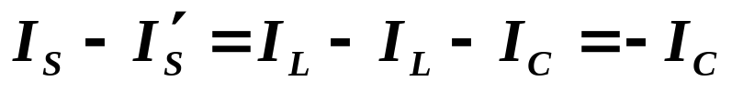 (9)
Substitution into eq. (4) yields:
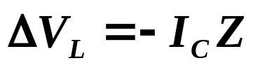 (10)
This says that the voltage rise at the load is proportional to the capacitor current times the impedance between the load and the nearest constant voltage source.

But what about the negative sign? Let’s investigate further….

Recall eq. (3), repeated here for convenience
Rearranging,
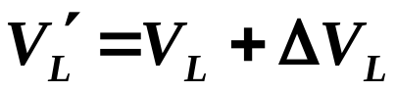 (11)
Substituting eq. (10) into (11), we get:
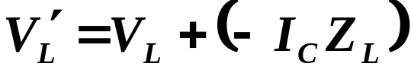 (12)
Now consider Z_{L}=R+jX. Then eq. (12) is:
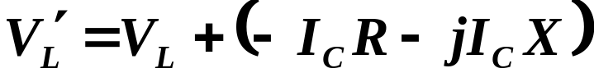 (13)
Assuming the V_{L} is our reference phasor, we can use eq. (13) to draw the phasor diagram, as shown in Fig. 4.
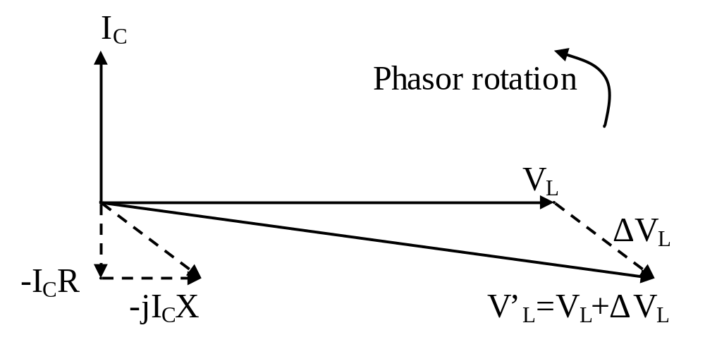Fig. 4

Note especially in Fig. 2 the dashed vectors corresponding to the vector addition of:
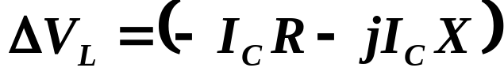 (14)

We also note in Fig. 4 that the magnitude (length) of the V’_{L} vector is greater than the magnitude (length) of the V_{L} vector, indicating that the effect of the capacitor has been in fact to produce a voltage rise.

Now make one more approximation. Assume that R=0. In this case, eq. (13) becomes:
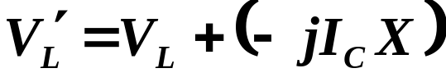 (15)
i.e.,
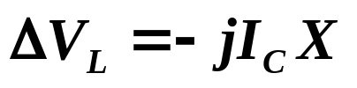 (16)
The corresponding phasor diagram is shown in Fig. 5:
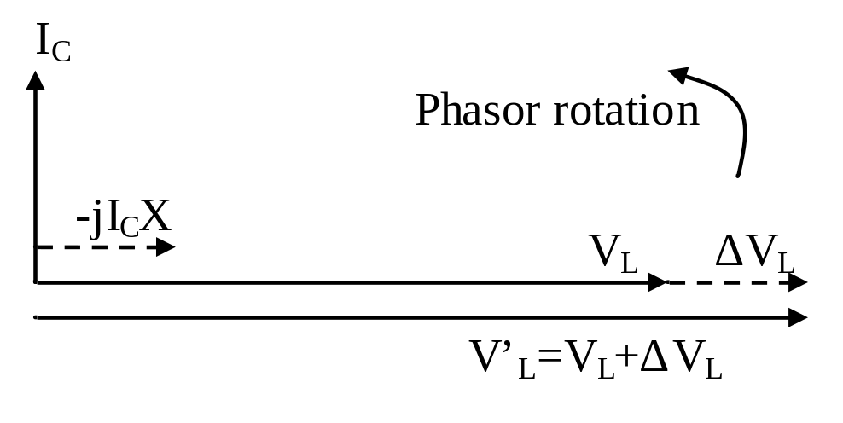
Fig. 5
In terms of voltage magnitude,
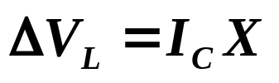 (17)
For a single phase system,
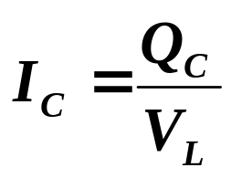 (18)
Substitution of (18) into (17) yields:
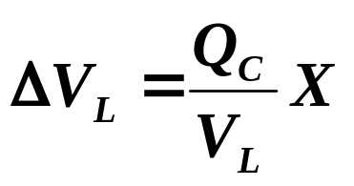 (19)
In terms of percentage voltage rise (%R), we have:
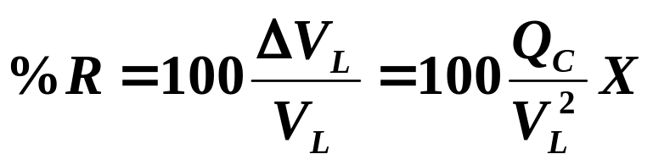 (20)
This equation also applies to a 3-phase system if we replace Q_{C} by Q_{C1φ} and V_{L} by V_{L,LN}, resulting in:
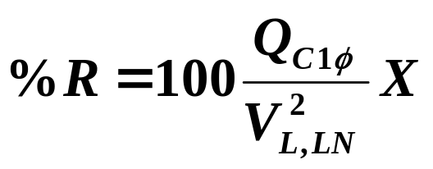 (21)
But Q_{C1φ}= Q_{C3φ}/3 and V_{L,LN}= V_{L,LL}/sqrt(3), so that eq. (21) may also be written as:
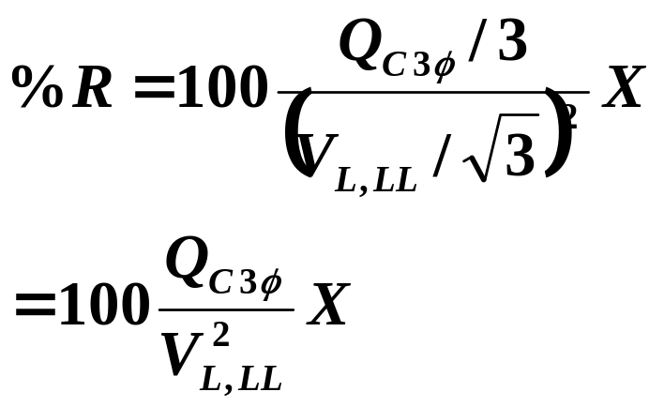 (22)

Equations (20) for single phase feeders and (22) for three phase feeders are quite useful relations that enable us to compute the %voltage rise we will get from installing a certain amount of reactive power at a certain voltage level.

17.2 Fixed Shunt Capacitors

The main concept here is that since these capacitors are on all of the time, they must apply to all loading conditions.

The consequence of this is that in sizing fixed capacitance for correcting voltage, we must do it for conditions that see the highest voltage level (if the highest voltage level exceeds allowable voltage levels, then of course we should NOT install fixed capacitance!).

Which conditions are these?
➔ The lightest-load conditions.
Otherwise, if we size for heavy load conditions, the less loaded conditions will see overvoltages.

Approach for sizing fixed capacitance:
- At the lightest load conditions (perhaps 25% of peak), identify the load-end voltage with no capacitors. Call this V_{light}.
- Identify the maximum feeder voltage allowable (typically corresponding to 126 volts on the residential service side). Call this V_{max}.
- Compute the allowable percent rise:
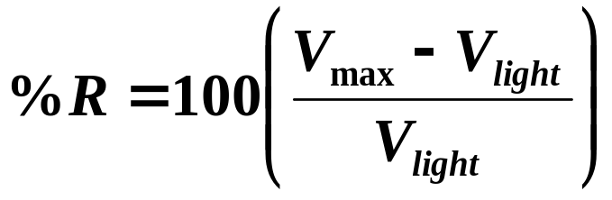 (23)
- Compute reactive power required from capacitance:
  - If single phase system, use eq. (20) to solve for Q, resulting in:
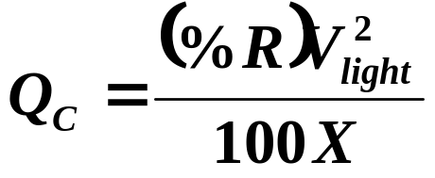 (24)
where V_{light} is line-to-neutral voltage.
  - If three-phase system, use eq. (22) to solve for Q, resulting in
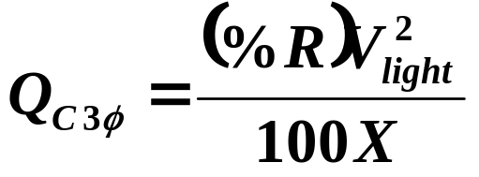 (25)
where V_{light} is line-to-line voltage.

17.3 Switched-Shunt Capacitors

At certain times of the day, the load will exceed the level for which the fixed shunt caps were designed. Based on our fixed shunt design strategy, this will happen at, say, 25% of peak load.

If we reach a load level where V<V_{min} on any bus, it is unacceptable.

Since the amount of fixed capacitors were identified in order to achieve maximum allowable voltages at minimum loads (e.g., 25% of peak), then there will be some amount of loading increase before any bus sees the minimum voltage.
Let’s assume that a bus hits minimum voltage at 50% of peak. Fig. 6 illustrates.
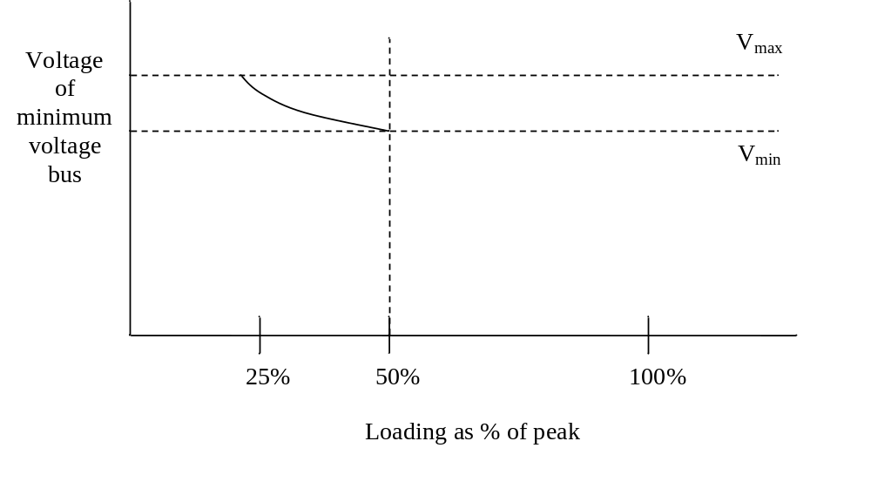
Fig. 6
So the loading level in which minimum voltage is reached with only fixed capacitors on is the point for which we should switch in additional capacitors. In this particular case, that loading level is 50% of peak.

Fig. 7 illustrates daily reactive load requirements of a typical feeder, distinguishing between times when fixed capacitors supply vars and times when switched capacitors supply vars. Clearly, switched shunt capacitors are used during higher-load time periods. In the case of Fig. 7, switched shunt capacitors are switched in at a reactive load of 700 kVAR, which is about 36% of peak.
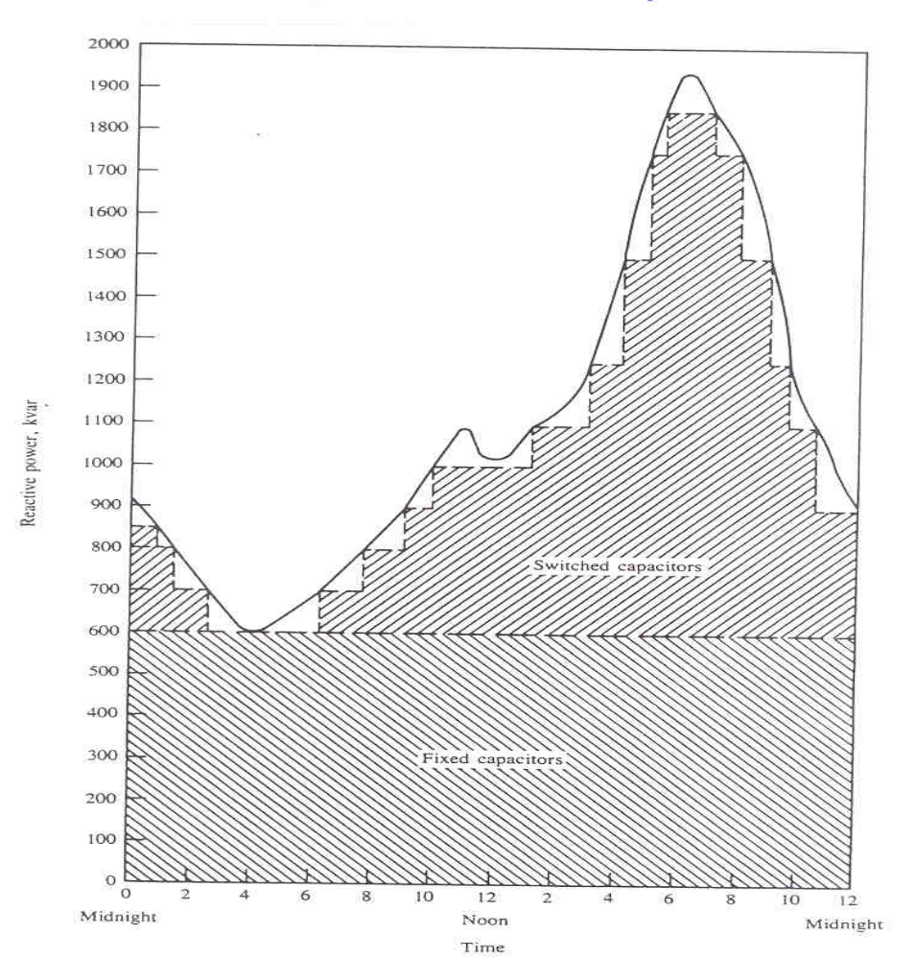Fig. 7 [1]

Available control methods for switching shunt capacitors are as follows [1]:
- Time clock: This is the simplest and most common scheme where the controller switches capacitors on and off based on the time of day. Modern controllers allow differentiation between weekends, weekdays, and holidays. This control is the least expensive but also the most susceptible to inappropriate switching.
- Temperature: This is another simple control where controller switches on and off depending on temperature.
- Voltage: The user can provide maximum and minimum switching voltages, bandwidths, and time delays. This is most effective control when voltage regulation is the primary role of the capacitor.
- Vars or power factor: This is the most effective method to ensure loss minimization.
Some controllers offer all of the above possibilities.
A common design is to use a combination of fixed, time-clock switched, and voltage-controlled switched capacitors.

This is because time-clock switched levels must be determined so that they do not cause overvoltages on typical days. This may prevent use of time-clock switched caps for providing enough voltage rise on peak days.

So voltage-switched capacitors are primarily used for peaks days and times. Fig. 8 illustrates the daily reactive load requirement of a typical feeder, distinguishing between times when fixed, time-clock switched, and voltage switched capacitors are supplying vars.

Observe that voltage-switched capacitors may also switch in just before the time-switched capacitors as the load rises. They may then switch back out as the time-switched capacitors switch in.
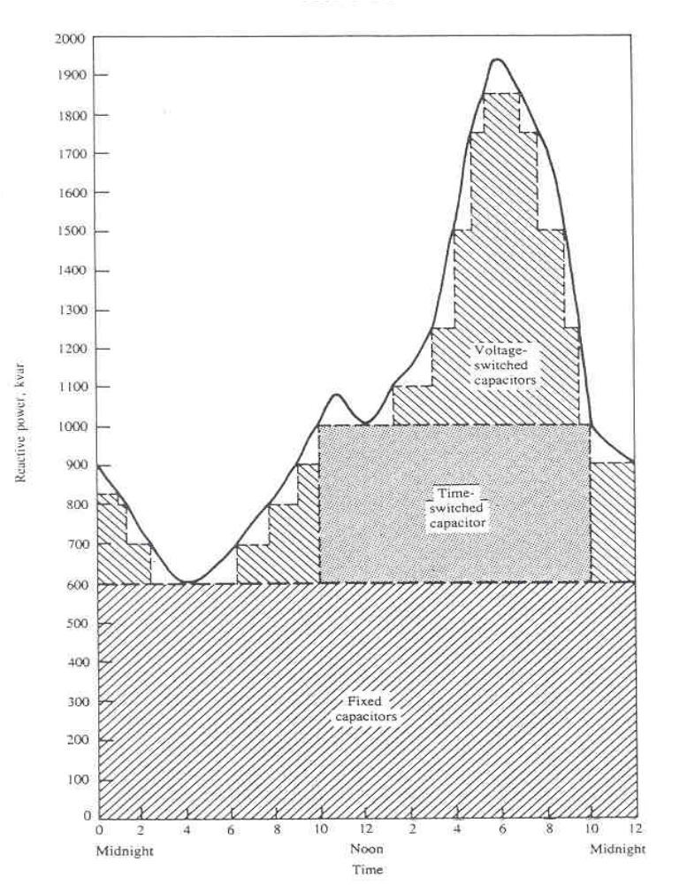Fig. 8 [2]

The design approach for time-clock switched capacitors is similar to that for fixed capacitors (given on pg. 13), except it is done at the loading level at which one bus is at minimum voltage level when all fixed shunt capacitors are in (e.g., 50% of peak). Thus, only step 1 of the procedure on pg. 13 is changed.

The time for switching in time-clock switched capacitors should be at a time after the loading is sure to rise beyond the design loading level (e g., 50% of peak). This may result in a short time undervoltage but will avoid any overvoltage.

The time for switching out time-clock switched capacitors should be set at a time before the loading is sure to decline below the design loading level (e.g., 50% of peak). Again, this will avoid overvoltages.

The design approach for voltage-switched capacitors is similar to that for fixed capacitors (given on pg. 13) and time-clock switched capacitors (given on pg. 20), except it is done at the loading level at which one bus is at minimum voltage level when all fixed and time-clock-switched shunt capacitors are in (e.g., 70% of peak). Voltage setting is minimum voltage, typically with some bandwidth to reduce switching frequency. Multiple voltage-switched capacitors on the same feeder require coordination, typically through staggered time delays, illustrated in Fig. 9.
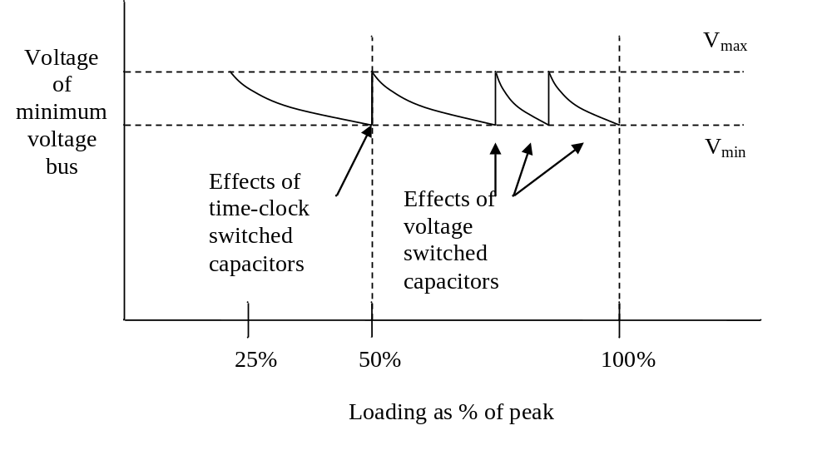
Fig. 9
17.4 Capacitor location [2]

Consider the following problem.
- We have a feeder of length 1.0.
- The feeder has a large number of loads uniformly distributed about its length.
- The feeder has a lumped load at the end, drawing a current I_{M}.
The situation is illustrated in Fig. 10.
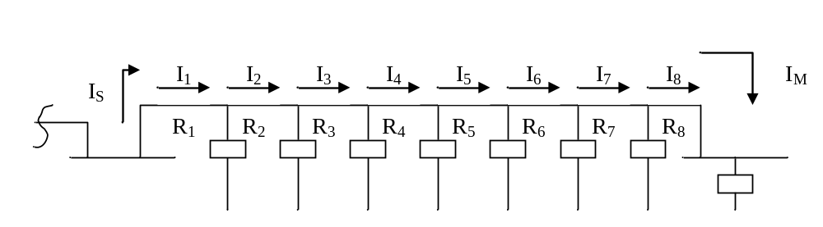
Fig. 10
Question: Where is the best place to locate a capacitor?

To answer this question, we need to know the design criteria. I propose:
- Minimize losses=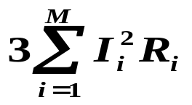
- Minimize voltage drop=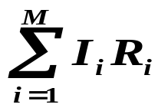
17.4.1 Simpler problem

Let’s look at a simpler problem first.
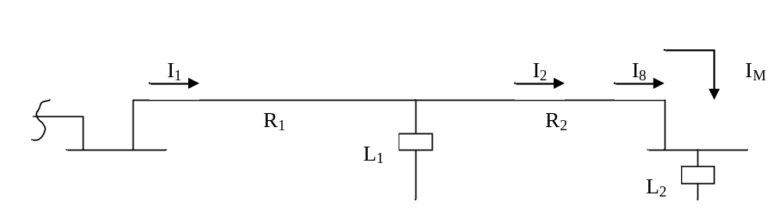
Fig. 11
Our two objective functions are:
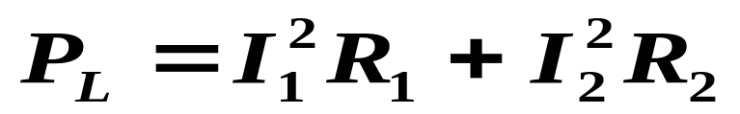 (26)
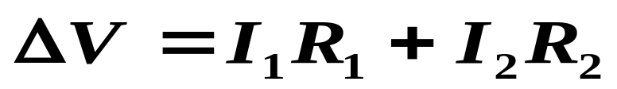 (27)
Notice is that a capacitor will affect the currents, and it has different effects on the currents depending on where it is placed.

The effects of a capacitor on the currents will then influence both the losses and the voltage drop. But it influences the losses through the square of the currents and the voltage drop through the currents themselves. Therefore, in general, the optimal location for minimizing losses will be different than the optimal location for minimizing voltage drop.
Therefore we will only focus on the problem of minimizing losses.

Now, given that we want to minimize the losses, what do we do? Place the capacitor at the end (L2)? Place it in the middle (L1)?

It is not obvious where to place it, as it depends on the relative magnitudes of I₁ and I₂.

To solve this problem, we need to develop an expression as a function of where the capacitor is located.

Before we do that, however, we turn our attention to a simplification.

17.4.2 Out-of-phase current component

We can prove that we need only deal with the out-of-phase current component.

What do I mean by out-of-phase and in-phase current components?

Voltage: 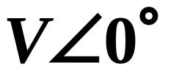

Current: 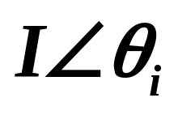

In-phase current component: 

Out-of-phase current component: 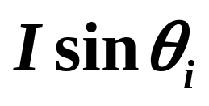

Instead, of proof, I relay on intuition:
➔ The in-phase component is unaffected by capacitors.

17.4.3 Losses without capacitor

In all of what follows, “I” denotes the out-of-phase current component, also called the reactive current.

Let’s go back to the case of a uniformly distributed load along the feeder (Fig. 10, repeated here for convenience)
Fig. 10
Define x as the distance along the feeder from the source, and recall that the feeder has length of 1.
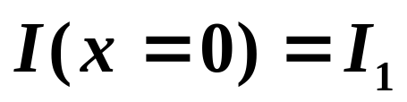 (28)
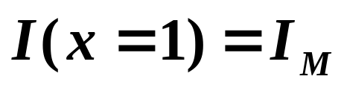 (29)

The decrease along the feeder of the reactive current due to the load is:
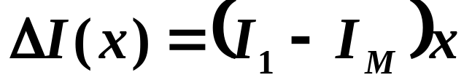 (30)
Then we can write down the current at any point x along the feeder as:
(31)
Now what are the losses in a small length of the feeder at x having resistance Rdx?

This will be:
(32)
And now we can find the total losses in the feeder as:
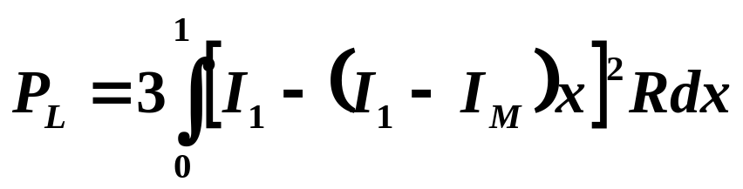 (33)

If you expand the integrand and then perform the integration, you will find that:
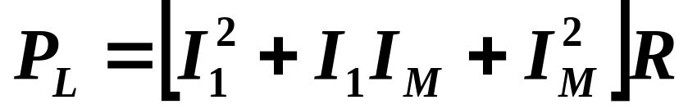 (34)

To remind you….
- P_{L} is total 3-phase losses in feeder w/o cap
- I₁ is reactive current at beginning of feeder
- I_{M} is reactive current at end of feeder
- R is total feeder resistance

17.4.3 Losses with capacitor

Now let’s consider installation of one capacitor bank. Assume it will be located at x=x₁, which is just some arbitrary point on the feeder, as illustrated in Fig. 12.
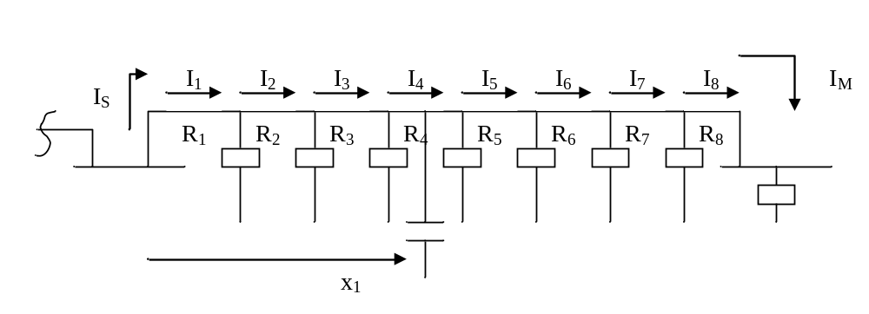
Fig. 12

We can use a similar procedure as before, except we must look at two separate cases.

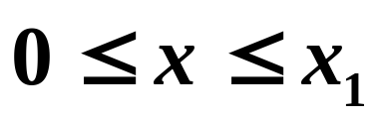:

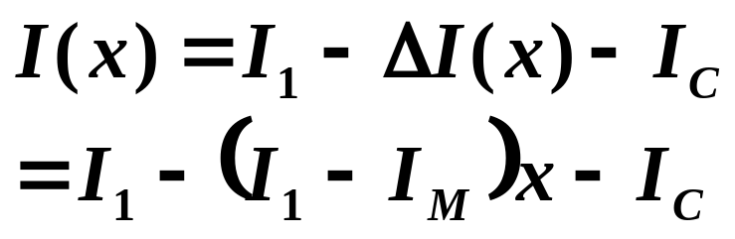 (35)
In the above we subtract off I_{C} because the load current is assumed to be lagging.

The losses in a small length of the feeder dx having resistance Rdx will be:
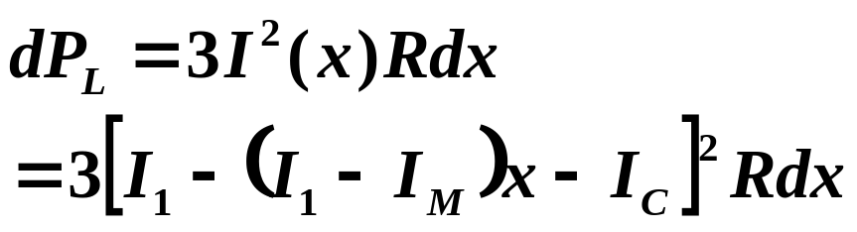 (36)

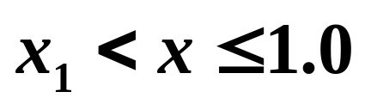:
The downstream load will not be affected by the capacitor! Therefore, for this case, the differential loss expression is the same as the expression without the capacitor, as given in eq. (32):
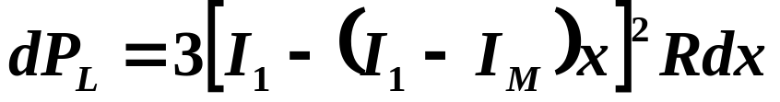 (37)

So the complete loss expression with the capacitor located a distance along the feeder x₁ from the source is given by:

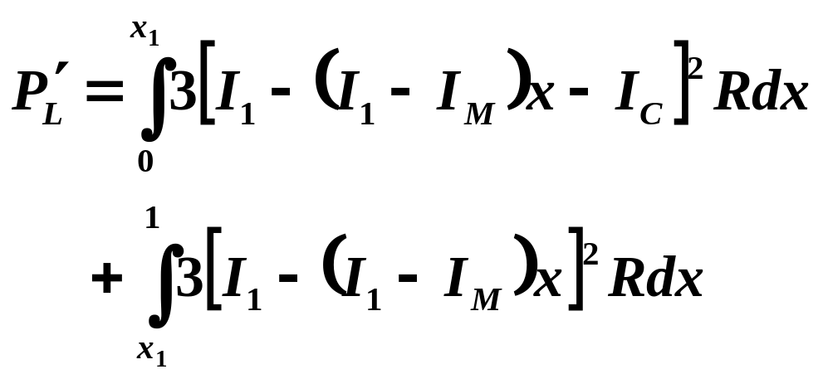(38)

Note that the primed notation on the P_{L} term denotes losses with capacitor.
Expanding eq. (38) and integrating yields:

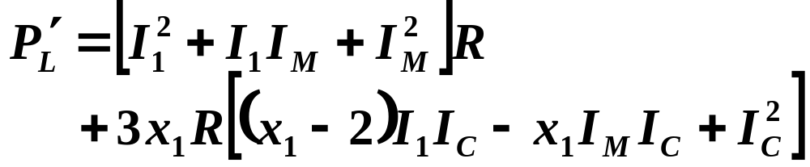 (39)
Therefore the loss reduction with the installation of the capacitor is:
(40)
Now let’s normalize the above expression by P_{L}, where P_{L} is given by eq. (34) repeated here for convenience:
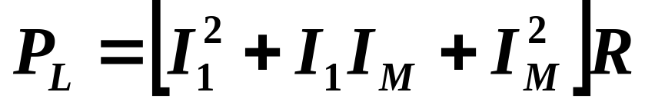
The normalization provides us with a % loss reduction (PLR):
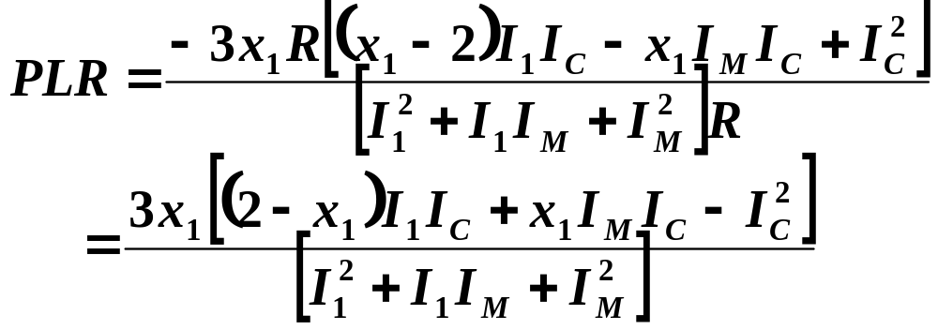 (41)
Now let’s factor out an I₁² from top and bottom, resulting in
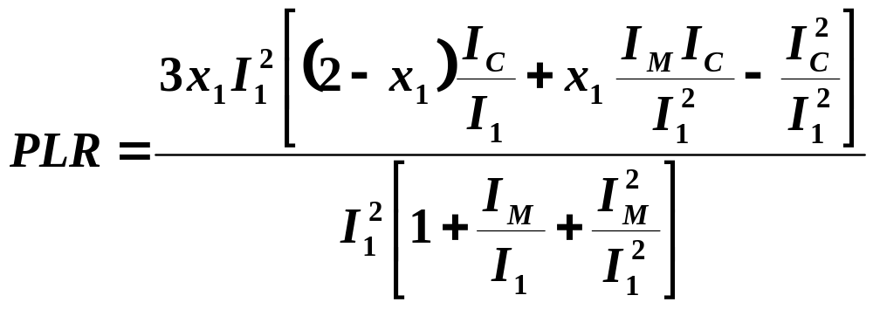
(42)
There are two interesting ratios that appear in eq. (42). One is I_{C}/I₁ and the other is I_{M}/I₁. Let’s cancel the I₁² out front and at the same time rewrite the various ratios so that the two of interest can be clearly observed.
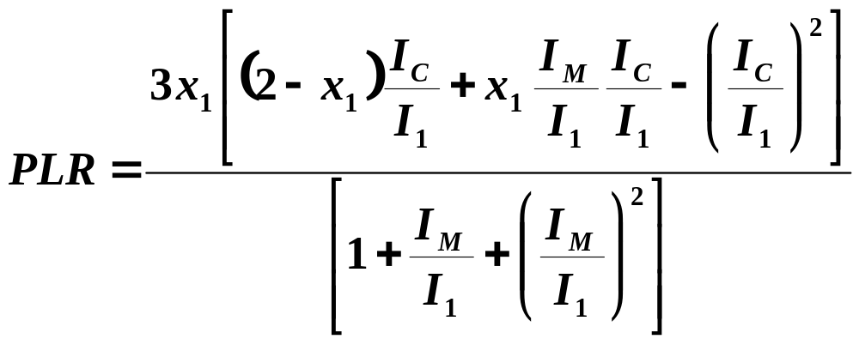 (43)
Now define these ratios:
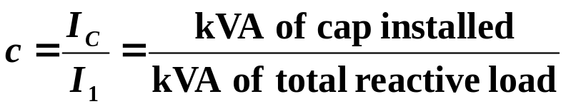 (44)
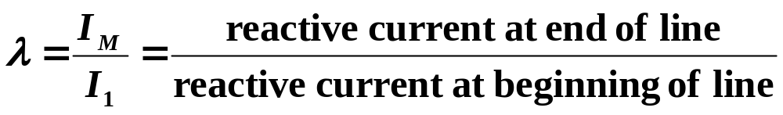(45)
The c-ratio of eq. (44) is the ratio of the capacitor current to the current at the beginning of the line. Assuming equal voltage magnitudes at the capacitor location and at the beginning of the line, then the c-ratio is also equal to the kVA of the capacitor to the kVA of the total reactive load, as indicated on the right-hand-side of eq. (44). Knowing this ratio gives information about “how much” capacitance.
The λ-ratio is a measure of how distributed is the load. Reference to eqs. (28-30) shows that the problem was set up assuming that I₁ and I_{M} are given, then their difference is distributed uniformly between the ends of the line. Describing the meaning of this ratio at its extreme values helps to see its significance.
- λ=1 means I_{M}=I₁, implying all load is concentrated at the end, and none of it is uniformly distributed between the ends.
- λ=0 means I_{M}=0, implying all load is uniformly distributed between the ends, and none of it is at the end.
Values of λ between 0 and 1 characterize situations between these extremes, with load concentration shifting from
- between the ends (highly distributed load) to
- the end (completed concentrated load)
as λ increases from 0 to 1.

Replacing the corresponding ratios in eq. (43) with these parameters, we have:
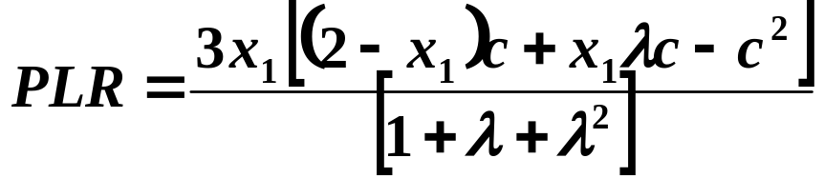 (46)
Factoring out the c-parameter from the bracketed term in the numerator, we have:
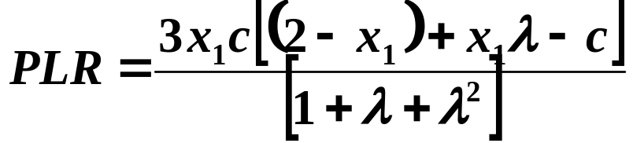 (47)

Equation (47) is a very useful equation. Since λ is determined by the feeder (not a design characteristic), then we can assume for a given situation that it is given. Then our problem is to identify
- The optimal amount (by identifying c)
- The optimal location (by identifying x₁).
We can use calculus to do this, by taking derivatives with respect to either c or x₁, setting to 0, and solving.

However, there is a problem. The optimal amount depends on the location, and the optimal location depends on the amount.

Hmmmm.

So our approach is as follows:
- Fix λ.
- Fix c at low number, e.g., c=k=0.1.
- Find optimal value of x₁.
- Increment c by k, i.e., c←c+k
- If c>1, stop, otherwise, go to 3.

This approach is just finding optimal location (x₁) for various values of c, as c is incremented by 0.1 from 0.1 to 1.

To perform step 3, let’s expand eq. (47).

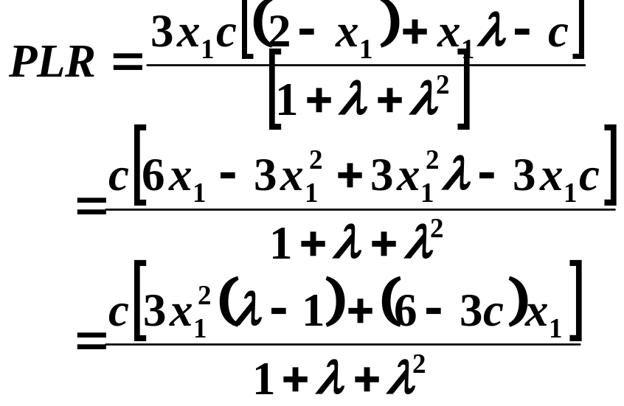 (48)
Now differentiate with respect to x₁, assuming λ and c are constants, and set to 0.
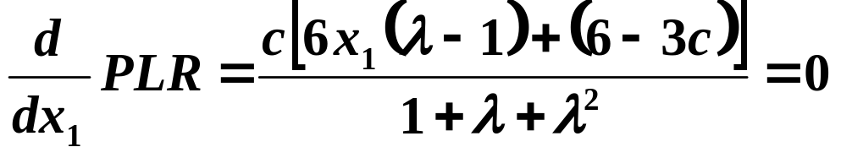(49)
If c=0, then it means we have no capacitor and therefore no capacitor location problem. So it must be the case that:
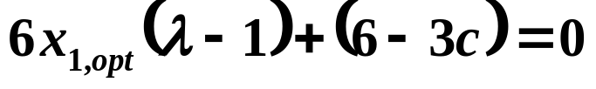 (50)
Solving eq. (50) for x₁ we obtain:
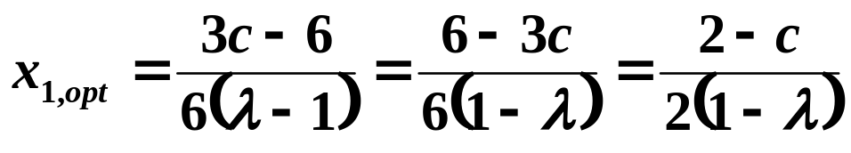 (51)

Equation (51) provides the optimal location. Yet, we are constrained by the physics of the problem that 0<x₁<1. Applying these constraints to eq. (51) results in
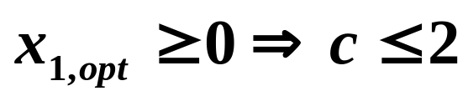 (52)
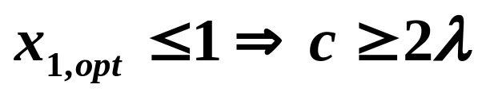 (53)
This means that in order for the optimal location to lie between 0 and 1, c must satisfy:
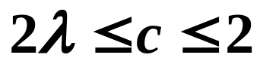 (54)
The implication is that the optimal value of x_{1,} x_{1,opt}, will always be between 0 and 1 (and therefore be physically realizable) if c satisfies eq. (54).

We do not have to worry about the upper bound on eq. (54) because c will always be less than 2. In fact, c will never exceed 1, i.e., we will never compensate more than the load kVA. Therefore we may replace eq. (54) with
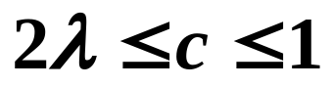 (55)

It is possible that c<2λ. What does it mean? It means that
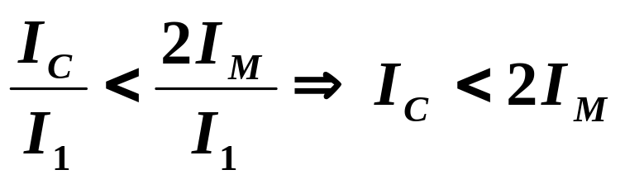 (56)
This is an interesting result. It says that if we choose to install capacitance having less than half the kVA as the load at the end of the line, that eq. (53) will be violated, implying that the mathematical optimal will have a location greater than x₁=1. It stands to reason that if the mathematical optimal is to the right of x₁=1, then the physical optimal is exactly at x₁=1.

We give several plots of eq. (47), PLR as a function of capacitor location x₁, for various values of λ and c in Figs. 13-19.
The Matlab code follows:
-------------------------
%This code plots eq. 47 in Notes 17 for EE 455.
L=0;
x=[0 .05 .1 .15 .2 .25 .3 .35 .4 .45 .5 .55 .6 .65 .7 .75 .8 .85 .9 .95 1];
c=1.0;
p10=((3*c)/(1+L+L^2))* x.*( (2-x)+x*L-c ) ;
c=0.9
p9=((3*c)/(1+L+L^2))* x.*( (2-x)+x*L-c ) ;
c=0.8
p8=((3*c)/(1+L+L^2))* x.*( (2-x)+x*L-c ) ;
c=0.7
p7=((3*c)/(1+L+L^2))* x.*( (2-x)+x*L-c ) ;
c=0.667
p667=((3*c)/(1+L+L^2))* x.*( (2-x)+x*L-c ) ;
c=0.6
p6=((3*c)/(1+L+L^2))* x.*( (2-x)+x*L-c ) ;
c=0.5
p5=((3*c)/(1+L+L^2))* x.*( (2-x)+x*L-c ) ;
c=0.4
p4=((3*c)/(1+L+L^2))* x.*( (2-x)+x*L-c ) ;
c=0.3
p3=((3*c)/(1+L+L^2))* x.*( (2-x)+x*L-c ) ;
c=0.2
p2=((3*c)/(1+L+L^2))* x.*( (2-x)+x*L-c ) ;
c=0.1
p1=((3*c)/(1+L+L^2))* x.*( (2-x)+x*L-c ) ;
plot(x,p10,x,p9,x,p8,x,p7,x,p6,x,p5,x,p4,x,p3,x,p2,x,p1);
---------------------------

In Fig. 13, λ=1, i.e., the load is lumped entirely at the end. Comments about this:
- Because the lower bound of eq. (56), 2λ<c or 2I_{M}<I_{C}, is always violated when λ=1, the mathematical optimal location causes x_{1,opt}>1.
- The PLR continuously increases with x₁ in the physically allowable range. Therefore the physical optimal is always to install the capacitor at the end.
- The optimal value of c is 1.0 (pf=1.0).
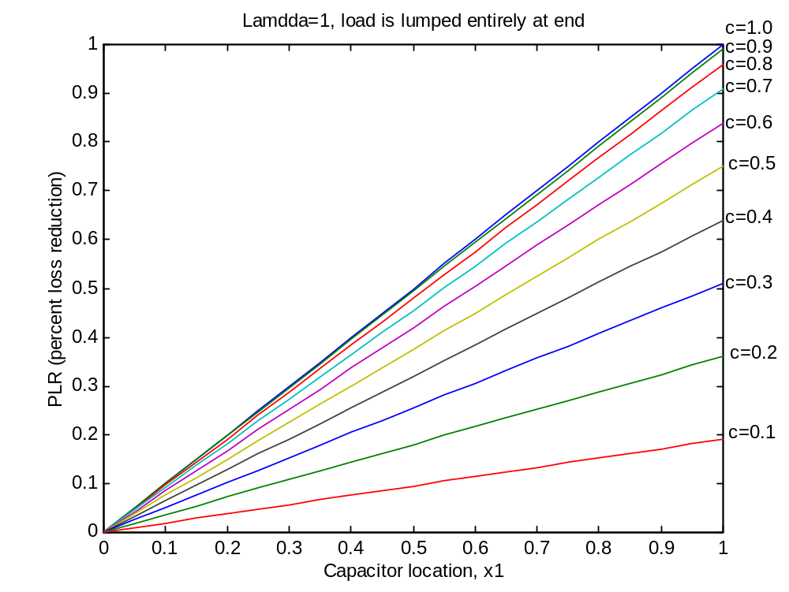
Fig. 13: λ=1
In Fig. 14, λ=0, i.e., the load is entirely distributed along the line, and none of it is located at the end. Comments about this:
- Because λ=0, eq. (56), 2λ<c<1 is always satisfied, and therefore the mathematical optimal location is always within 0<x_{1,opt}<1.
- The optimal location depends on the amount.
- We observe from that the largest PLR occurs for c=0.7, x₁≈0.65. Let’s investigate this some more.
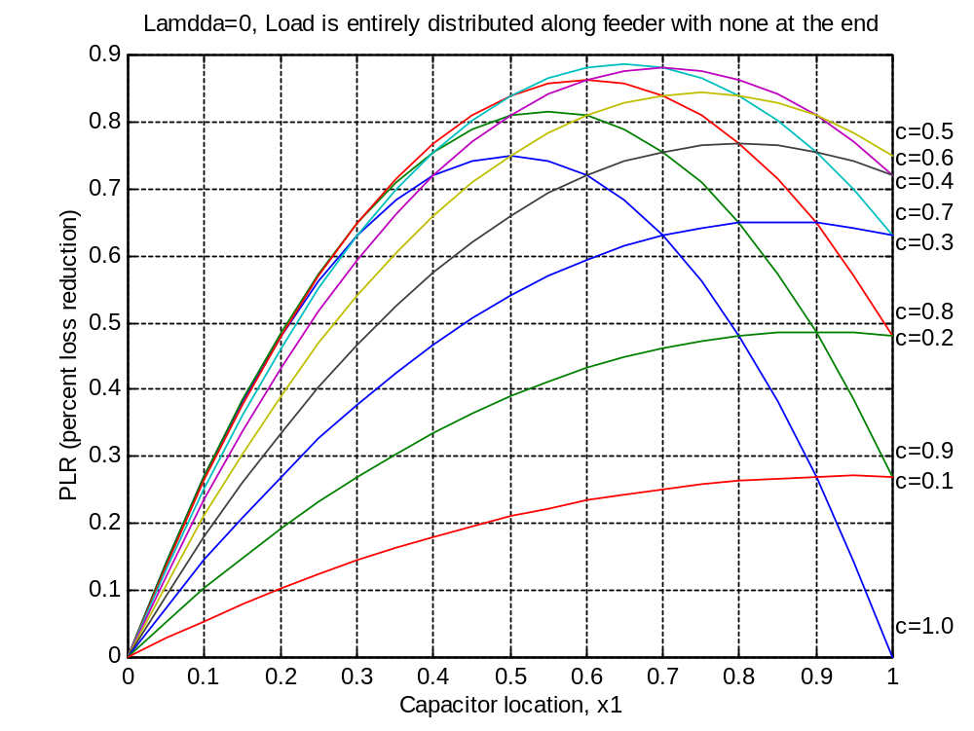
Fig. 14: λ=0
Figure 15 shows a blow-up of Fig. 14, for c=0.6, c=0.667, and c=0.7.
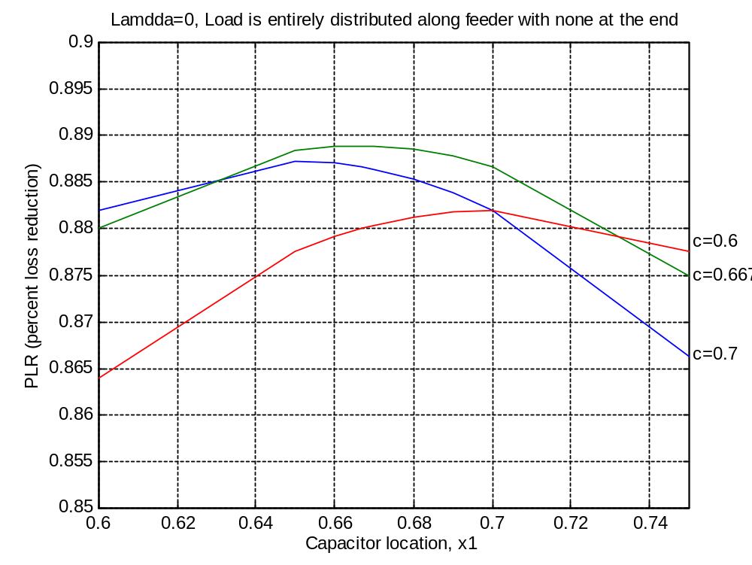
Fig. 15: Blow-up of λ=0
From this plot, we can observe:
- The optimal amount corresponds to c=0.667.
- The optimal location is at x_{1,opt}=0.667.
- The PLR at the optimal amount and optimal location is about 0.888.
Interesting….for λ=0, the optimal amount should be 2/3 of total load located 2/3 of distance from the source (for 1 capacitor).
HW6 Assignment:
- For a single capacitor design, express the PLR, eq. (48), given that the capacitor is always placed at the optimal location per eq. (51). Make plots of the resulting PLR as a function of c for λ=1, ¾, ½, ¼, and 0.
- For a single capacitor design, find an expression for the optimal c as a function of x₁. That is, if I give you the location of the capacitor, your equation should tell me the amount of capacitance that will maximize PLR.
- For a single capacitor design, express the PLR, eq. (48), given that the capacitor is always sized optimally per your result in problem 2. Make plots of the resulting PLR as a function of x₁ for λ=1, ¾, ½, ¼, and 0.

17.4 Locating multiple capacitors [2]

All of the above was done for the case when we are restricted to locating a single capacitor. We now consider the case when we may locate any number of capacitors.

In order to be brief, I will not derive results but rather just give them.

Define n as the number of capacitors.
We assume that all capacitor banks are of equal size, given by eq. (44), repeated here for convenience:
and that the load is described by eq. (45), also repeated here for convenience:

By going through a process of setting up the loss expression integrals, performing the integration, and substituting the variables c and λ, we can develop the PLR expression as before.

In the general case of n capacitors, the resulting PLR expression for the general (not necessarily optimal) case is given by:
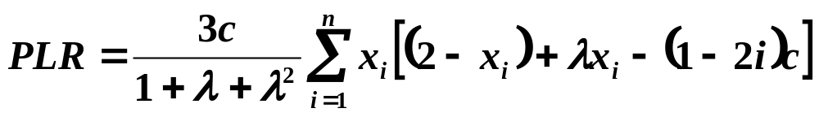 (57)
where x_{i} is the location of the i^{th} capacitor.

The optimal location is found by differentiating PLR of eq. (57) with respect to x_{i}, setting to 0, and solving for x_{i,opt}. This results in:
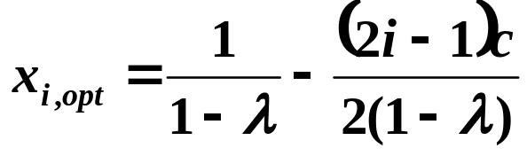 (58)
Substitution of eq. (58) back into (57) and simplifying results in PLR when the capacitors are located optimally:
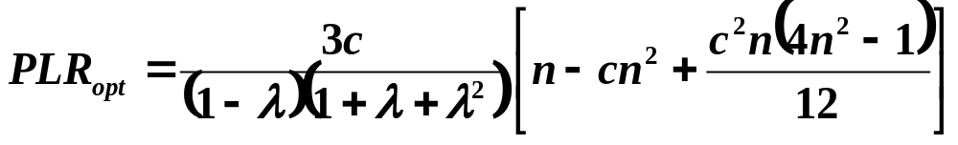 (59)
We can also find the optimal amount of capacitance by solving for c from:
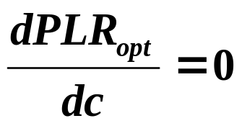 (60)
If we do that, we will obtain:
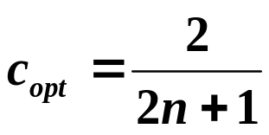 (61)
For example, if n=1, then c_{opt}=2/3, which means that, for n=1, the optimal amount of capacitance is 2/3 of the total reactive load.
HW6 extension:
- Use eq. (58), (59), and (61) of “Notes 17” to obtain expressions for x_{1,opt} and PLR_{opt} for the n=1 capacitor location problem. Compare this result to the bottom of page 43.
References
[1] T. Short, “Electric power distribution handbook,” CRC press, 2004.
[2] T. Gonen, “Electric Power Distribution System Engineering,” McGraw-Hill, 1986.

